**Group 6: PROgrammers**

**Part D**

***URL:*** [***http://waytohire.net/***](http://waytohire.net/)

Group Captain: Yessica Rodriguez 0414909

Oscar Torres 463454

Daniela Tamayo 20336461

Ulvi Bajarani 20539914

**Table of Contents**

**1.** **INTRODUCTION** 4

**1.1.** **Purpose** 4

**1.2.** **Problem Description** 4

**1.3.** **Definitions acronyms and abbreviations** 4

**2.** **DESIGN** 4

**2.1.** **Database Design** 4

**2.2.** **System Design** 6

**2.2.1.** **Decomposition description** 6

**2.2.1.1.** **DataStore Module Description** 6

**2.2.1.2.** **DataProcessing Module Description** 7

**2.2.1.3.** **UserInterface Module Description** 7

**2.2.2.** **Process Integration** 8

**3.** **IMPLEMENTATION** 9

**3.1.** **Database Implementation** 9

**3.2.** **Server-Side Application Program Implementation** 9

**4.** **USABILITY** 22

**4.1.** **User Interface** 22

**4.1.1.** **Main entrance to the system: welcome page** 22

**4.1.2.** **Register Page** 23

**4.1.3.** **Login Page** 24

**4.1.4.** **Password Reset Page** 25

**4.1.5.** **Change Password Page** 26

**4.1.6.** **Profile Page** 26

**4.1.7.** **Info Phone Page** 27

**4.1.8.** **Info Address Page** 29

**4.1.9.** **Schedule Page** 30

**4.1.10.** **Create-Edit Job** 31

**4.1.11.** **Jobs Page** 31

**4.1.12.** **Job Page** 32

**4.1.13.** **Chats Page** 35

**4.1.14.** **Payment Page** 35

**4.2.** **Administrator User Interface** 36

**4.2.1.** **Administrator Login Page** 37

**4.2.2.** **Administrator Password Reset Page** 37

**4.2.3.** **Administrator Change Password Page** 39

**4.2.4.** **Dashboard Page** 39

**4.2.5.** **File Manager Page** 40

**4.2.6.** **Database Record Pages** 40

**4.2.7.** **Create Page** 42

**4.2.8.** **Show Page** 43

**4.2.9.** **Edit Page** 44

**4.2.10.** **Edit Account Info Page** 45

**5.** **TESTING** 46

**6.** **GROUP MEMBER CONTRIBUTIONS** 48

**6.1.** **Yessica Rodriguez -** 48

**6.2.** **Oscar Torres -** 48

**6.3.** **Daniela Tamayo -** 48

**6.4.** **Ulvi Bajarani -** 48

**7.** **CONCLUSION** 48

**8.** **REFERENCES** 49

# **INTRODUCTION**

## **Purpose**

In this document, we describe the HomeNeedsService.com system design and implementation along with the group members contributions. In Section 2, we present the design of the database and system. In Section 3, 4 and 5, we present the implementation of the HNS system. In Section 6, the group members’ contributions to the system are described in detail. In Section 7, the overall performance and functions of the system are summarized along with a detailed description of possible improvements. In Section 8, the references for this project are listed.

## **Problem Description**

With advances in technology, the usage of the internet has increased. People use the internet to shop, conduct research, get entertained, and more. No longer do ads in the newspaper work. However, it is not easy to find someone who offers more household or “handyman” services on the internet or for these people to find customers. Therefore, in this project, an application, HomeNeedsService.com, will be created to provide a platform for users to schedule providers for these services. In the application, the user will be able to search a service and enter all the necessary information to schedule the service. The information would include the location, time, and date. Once that is completed, providers of the service that have an account in this application and are available during the scheduled time will be notified. A provider will take up the accept the offer and the user will receive confirmation. This application will be connected to a database that will contain all necessary information.

## **Definitions acronyms and abbreviations**

HDBD HomeNeedsService.com Database Design

HNS ***HomeNeedsService.com***

AWS Amazon Web Services

# **DESIGN**

## **Database Design**

The database created is a relational database consisting of 22 tables. An Entity-Relational (E-R) Model was created to map out the relationship between each entity or table in the database. The model is shown in Figure 2.1.1.

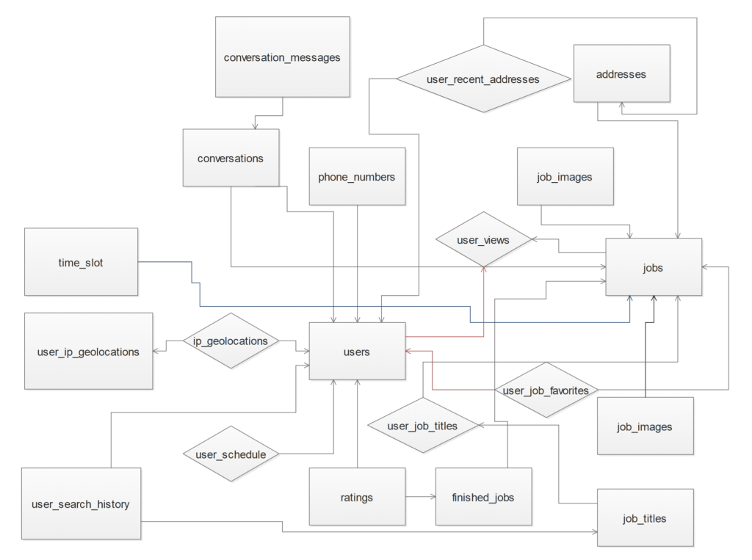

**Figure 2.1.1** E-R Model

Using this model, the database was created. The schemas of those tables and their relations are shown in Figure 2.1.2.

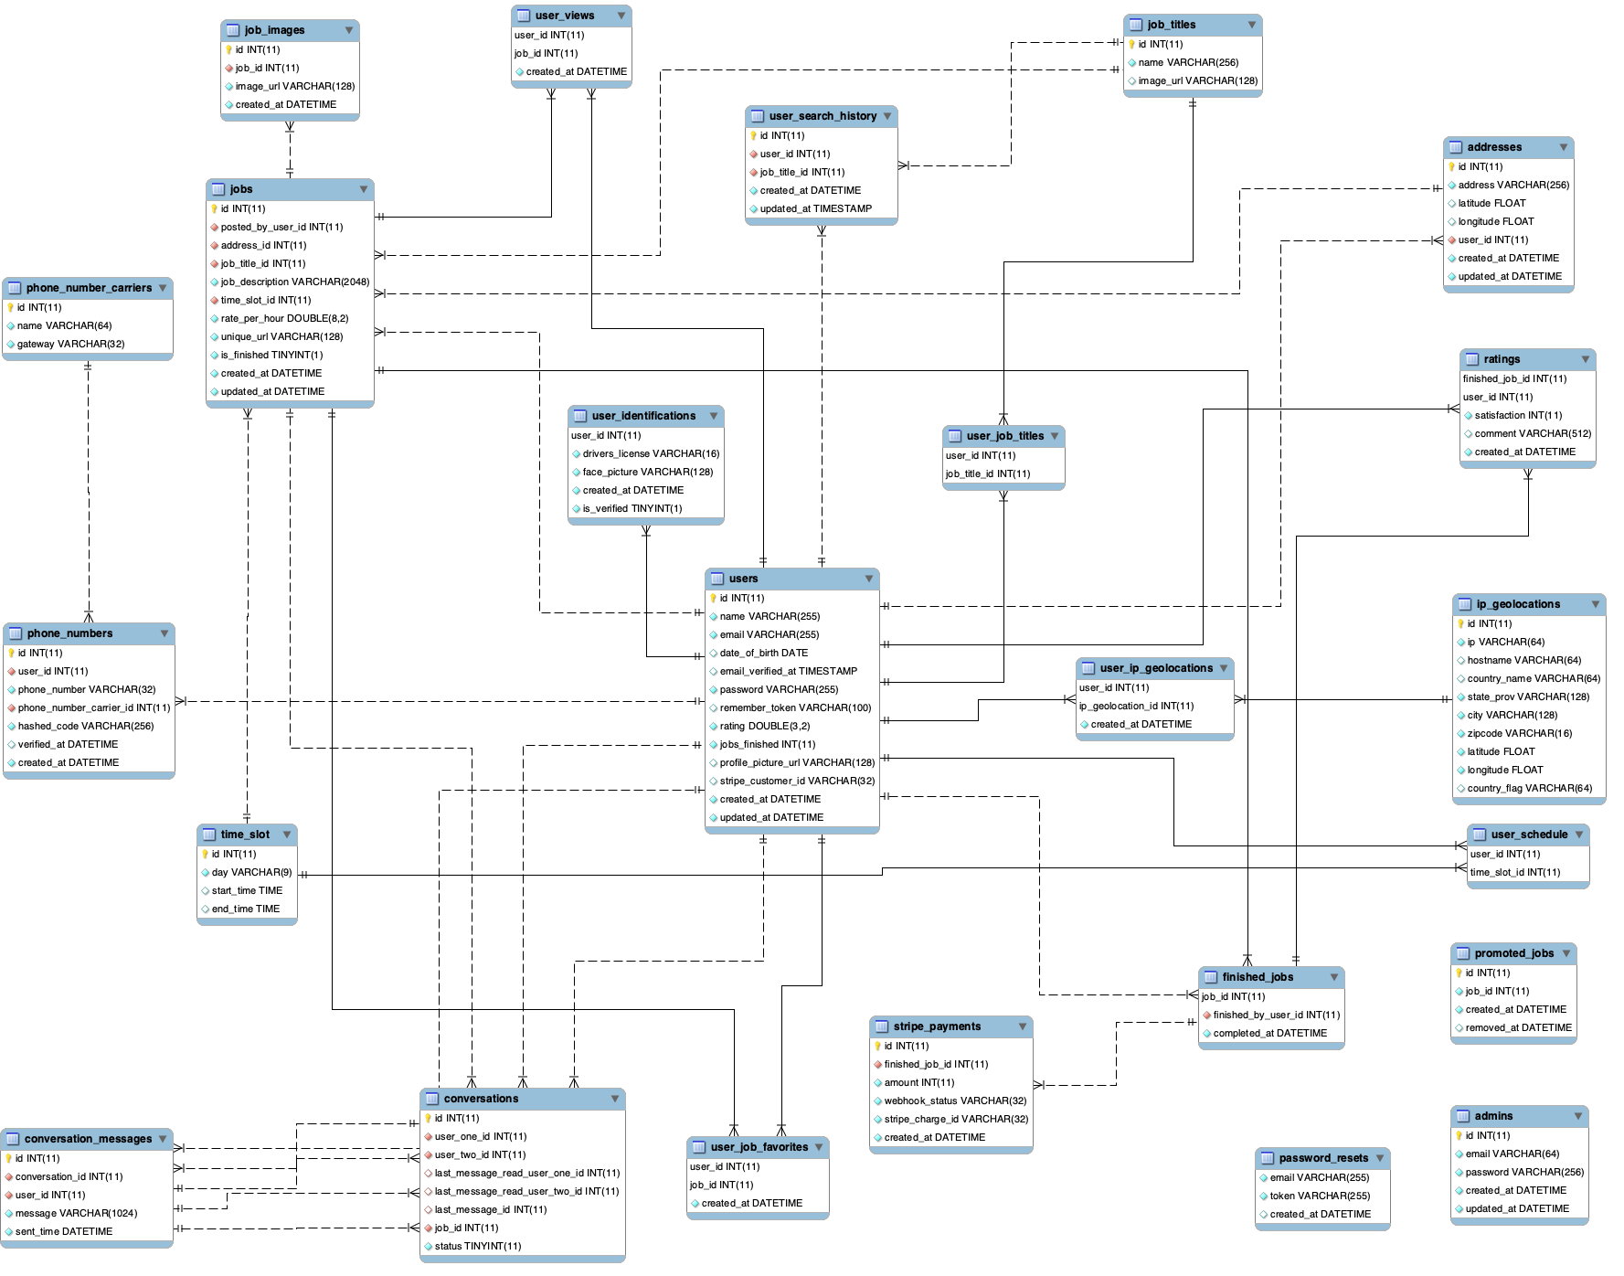

**Figure 2.1.2** Relational Diagram

## **System Design**

### **Decomposition description**

At the high level, the HNS system consists of three modules, DataStore, DataProcessing, and UserInterface. Figure 2.2.1 gives structure chart of the system framework.

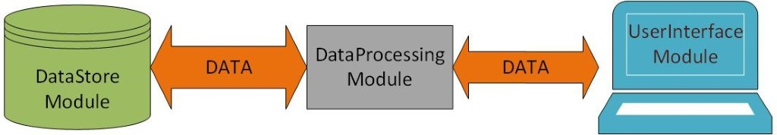

**Figure 2.2.1** Structure Chart of DB_PROJECT Software Framework

### **DataStore Module Description**

DataStore Module stores data that can be accessed and modified by DataProcessing Module to satisfy user requirements of data storing, updating, and querying. It is the database of the system, which is presented and described in the section above. In addition, one can refer to HDBD (Part B) for detailed database able description.

### **DataProcessing Module Description**

DataProcessing Module performs all the operations that the HNS system provides to the users. It controls the data processing procedure of the system and generates the dynamic data of the web pages to the users. This module consists of 5 function sets, which are Computation Function Set, Database Connection Function Set, Data Retrieval Function Set, Data Update Function Set, and User Authentication Function Set.

Computational Function Set includes all the sub-functions that perform validation, formula calculation, and other computation required by users or application programs. Database Connection Function Set consists of the functions that connect to the database server. Data Retrieval Function Set consists of all the functions that retrieve specific data or information from the database. Data Update Function Set consists of all the functions that add new data to the database or modify original data of the database. User Authentication Function Set consists of all the functions of user authorization and session management.

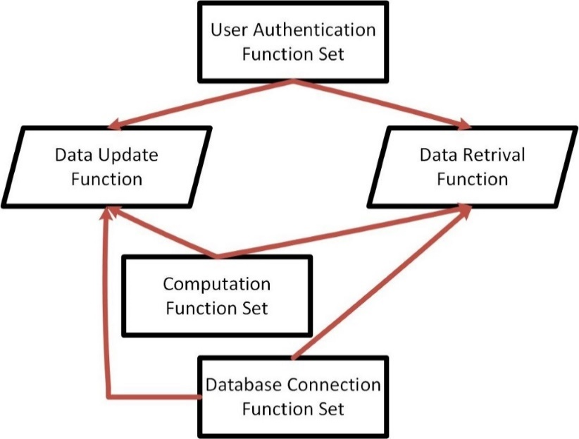

**Figure 2.2.1.2** Function Call Relationship Diagram Among Function Sets

Figure 2.2.1.2 gives the function call relationship among function sets of the module. An arrow shows relationship from a callee to a caller. A caller can call a function in the function set that has an arrow line pointing to the caller.

### **UserInterface Module Description**

UserInterface Module is used to maintain consistent appearances for all aspects of the system. It provides interfaces for users to interact with the system.

### **Process Integration**

The functions of DataProcessing Module and web pages of UserInterface Module are integrated into PHP code program to satisfy the requirements for each page. Figure 2.2.2 gives state transition diagram of the PHP processes of the system.

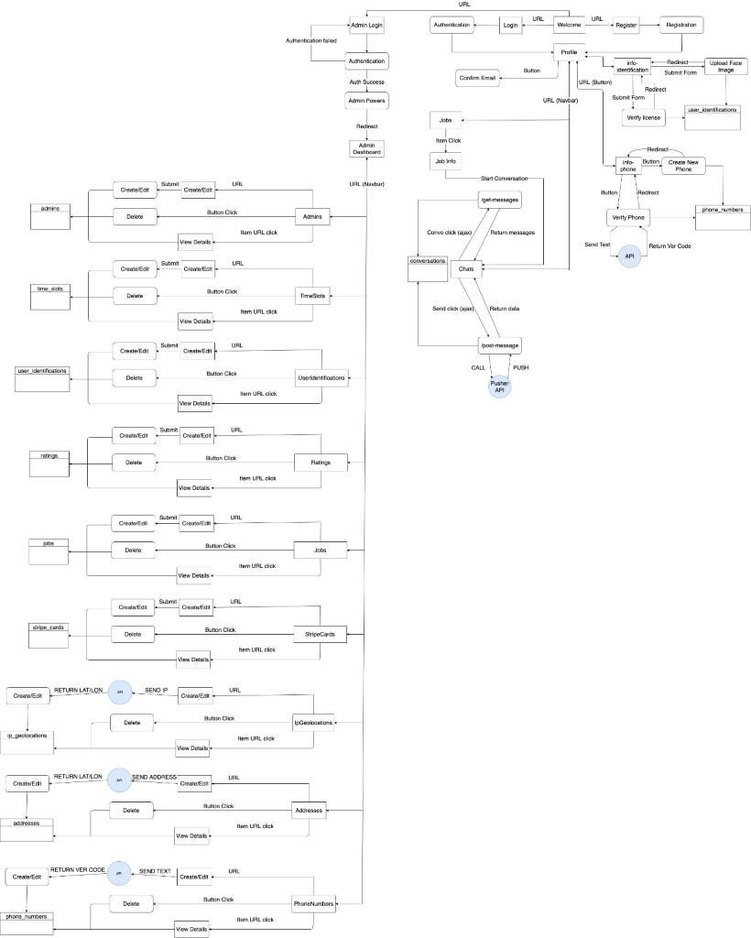

**Figure 2.2.2** State Transition Diagram

# **IMPLEMENTATION**

## **Database Implementation**

The server-side resides in a server machine with the database named db_project. The database is written and maintained with MySQL using a PDO connection to Eloquent and its models.

DataStore Module depends on the Amazon Web Services (AWS), while hardware might be selected in order to satisfy the demands of performance.

DataProcess Module resides and is executed in the same Web Server machine. This module accesses DataStore Module through PDO_MYSQL and exchanges data with UserInterface Module through AWS services. DataProcess Module functions process and retrieval data from/to both DataStore Module and UserInterface Module.

**DataProcessing Module**

DataProcessing Module resides and is executed in the same Web Server machine. This module accesses DataStore Module through PDO_MYSQL and exchanges data with UserInterface Module through AWS services. DataProcessing Module functions process and retrieval data from/to both DataStore Module and UserInterface Module.

**UserInterface Module**

The UserInterface Module resides on the same Web Server machine as DataProcessing Module and Database sharing the same resources. It generates HTML web pages for the users to interact with the system. The web pages can execute on any client PC that connects to the Web Server through Internet and can be accessed by any client PC to Web Server via a web browser such as Internet Explorer and Google Chrome.

## **Server-Side Application Program Implementation**

The site is based on the Bootstrap CSS framework and Laravel PHP web framework. PHP, JavaScript, CSS and HTML are used for the design. PHP and JavaScript are used for back-end, while JavaScript, CSS, HTML are used for the front-end code. In this section, due to the fact that the system contains a lot of files, only some important files of the system are described.

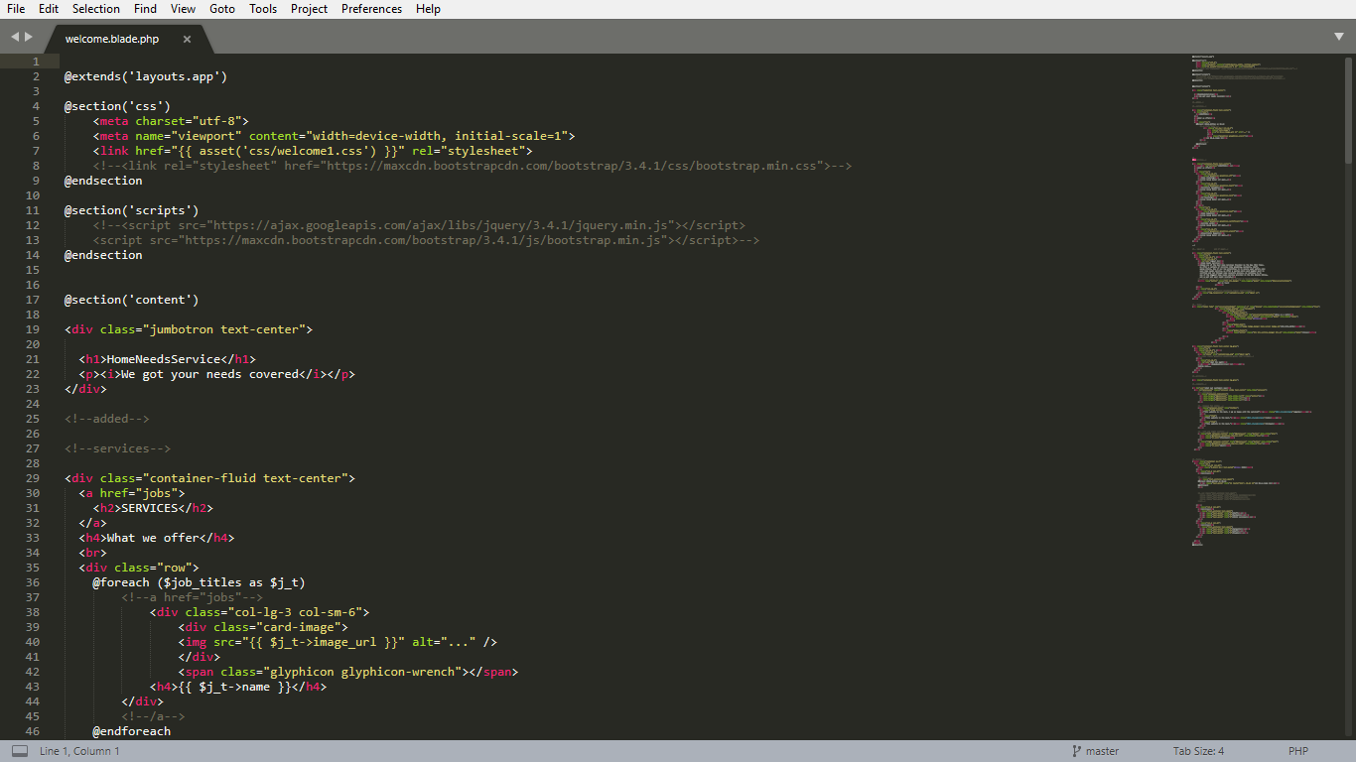

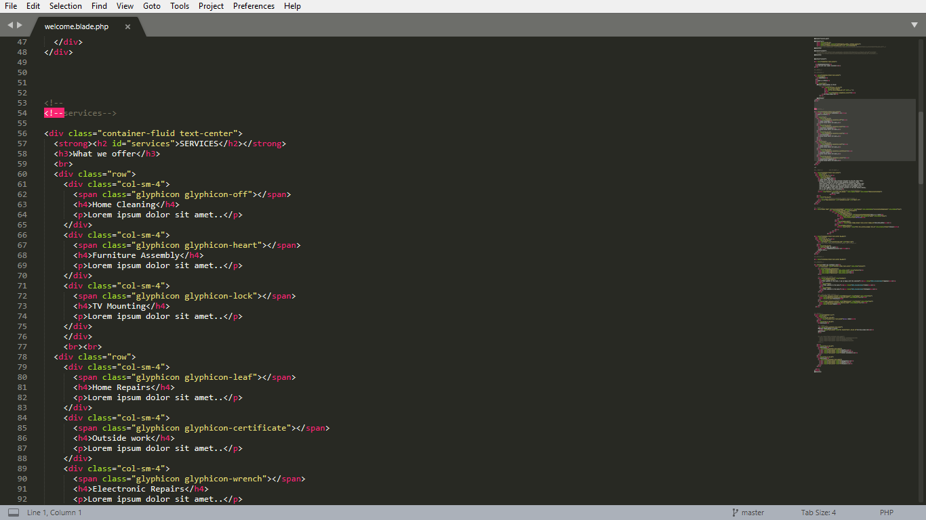

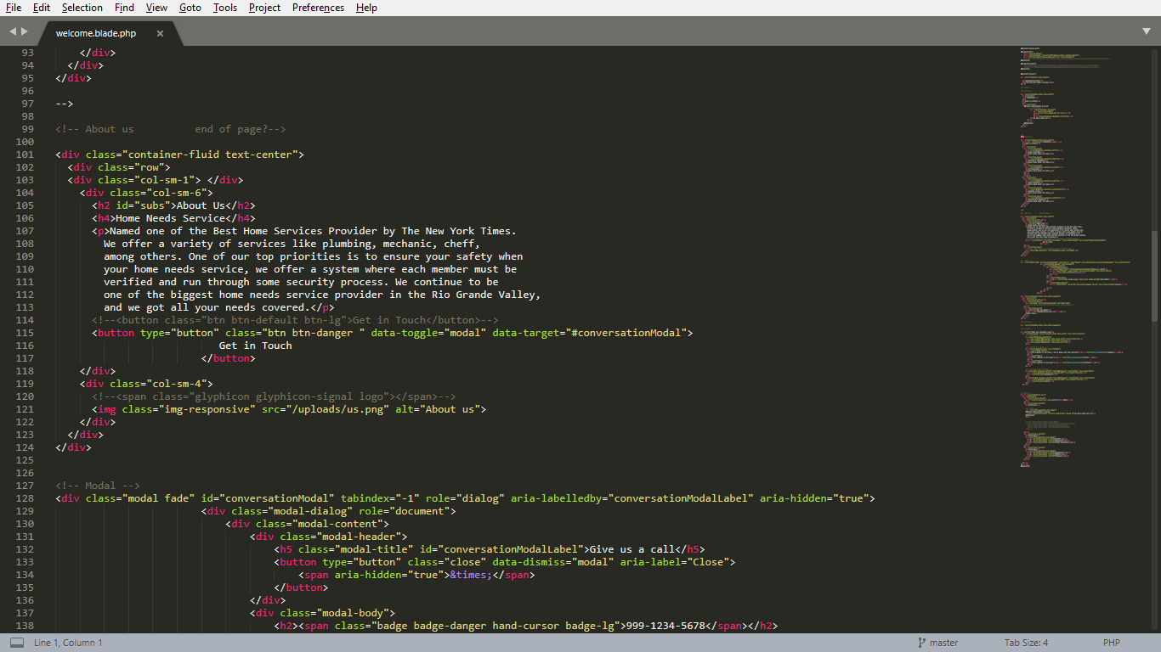

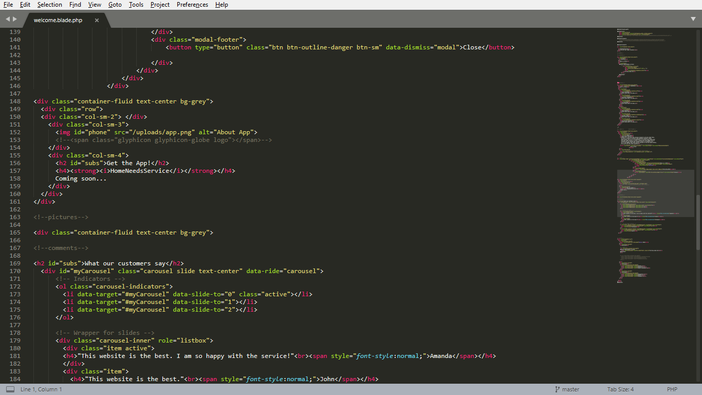

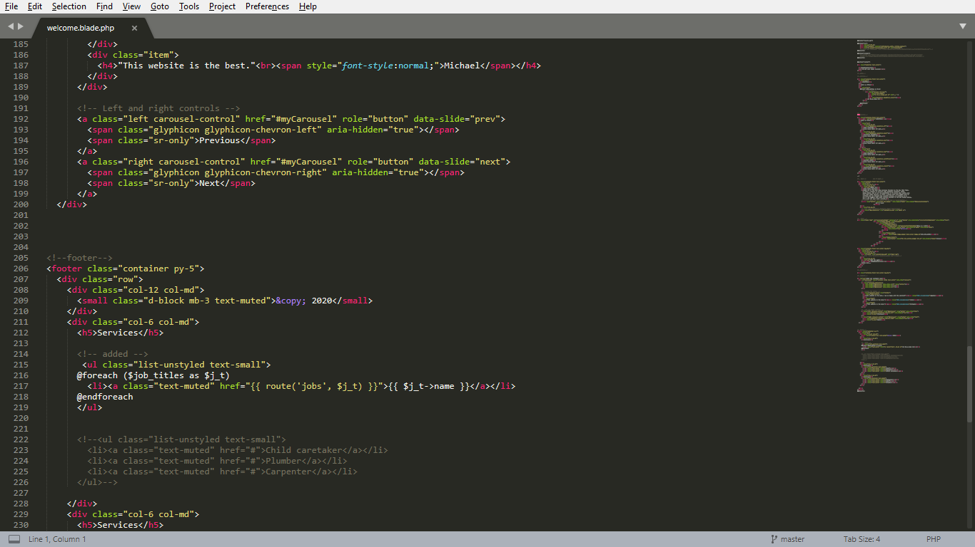

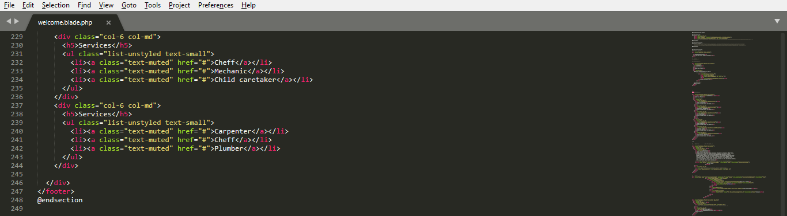

**Figure 3.2-1** The code of welcome.blade.php file.

The welcome.blade.php file, which is located in the \resources\views\ address of the project, contains a code of the welcome page. The file contains various Bootstrap methods, such as container-fluid to merge various classes (columns, rows, etc.) into one whole element, carousel to use sliders, jumbotron to attract users. Additionally, some parts of the page are responsible to a size of the screen, which are done by col-12, col-md classes. All classes are inside the <div> tags.

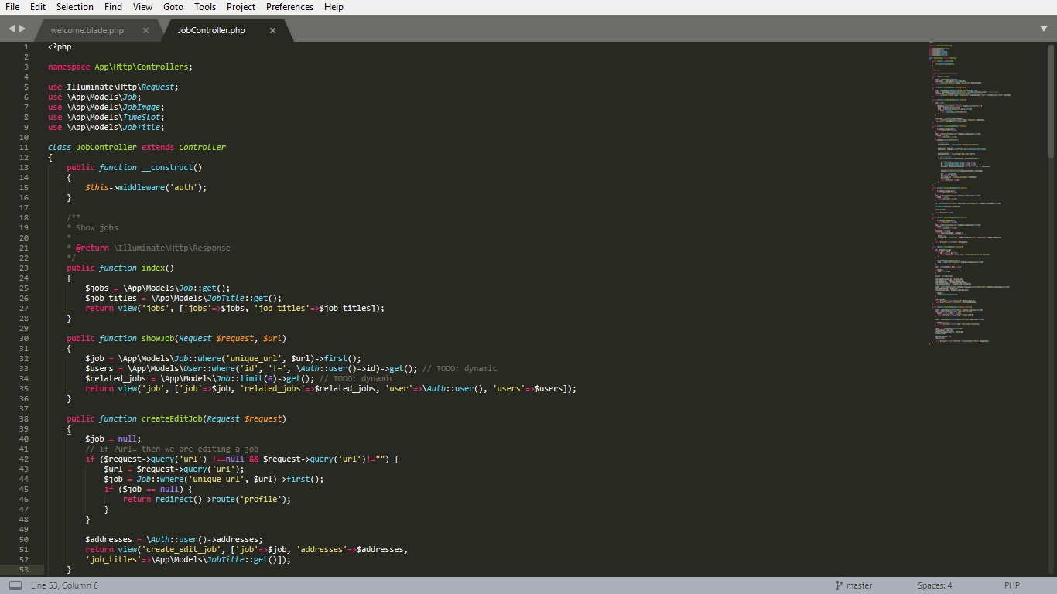

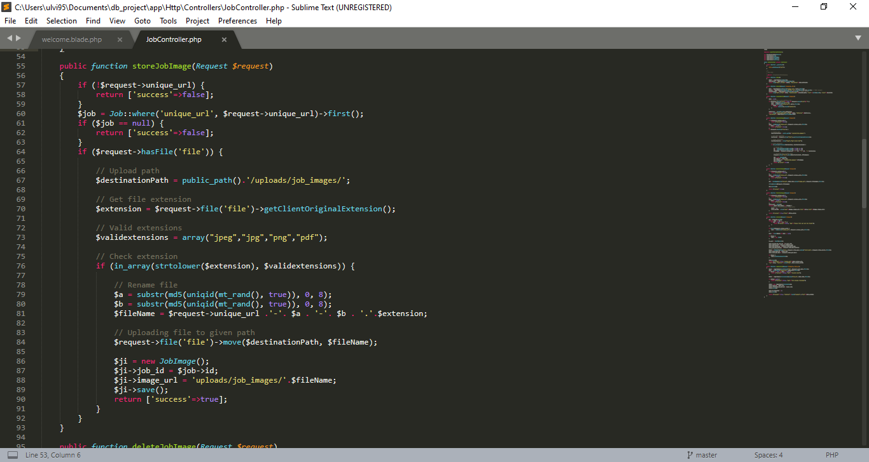

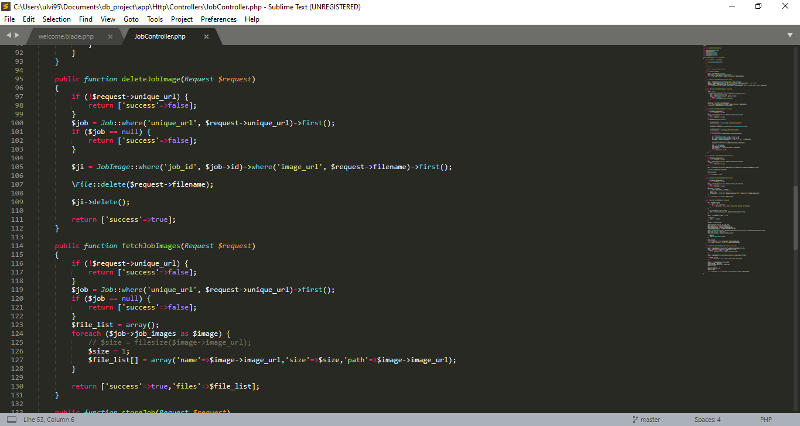

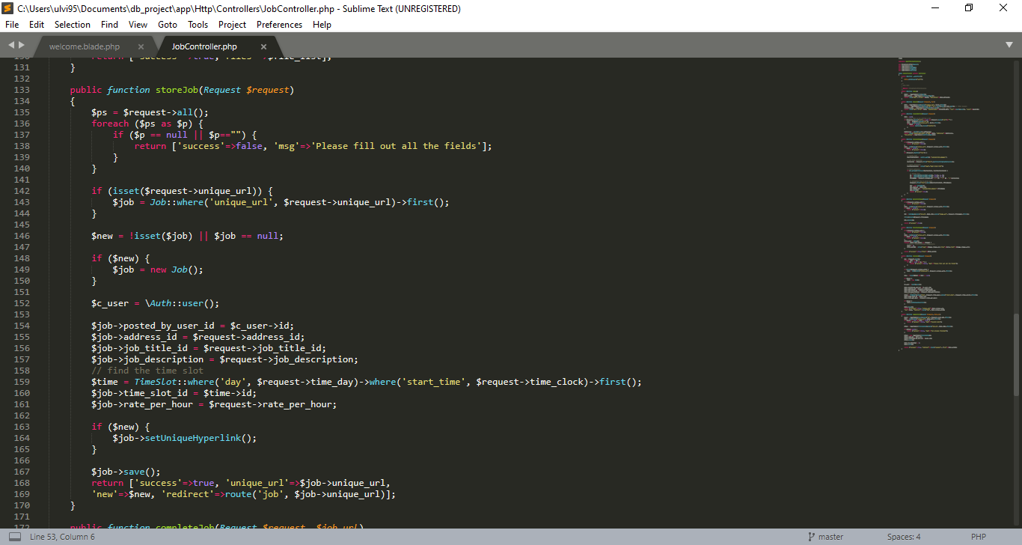

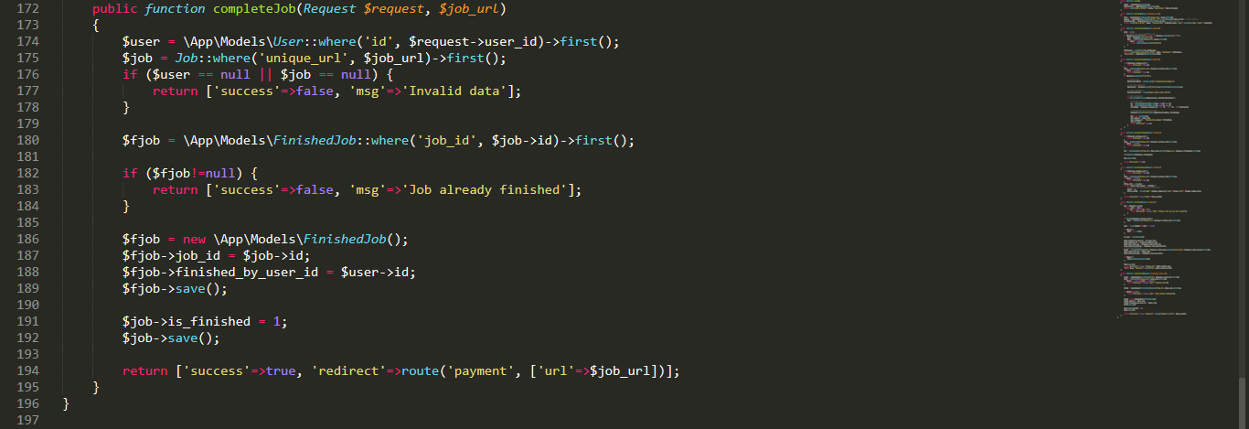

**Figure 3.2-2** The code of JobController.php file.

The JobController.php file, which is located in the \app\Http\Controllers address of the project, contains a code of the both JobController class and \jobs page. The JobController class contains not only the construct function for the page construction and the index function to the page initialization, but also various functions to show the jobs (showJob), to create and edit jobs (createEditJob), to store the job in the system (storeJob) to complete the job (completeJob), and three functions to handle the job images (deleteJobImage, fetchJobImages, storeJobImage).

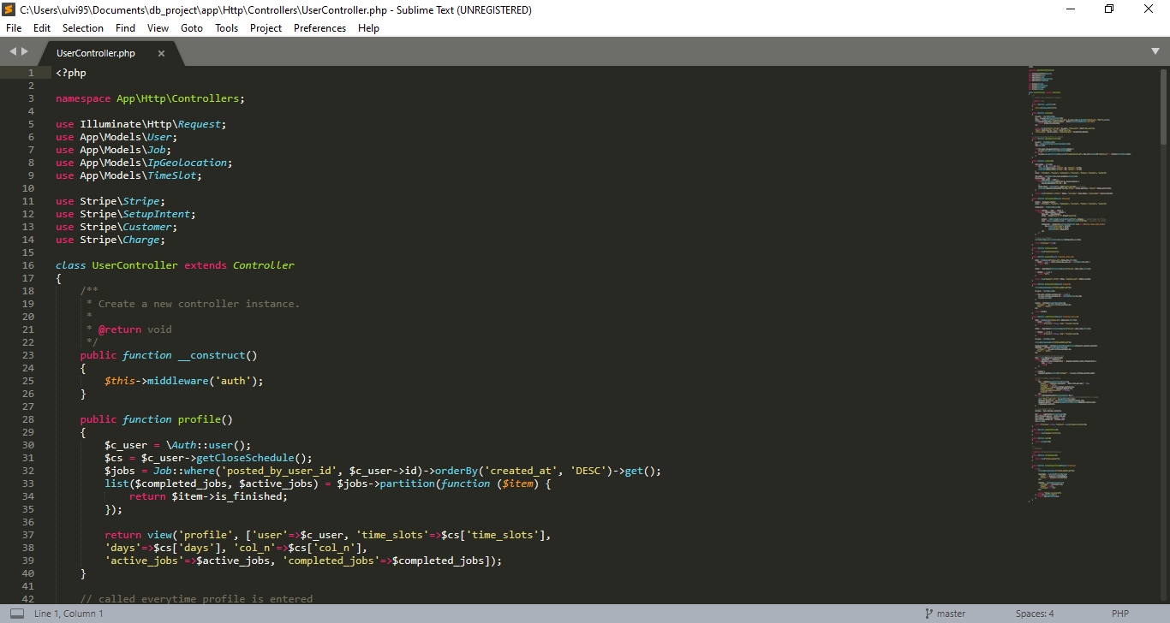

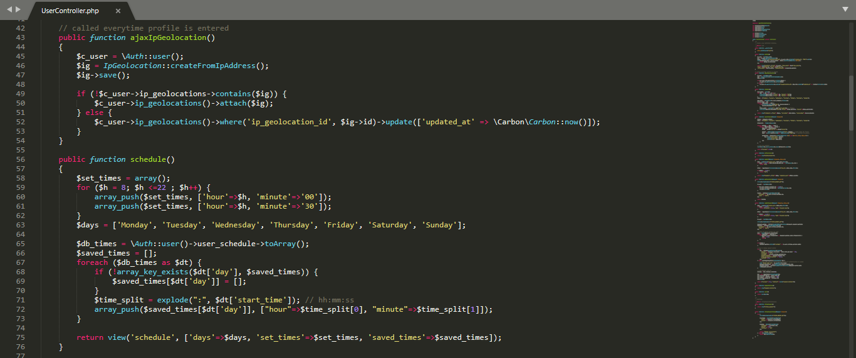

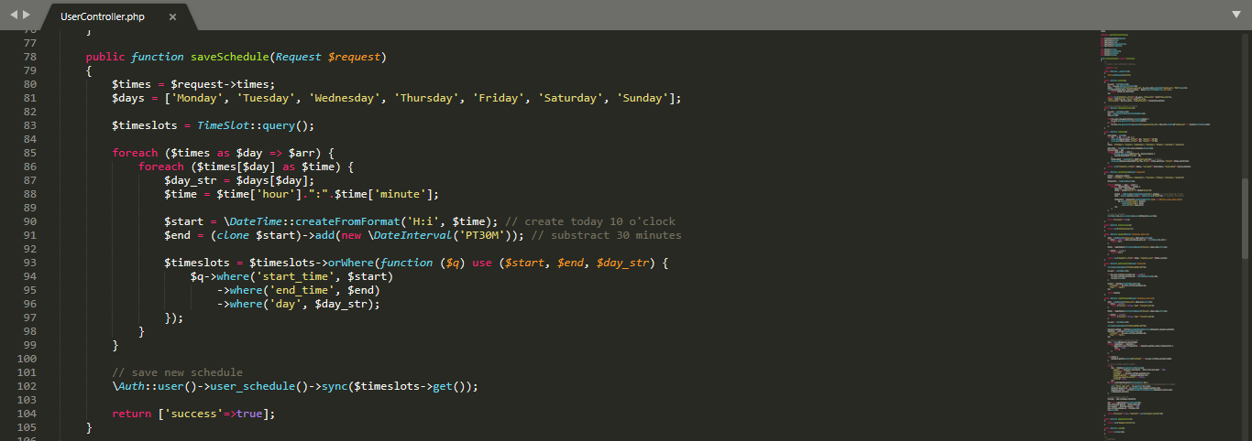

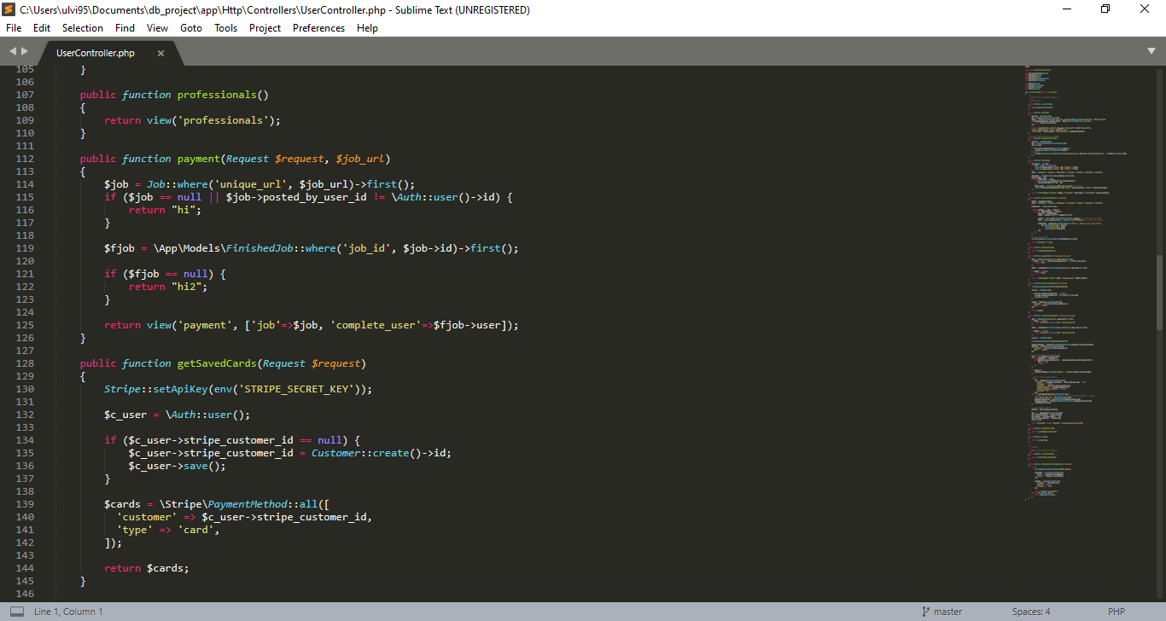

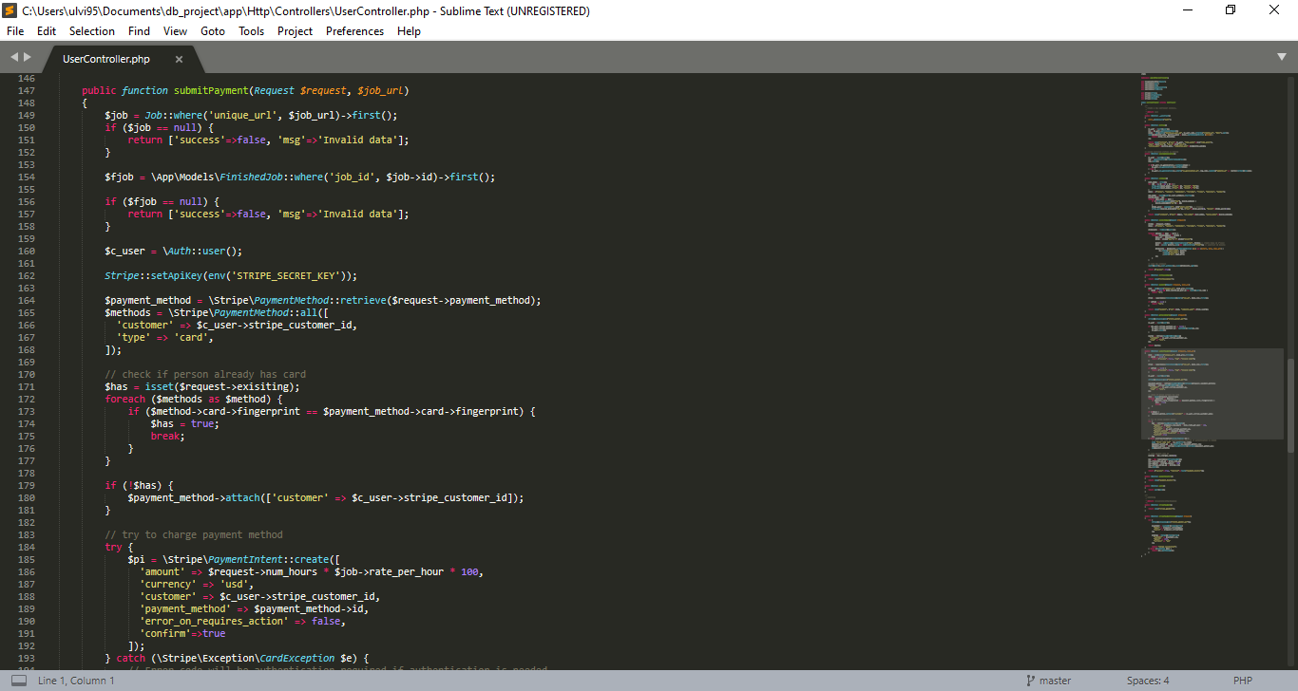

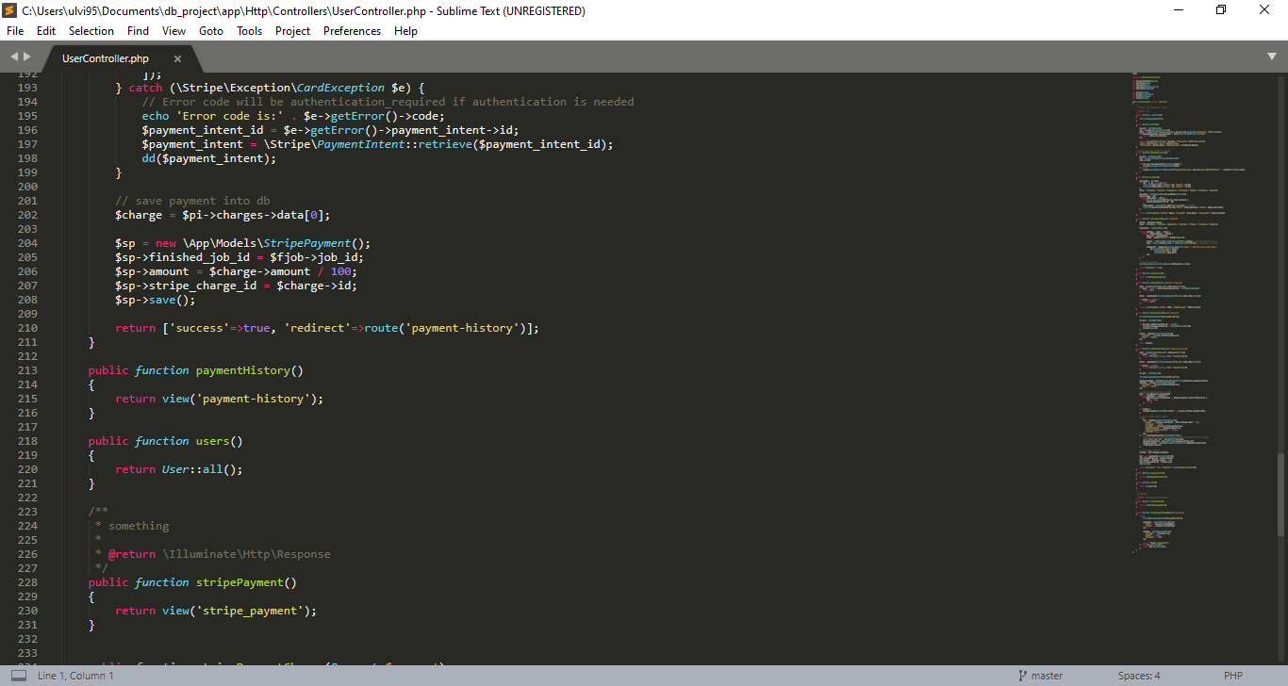

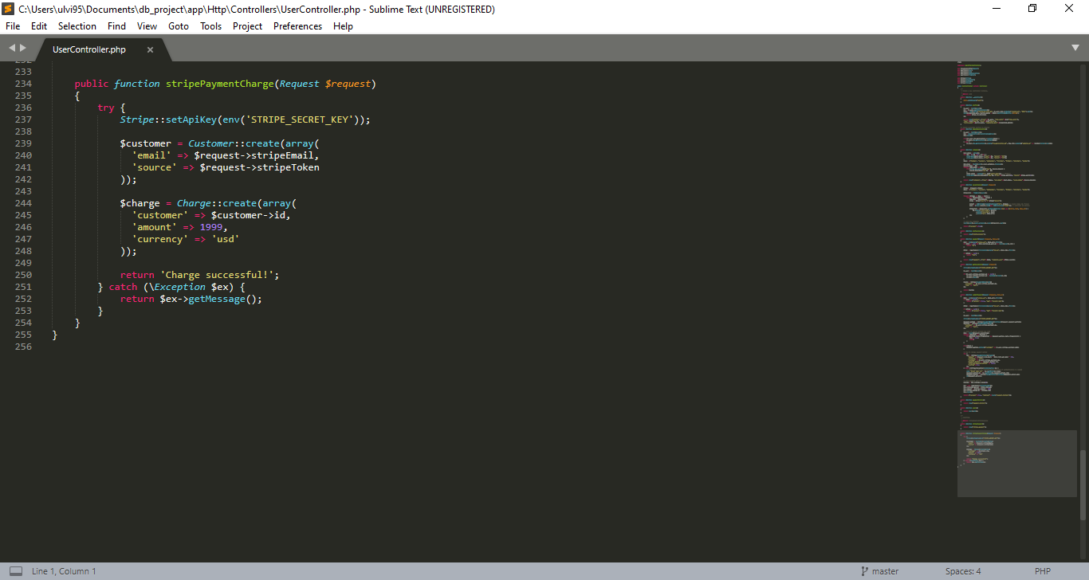

**Figure 3.2-3** The code of UserController.php file.

The UserController.php file, which is located in the \app\Http\Controllers address of the project, contains a code of the UserController class. Most of the custom user functions are realized in the UserController class. Some of them are responsible for the view of the page (the profile function for /profile page describing the logged user page, the professionals function for /professionals page describing available professionals in the system, the paymentHistory function to describe a payment history of the user, the users function to describe the available users to admin , the schedule function to describe the user’s schedule, the stripePayment function to describe a stripe-payment page). Others are responsible to handle the actions (the saveSchedule function to save the schedule, the getSavedCards function to get the stripes made by a user the ajaxIpGeolocation function to calculate the geolocation of a user’s IP, the stripePaymentCharge function to charge the payment).

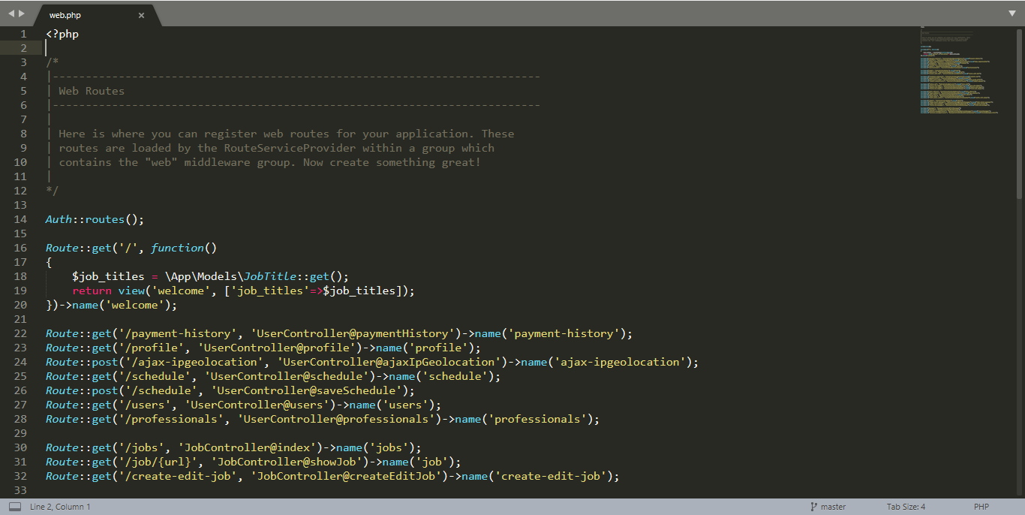

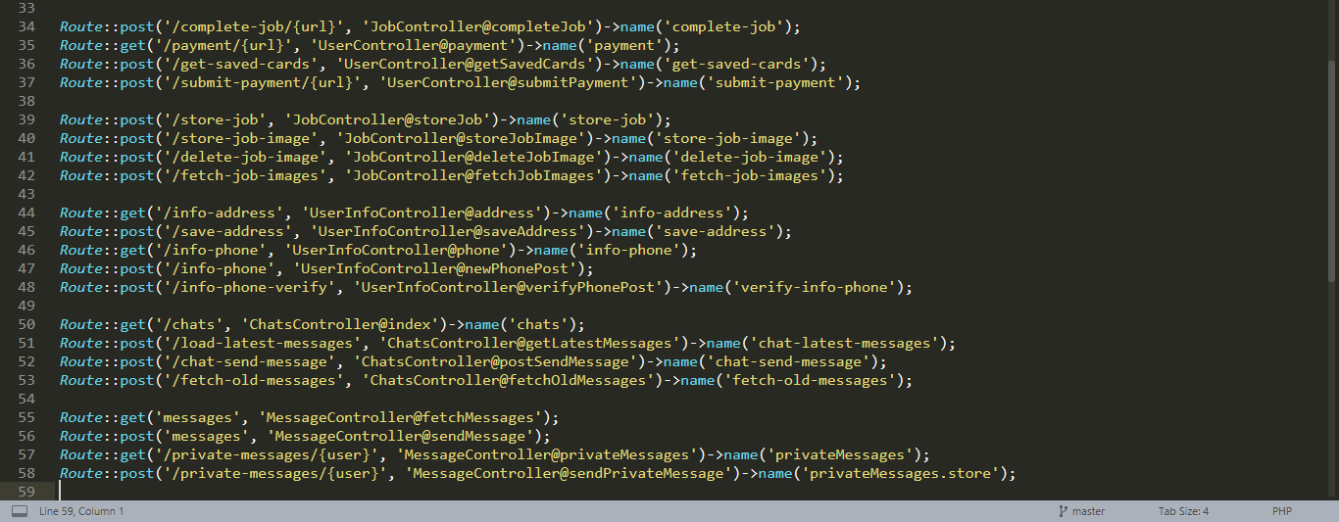

**Figure 3.2-4** The code of web.php file.

The web.php file, which in the /routes, contains all get and post requests to various controllers.

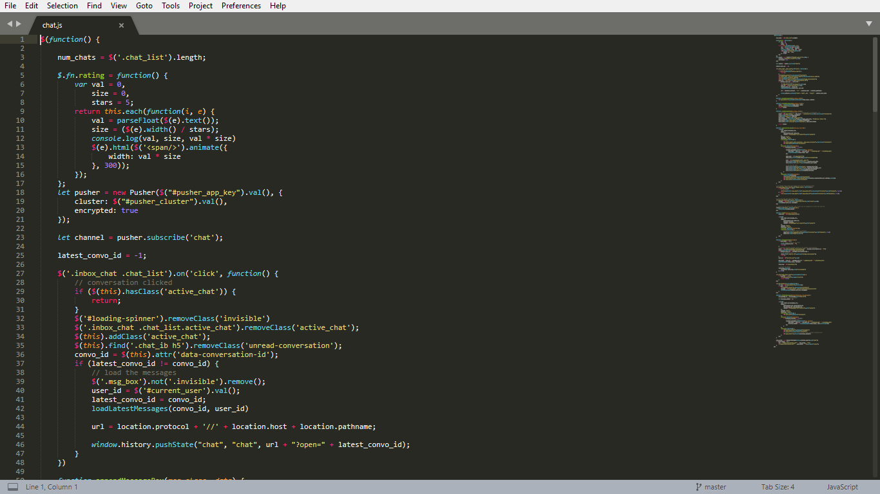

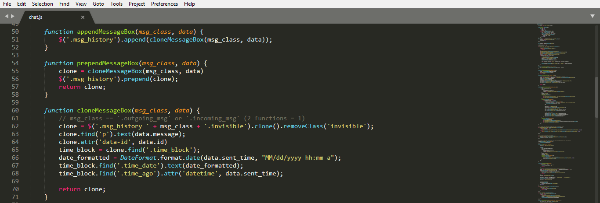

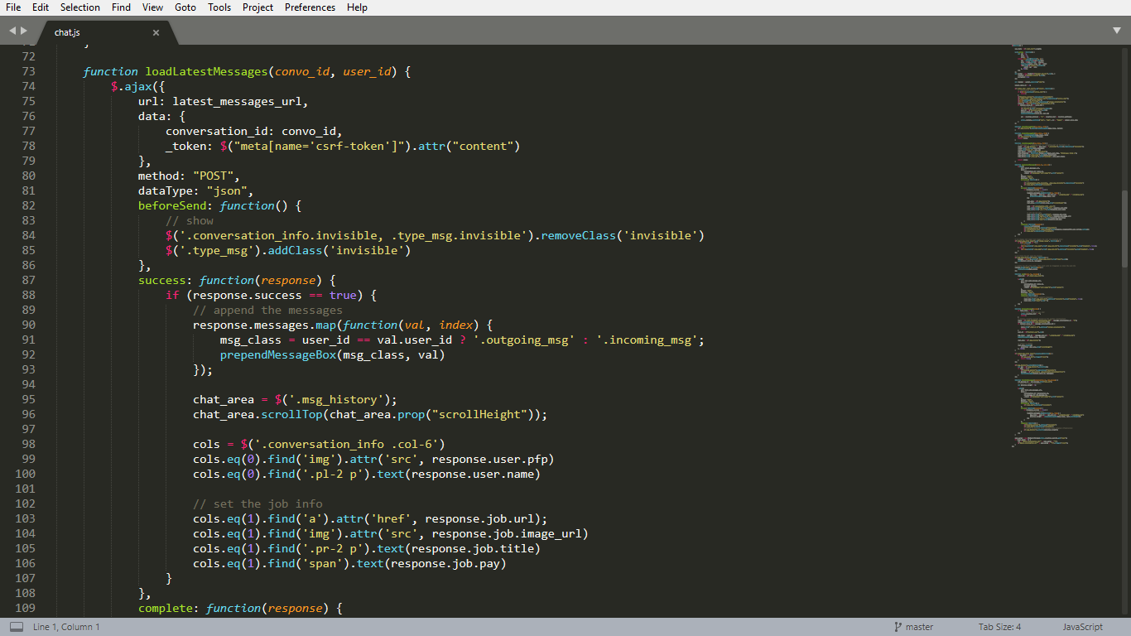

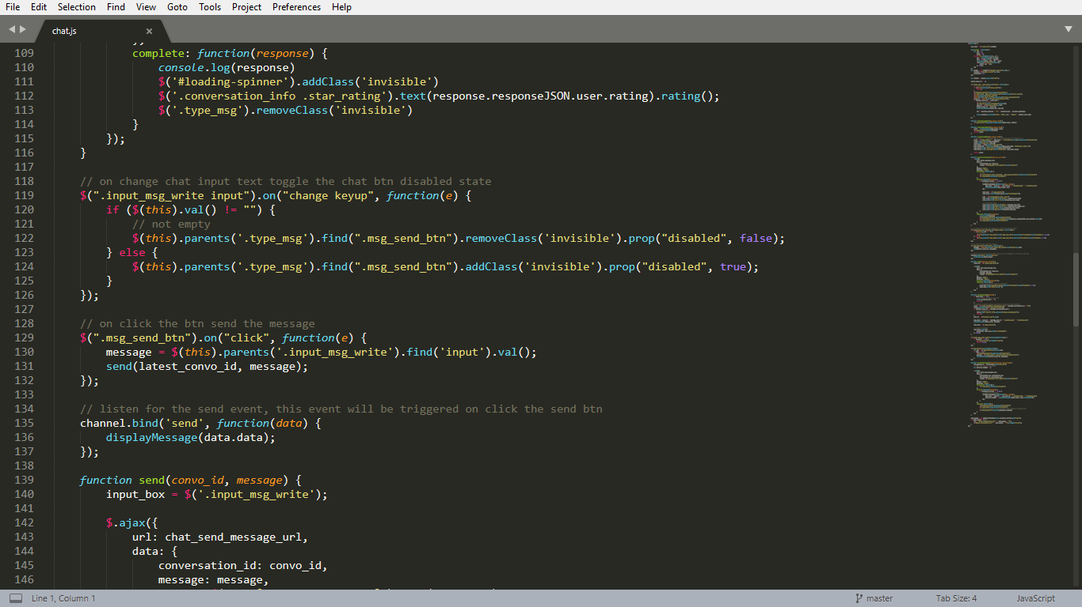

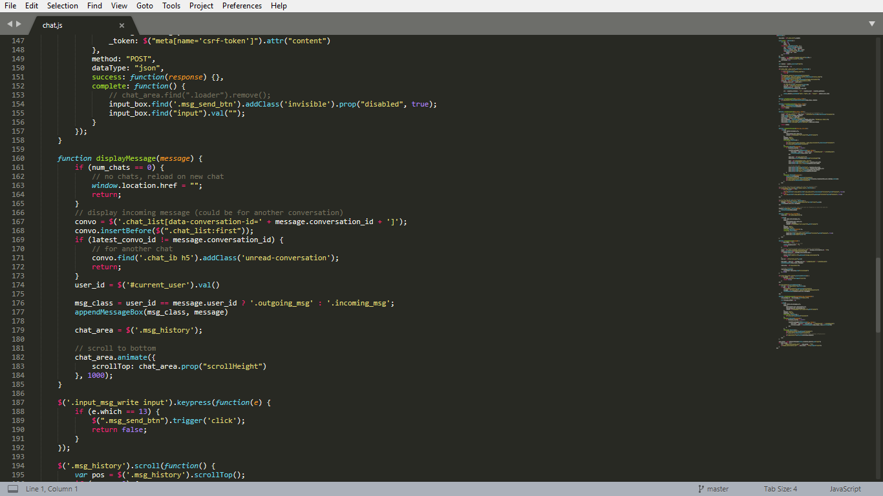

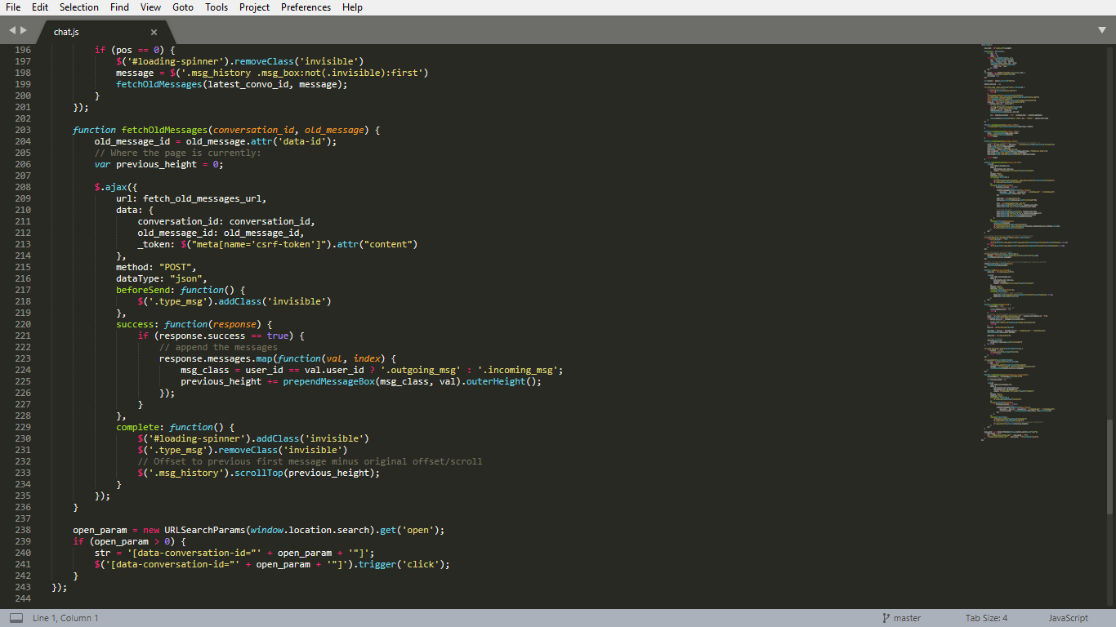

**Figure 3.2-5** The code of chat.js file.

The chat.js file, which is located in /public/js address of the project, is the JavaScript code for the chat between users. The file contains a main function with several functions such as the appendMessageBox function to append a message box, the prependMessageBox function to prepend a message box, the loadLatestMessages function to load the latest messages, the send function to send the message, cloneMessageBox to create the clone of the message box, displayMessage to display the message, fetchOldMessages to fetch the old messages.

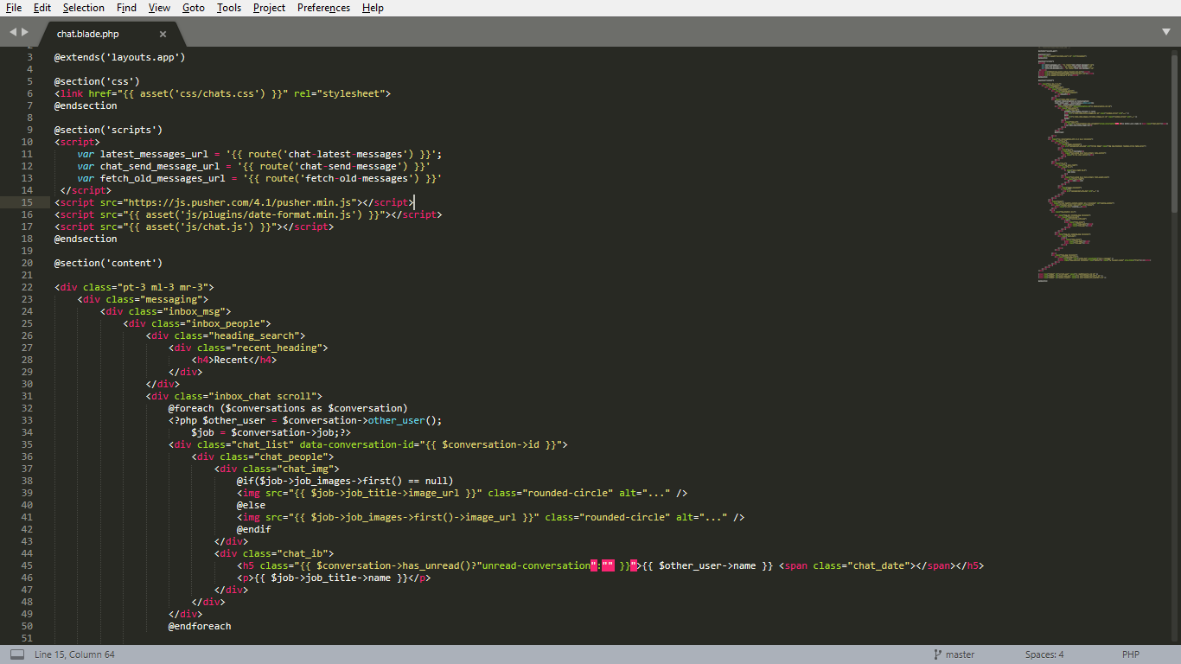

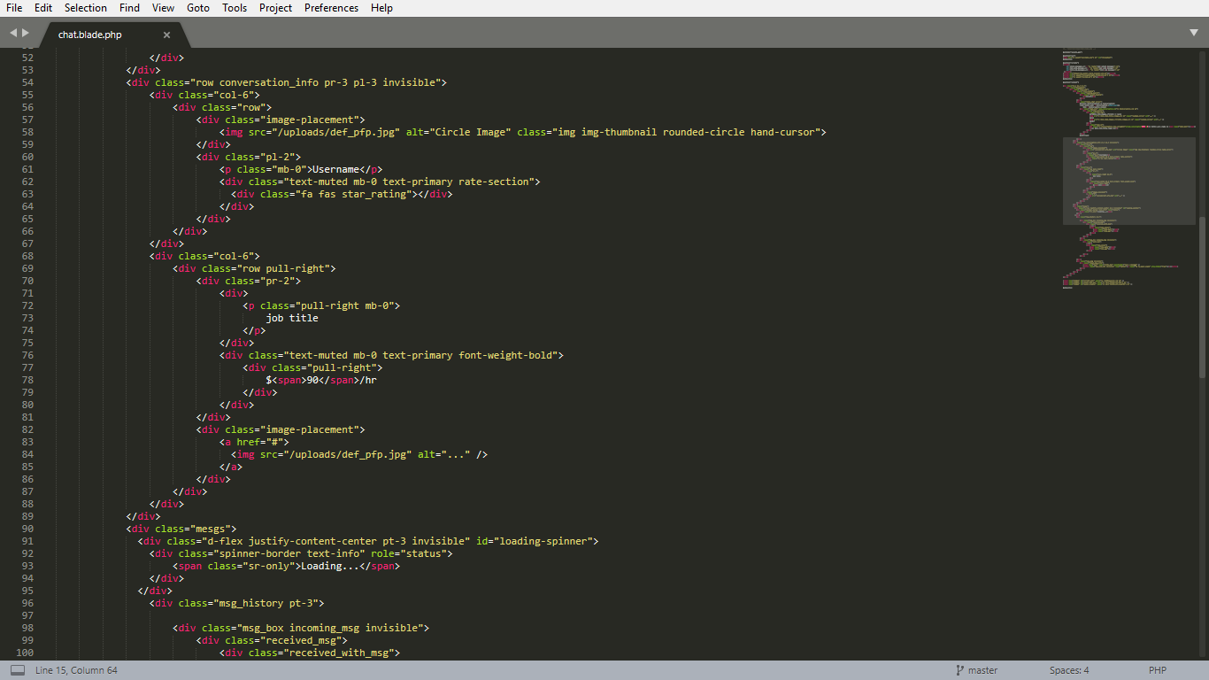

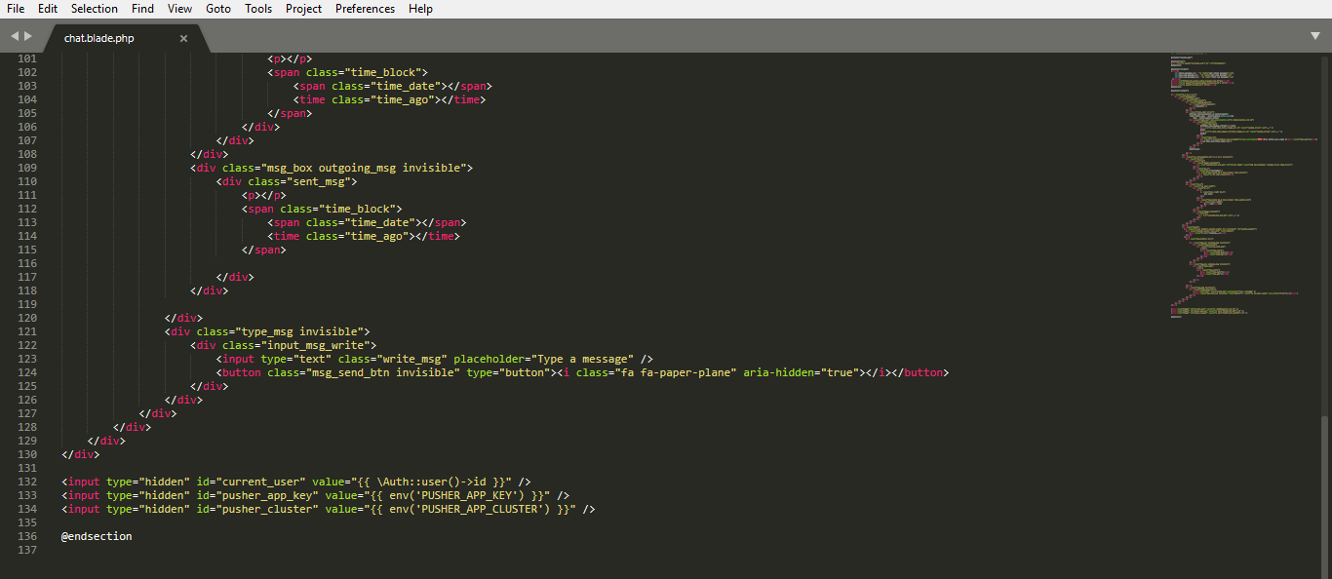

**Figure 3.2-6** The code of chat.blade.php file.

The chat.blade.php file, which is located in the \resources\views\ address of the project, contains a code of the \chat page. The file contains various Bootstrap methods, such as container-fluid to merge various classes (columns, rows, etc.) into one whole element, invisible to affect the visibility of an element. Additionally, some parts of the page are responsible to a spacing and margin, which are done by pr-3, pl-3, pt-3, ml-3 mr-3, classes. All classes are inside the <div> tags.

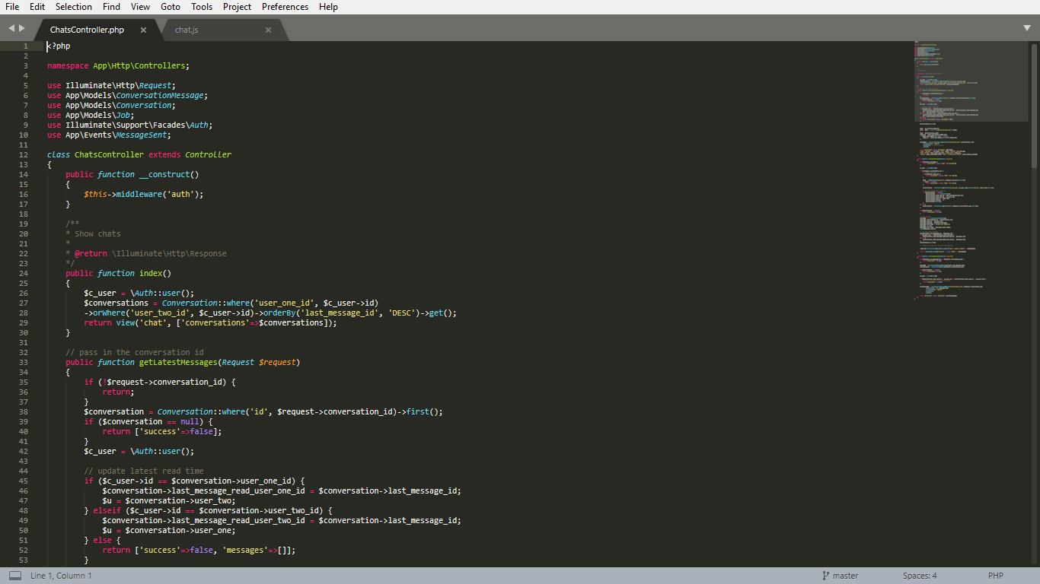

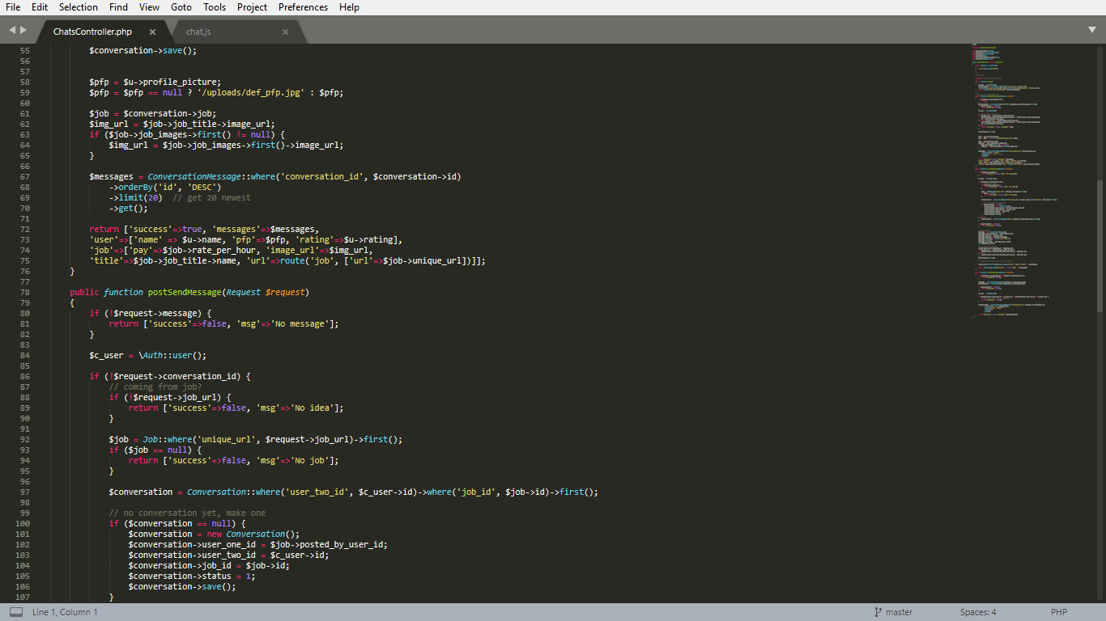

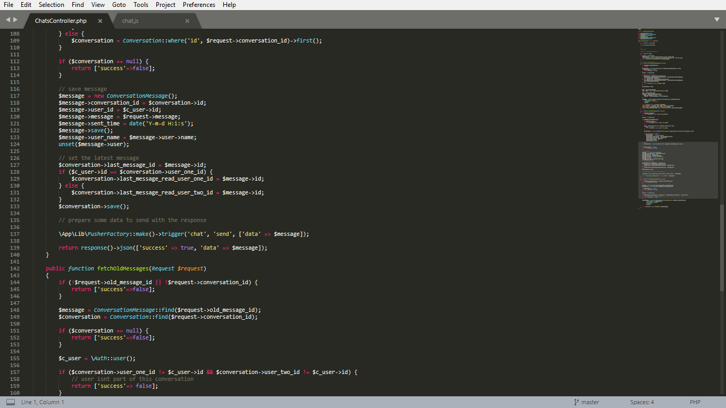

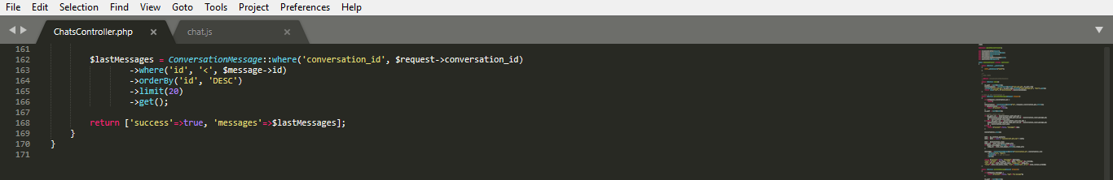

**Figure 3.2-7** The code of ChatsController.php file.

The ChatsController.php file, which is located in the \app\Http\Controllers address of the project, contains a code of the both ChatsController class and \chat page. Unlike chat.js what is responsible for the dynamic chat elements, ChatsController.php handles the connection of /chat page between the project elements and the database. The file contains not only the constructor and the index function for the page, but also various functions, such as the getLatestMessages function to get the latest messages, the postSendMessage function to post the message, the fetchOldMessages function to fetch old messages.

# **USABILITY**

The cite can be accessed with the URL <http://waytohire.net>, which is provided in the cover page as well. However, a majority of the pages require a user account (regular or administrator type) to be able to access and use. Thus, the following credentials for a regular and administrator user accounts can be used to view and use the site. However, keep in mind that the email address used in the creation of the account is fake. To test the email for password change, one could edit the user information as an administrator.

User (regular):

Email: [user@test.com](mailto:user@test.com)

Password: password

Administrative User:

Email: [admin.user@test.com](mailto:admin.user@test.com)

Password: password

## **User Interface**

Every user interface in the system will be structured as shown in the following figure.



**Figure 4.1** The Main User Interface Components

The top part, named “Easy access menu,” will have three part. On the left, there will be link called “WayToHire” that will lead the user back to the welcome page. On the right, there are two different option of what can be there. If the user is not logged in, there will be a Login and Register buttons that will lead to the appropriate pages. If the user is logged in, there will be Your Chats button, which directs the user to the chats page, and dropdown menu called by the user’s name, which contains links to the profile page or to the process of logging out the user. In addition, there is a link to the create edit job page called “Post Job.” Below this menu, the contents take place. For the welcome page, this part is further divided into parts.

### **Main entrance to the system: welcome page**

This page will be the main entrance to the site. Users will see some information on Home Needs Services. The first section is the header of the page. The bottom section is used a footer, which contains links to other pages in this site. Figure 4.1.1 shows the appearance of the page.

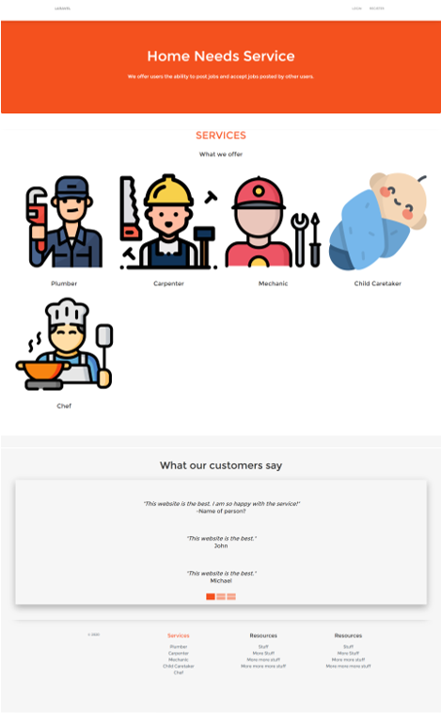

**Figure 4.1.1** The Welcome Page of the HNS program

On the middle section, is composed of two parts – Services and Customer Reviews. The Services part contains information on the main job types that are available in the site and a link. The “SERVICES” link returns the jobs page if the user is already logged in. If not, it returns the login page. Furthermore, the Customer Reviews part includes feedback from other users. Furthermore, the middle section and footer contain links to the jobs page.

For any page in the system, user can return back to the welcome page by just clicking on the “WayToHire” link in the easy access menu.

### **Register Page**

Users who wish to play an active role in the system (in this case all users – contractors or user in need of service) should create an account with the system to be able to later be authenticated by the system in future uses of the site and store all their relevant information. This page provides users an interface, where they can put their information to create their own accounts.

Users can get to this page from any page in the site as long as there is no current user already logged in. If there is, the currently logged in user would need to logout to obtain the link to this page from the easy access menu.

The content part contains the actual form that users should fill that is necessary for the creation of their account. It consists of four text fields and a button to submit the form. “Name” field is for the user to enter his/her username. This is a plain text field. “E-Mail Address” field is for the user to enter his/her email address. This is a plain text field. “Password” is for the user to enter his/her password. This is a password-type input field. “Confirm Password” is for the user to re-enter his/her password. This is a password-type input field.

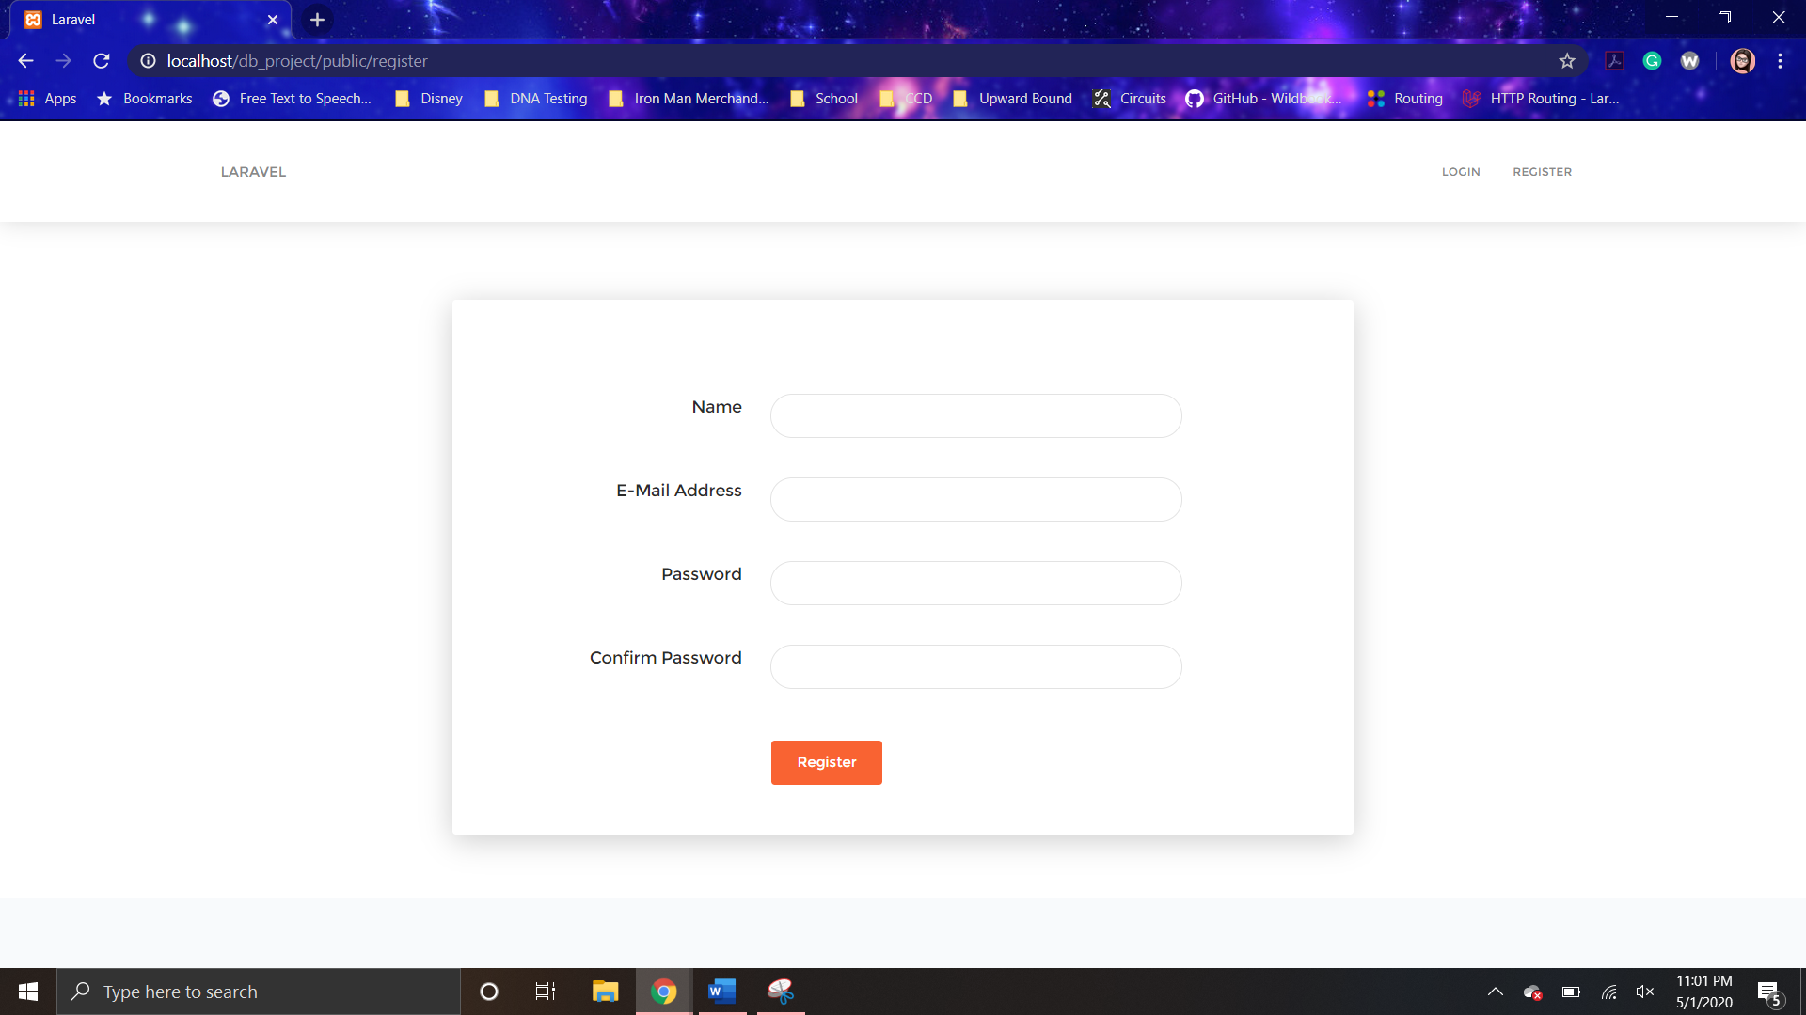

**Figure 4.1.2** The Register Page

The only operation provided by this page is to create a user account. He/she enters his/her information in the appropriate field. Then, he/she clicks on the “Register” button, which sends the data to the HNS web server. If the web server finds an error with the information entered by the user, it responds with an error page. Issues with information include: the e-mail address format being incorrect (no “@” or text before or after that symbol), password not 8 characters long, or that the password and confirmation password do not match. However, if all the entered information is appropriate the account will be created and return the profile page for him/her.

### **Login Page**

Users who play an active role in the system (in this case all users – contractors or user in need of service) should be authenticated by the system. This page provides users an interface, where they can put their authentication information and authenticate themselves to the system.

Users can get to this page from any page in the site as long as there is no current user already logged in. If there is, the currently logged in user would need to logout to obtain the link to this page from the easy access menu.

The content part contains the actual form that users should fill in for authentication. It consists of two fields, a button to submit the form, a link, and a checkbox. “E-Mail Address” field is for the user to enter his/her email address. This is a plain text field. “Password” is for the user to enter his/her password. This is a password-type input field. Login button, once clicked, submits the form with the contended filed values. “Forgot Your Password?” link that leads the user to the password reset page. “Remember Me” checkbox is used to indicate to the site to remember the authenticated user.

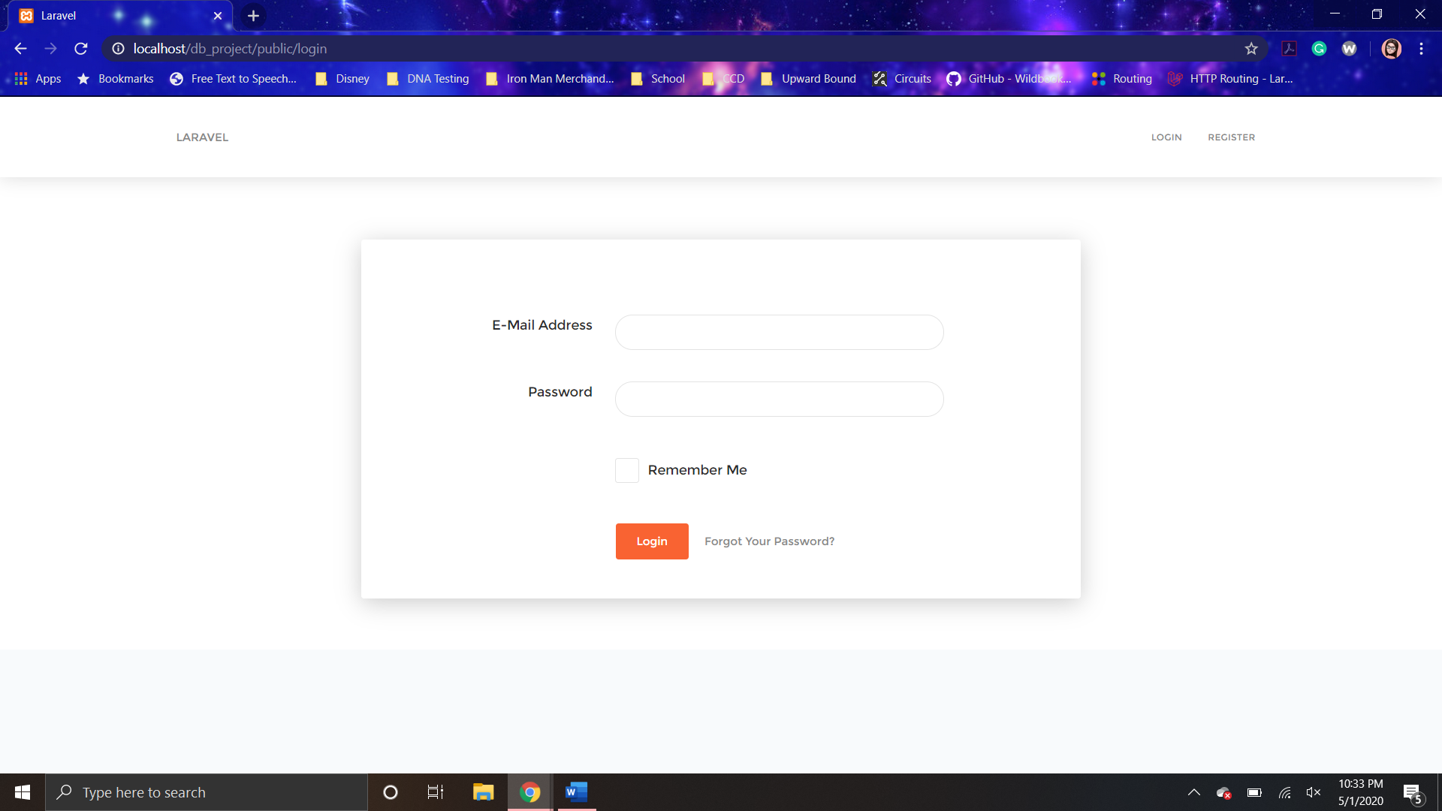

**Figure 4.1.3** The Login Page

The only operation provided by this page is to authenticate user. He/she enters his/her email address into “E-mail Address” filed and his/her password into “Password” filed. Then he/she clicks on the “Login” button, which sends these data to the HNS web server. The web server will authenticate the user and return the profile page for him/her. If the web server cannot authenticate the user (password or email address is wrong), it responds with an error message.

### **Password Reset Page**

This page is provided as a method to obtain permission to change their account password for those users who forget their passwords. Users can get to this page only from the login page. Figure 4.1.4-1 shows the appearance of this page.

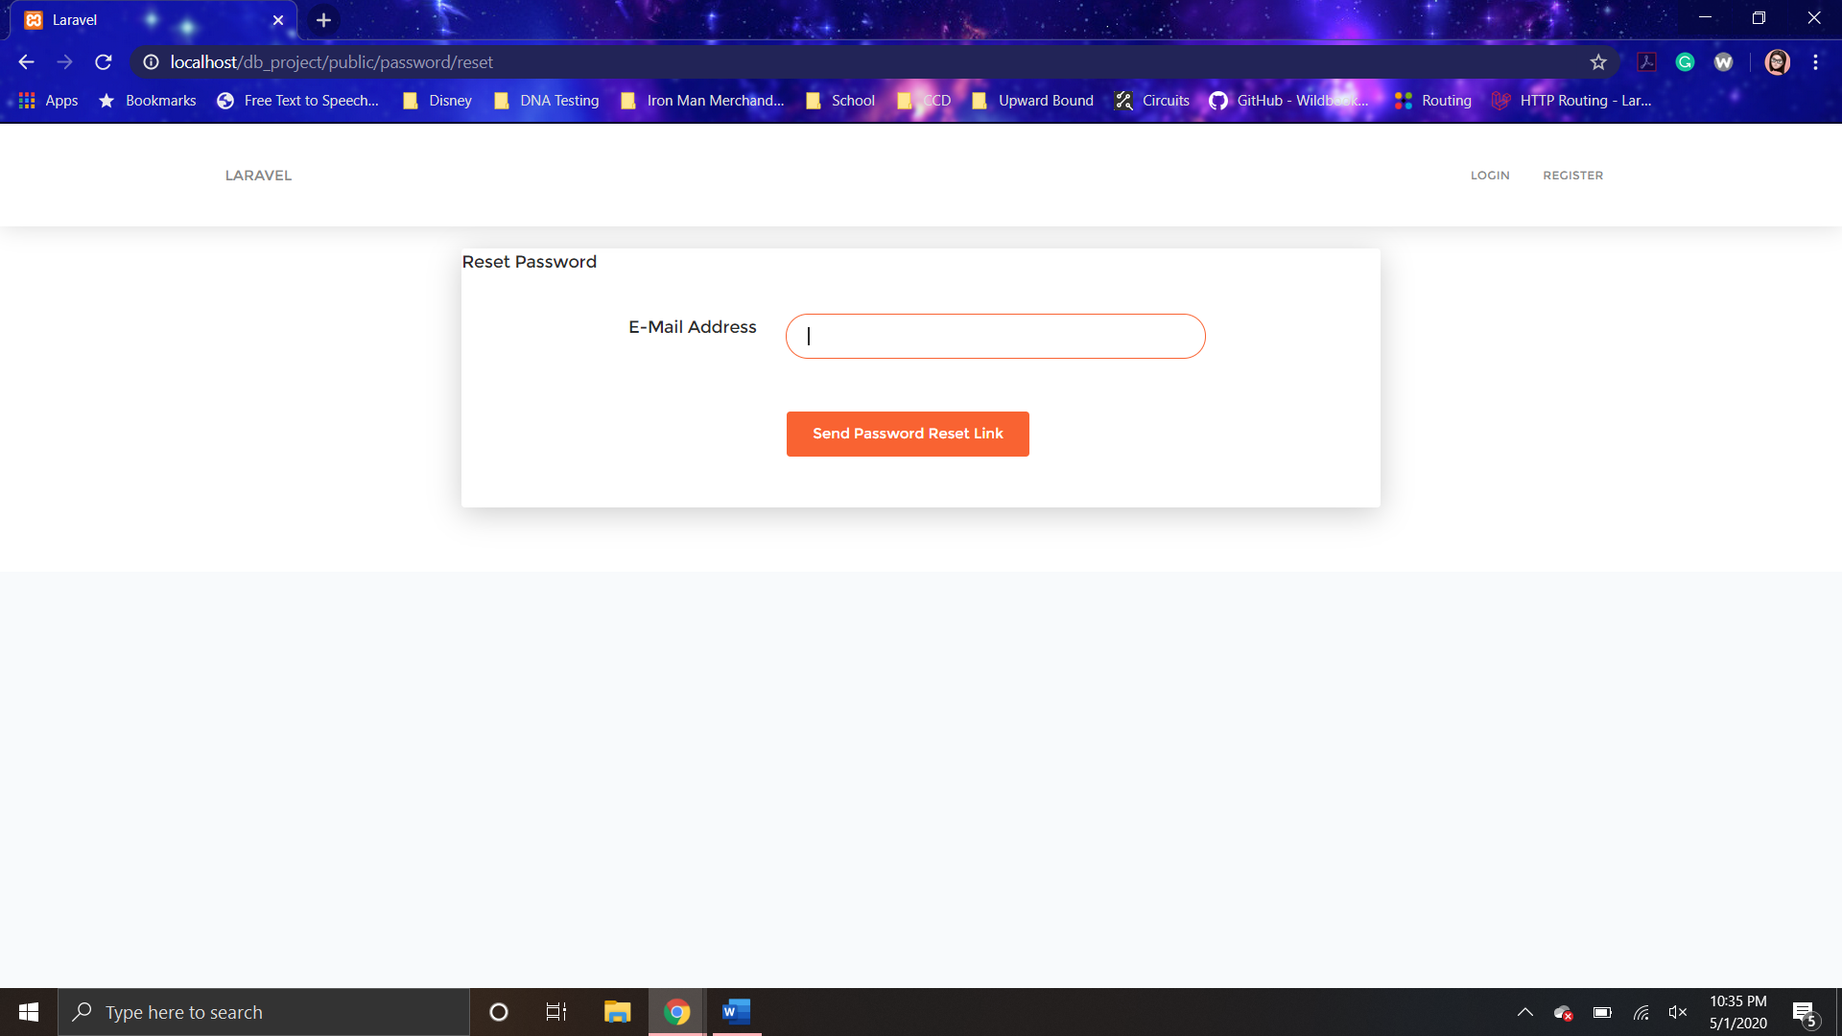

**Figure 4.1.4-1** The Password Reset Page

This page asks for the user’s email address only. After user enters user email address, he/she shall click on the “Send Password Reset Link” button, which sends the entered email address to the HNS web server. If the email address does not match the email address of a user in the HNS database, an error message is shown to the user. However, if the email address does match, the change password link is sent to that email address. In addition, a message appears informing the user that the link has been sent.

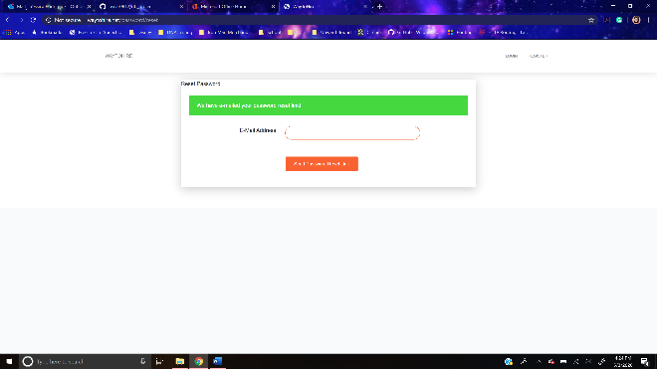

**Figure 4.1.4-2** The Password Reset Page Success Message

In the email entered, the user will find in their inbox an email with the appearance as shown below.

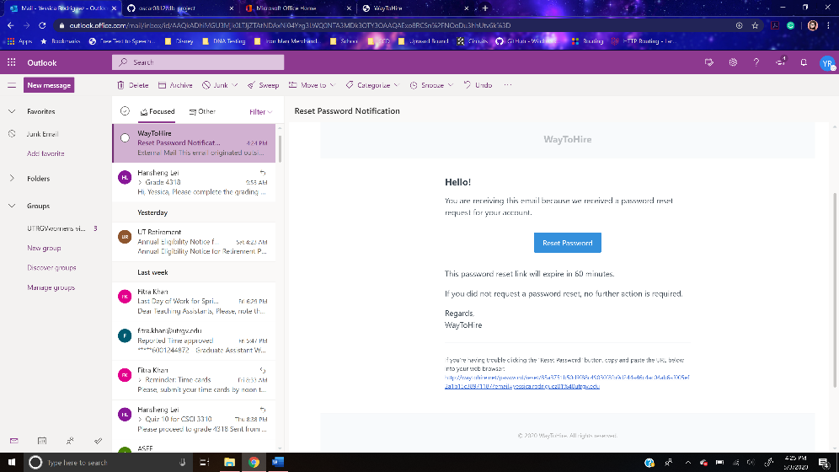

**Figure 4.1.4-3** The Password Reset Sent Email

The “Reset Password” button returns the change password page.

### **Change Password Page**

The content part of this page contains a form that users should fill in to change their password and authenticate themselves with the new password. It consists of three fields. “E-Mail Address” field is for the user to enter his/her email address. This is a plain text field. “Password” and “Confirm Password” is for the user to enter his/her new password. They are both password-type input fields. “Reset Password” button, once clicked, submits the form with the contended filed values.

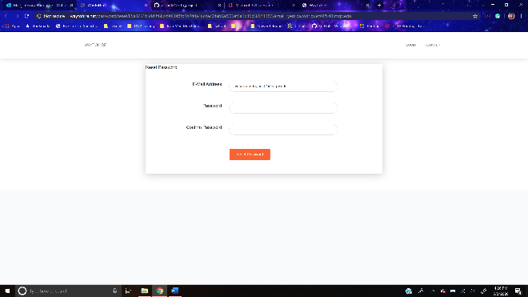

**Figure 4.1.5** The Change Password Page

The operations provided by this page is to change the user’s password and to authenticate user. He/she enters his/her email address into “E-mail Address” field and his/her new password into “Password” and “Confirm Password” fields. Then he/she clicks on the “Reset Password” button, which sends these data to the HNS web server. The web server checks if the entered passwords in “Password” and “Confirm Password” match. If it does, it will authenticate the user and return the profile page with the user’s information. In addition, it changes the password stored for the user in the HNS database. On the other hand, if the passwords do not match, an error message appears.

### **Profile Page**

This page is the first page that a user will see after he/she is authenticated. Users can get to this page from any page in the site as long as he/she is logged in. If the user is not logged in, the currently logged in user would need to log in to obtain the link to this page from the easy access menu. This page contains four main sections.

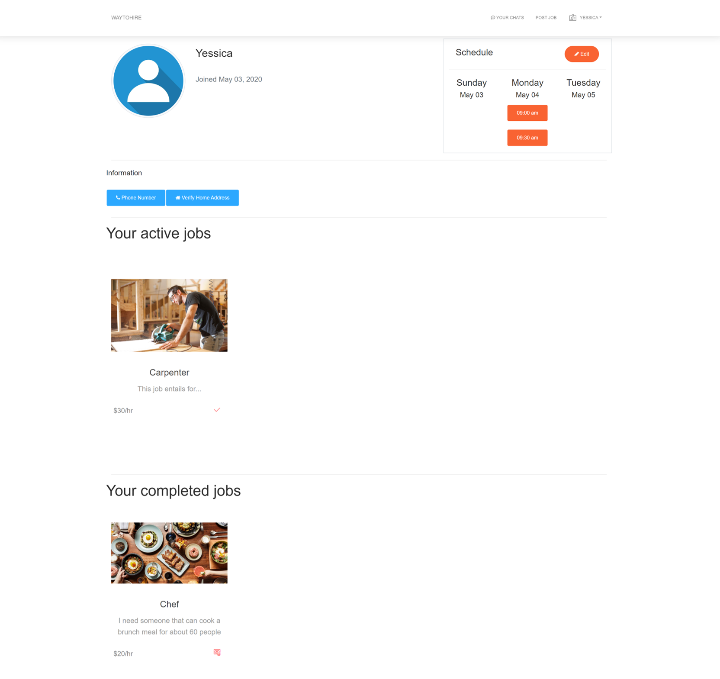

**Figure 4.1.6** The Profile Page

The first section contains the user’s profile information. This profile information includes the user’s profile picture, username, date joined, and a schedule section. The schedule section displays the user’s saved schedule, which involves available time to work and scheduled jobs, of the current and next two days. In addition, there is a “Edit” button that returns the schedule page.

The second section contains three buttons that allow the user to view more of their saved information as well as edit it. The “Phone Number” button returns the info phone page. “Verify Home Address” button returns the info address page. The button “Important Documents” returns the info documents page.

The third and fourth sections are for the jobs posted by the user. In the third section, the active jobs, which are the not completed jobs, are displayed. The completed jobs are displayed in the fourth section. Each job thumbnail contains a link, which is the job title, to the job page for the selected job.

### **Info Phone Page**

The content part of this page contains two main sections. These sections are the new phone form and user’s current phones list. The user’s current phone list is not displayed if the user does not have any already stored phone numbers.

The new phone form that users should fill in to store their phone number(s) stored in their account. It consists of a text field, a dropdown menu, and a button to submit the form. “New Phone Number” text field is for the user to enter his/her phone number. This is a plain text field. The “Phone Carrier” dropdown menu contains a list of options for the user to select their phone carrier.

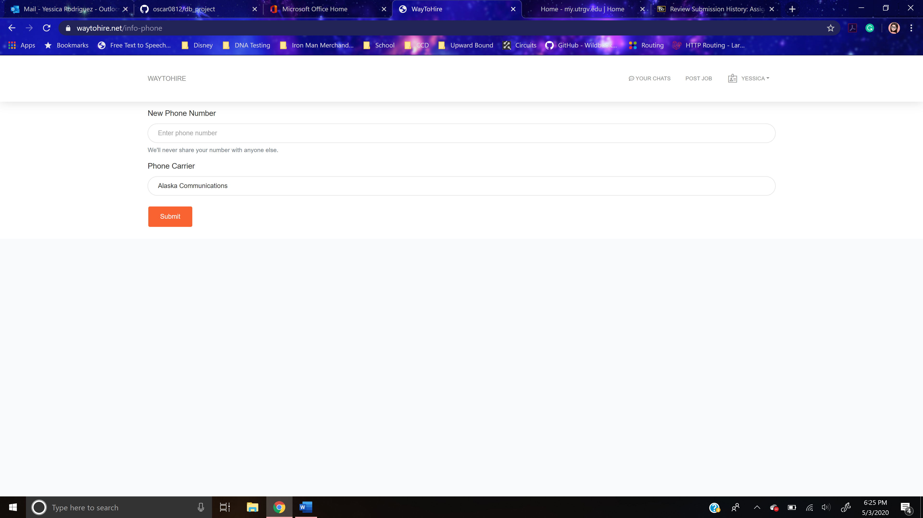

**Figure 4.1.7-1** The Info Phone Page

The only operation provided by this page is to edit the user’s phone number information. He/she enters his/her phone number into “New Phone Number” field and selects his/her phone carrier from the “Phone Carrier” dropdown menu options. Then, he/she clicks the “Submit” button, which sends this data to the HNS web server. The web server will add the new number to the user’s phone information in the HNS database. In addition, it sends a text message to the phone number entered with a four-digit verification code. This is illustrated in the figure below with the code blocked out in red.

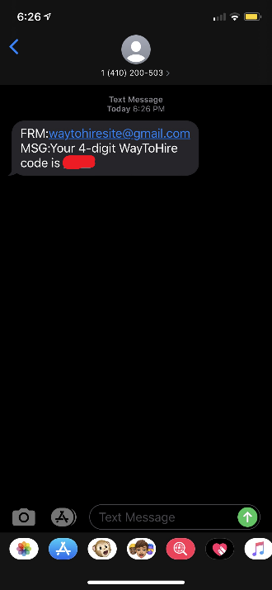

**Figure 4.1.7-2** The Info Phone Page Message

Thus, the user’s current phone list section is displayed with a row for the new phone record. The row has a textbox, text field, and button. The textbox consists of the date the phone record was submitted, an alert notifying the user that the phone needs to be verified, and the phone number. The “4-digit code” field is where the user enters the code, he/she was text messaged by the web server. This is a plain text field.

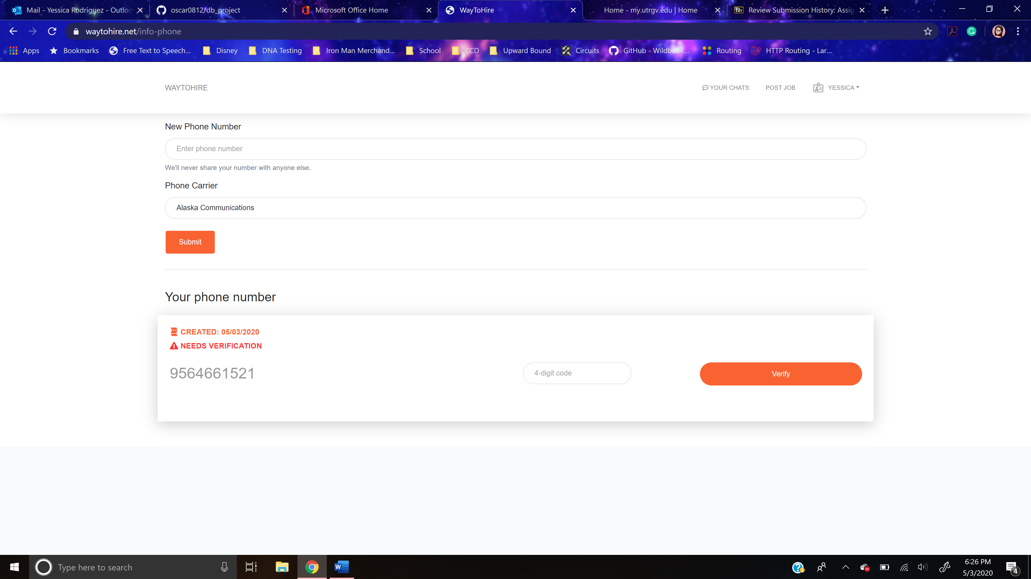

**Figure 4.1.7-3** The Info Phone Page Verify Phone

Continuing with their only operation, the user enters the appropriate code and presses the “Verify” button. It sends the data to the HNS web server. The web server compares the entered code with the one stored in the HNS database. If it matches, the phone number is considered verified and its information in the HNS database is modified. In addition, the “4-digit code” field and “Verify” button disappear as is shown below.

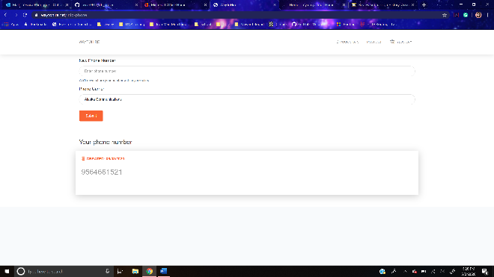

**Figure 4.1.7-4** The Info Phone Page with Saved (Verified) Phone

Thus, each phone stored for the user, a row will appear in the user’s current phone list section, which appears as soon as at least one phone number is stored for the user in the HNS database. Furthermore, if the code doesn’t match, a pop-up appears informing the user.

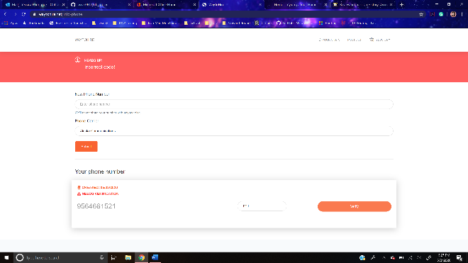

**Figure 4.1.7-5** The Info Phone Page Verify Phone with Error Message

### **Info Address Page**

The content part of this page contains two main sections. These sections are the new address form and user’s current addresses list.

The user’s current addresses list displays the stored user’s addresses along with the date that it was added to the user’s account information.

The new address form that users should fill in to store their address(es) stored in their account. It consists of a text field and a button to submit the form. “Type your address” text field is for the user to enter his/her address. This is a plain text field.

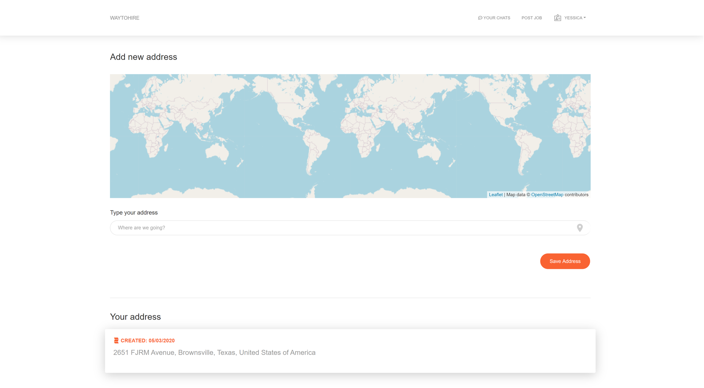

**Figure 4.1.8** The Info Address Page

The only operation provided by this page is to edit the user’s phone address information. He/she enters his/her address into “Type your address” field. Then, he/she clicks the “Save Address” button, which sends the data to the HNS web server. The web server will add the new address to the user’s address information in the HNS database.

### **Schedule Page**

The content part of this page contains the actual form that users should fill in to edit and store their schedule. It consists of a button, a table of buttons, and a button to submit the form. “Profile” button returns the profile page. The table of buttons contains a column of buttons for each day of the week. Each button represents a timeslot in that day.

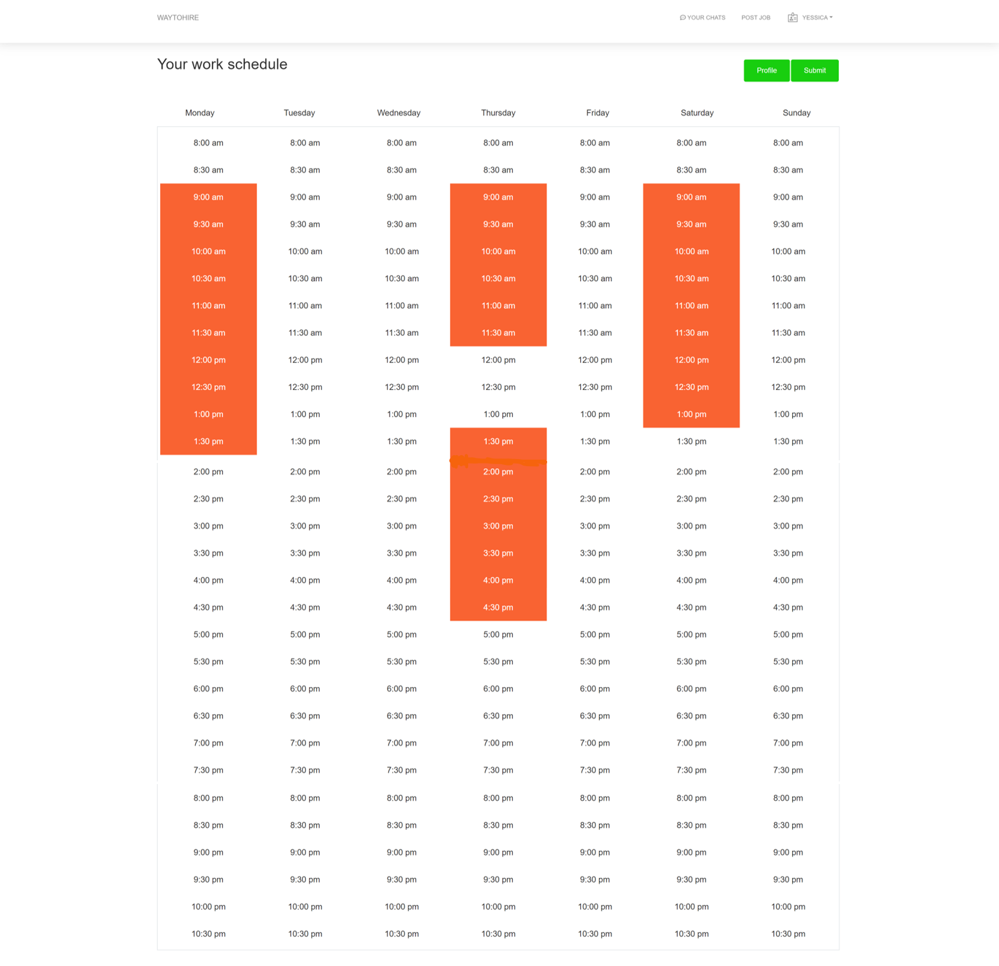

**Figure 4.1.9** The Schedule Page

The only operation provided by this page is to edit the user’s schedule information. He/she selects the timeslots, which were turn orange, that reflect the periods of time he/she is available. Then, he/she clicks the “Submit” button, which sends the selected time slots to the HNS web server. The user’s timeslots records in the HNS database are updated.

### **Create-Edit Job**

This page is accessible from any page once the user is logged in. The content part of this page consists of a header and a form. The header contains the title of the page.

The form consists of an upload image file selector, four dropdown menus, a link, two text fields, and a button to submit the form. The “Images” upload image file selector when pressed opens the machine’s file explorer and allows the user to select an image(s) to upload as the job’s images. “What are you looking for?” dropdown menu provides an options list composed of all the job titles in the HNS database, which the user can select. It will automatically choose the first job title in the HNS database. Furthermore, the “Which address?” dropdown menu provides an options list composed of all the user’s saved addresses, which the user can select. The “Add new address” link returns the info address page. “Your pay per hour” field is where the user can enter the amount, which is in US dollars, they are willing to pay per hour for the job. This is a plain text field. The “Description” field is where the user can enter a description of the qualifications and specific services they are looking for. It is a plain text field.

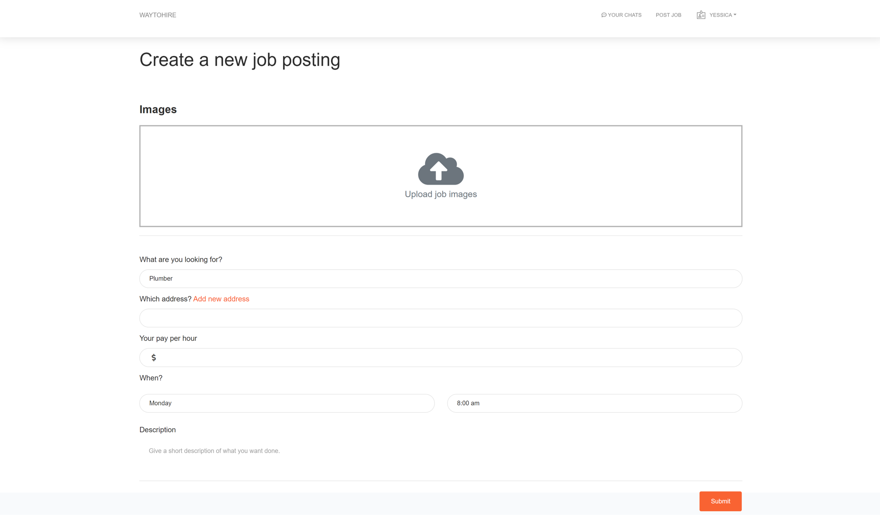

**Figure 4.1.10** The Create-Edit Job Page

The only operation provided by this page is for the user to post new job. He/she presses the Images upload image file selector, which opens the machine’s file explorer. Then the user selects the image(s) that he/she wants. Next, the user selects a job title based on the job or service he/she is looking for, selects the appropriate address, enters the pay per hour, and enters a job description. Once everything has been filled out, the user presses the “Submit” button, which sends the information to the HNS web server. The new job record is entered into the HNS database.

### **Jobs Page**

The content part of this page consists of a header, sidebar, and gallery. The header contains the title of the page, which is “Services.”

The sidebar contains a button and dropdown menus that are different options to filter the job thumbnails in the gallery. The “Refresh” button resets all the filter options selected. “Service” dropdown menu displays a list of checkboxes for each job title. “All” checkbox is already pressed. The user can press any job title checkbox to obtain in the gallery only job thumbnails for that job title. On the other hand, the “Price Range” dropdown menu displays a slider that the user can move to select his/her desired price range.

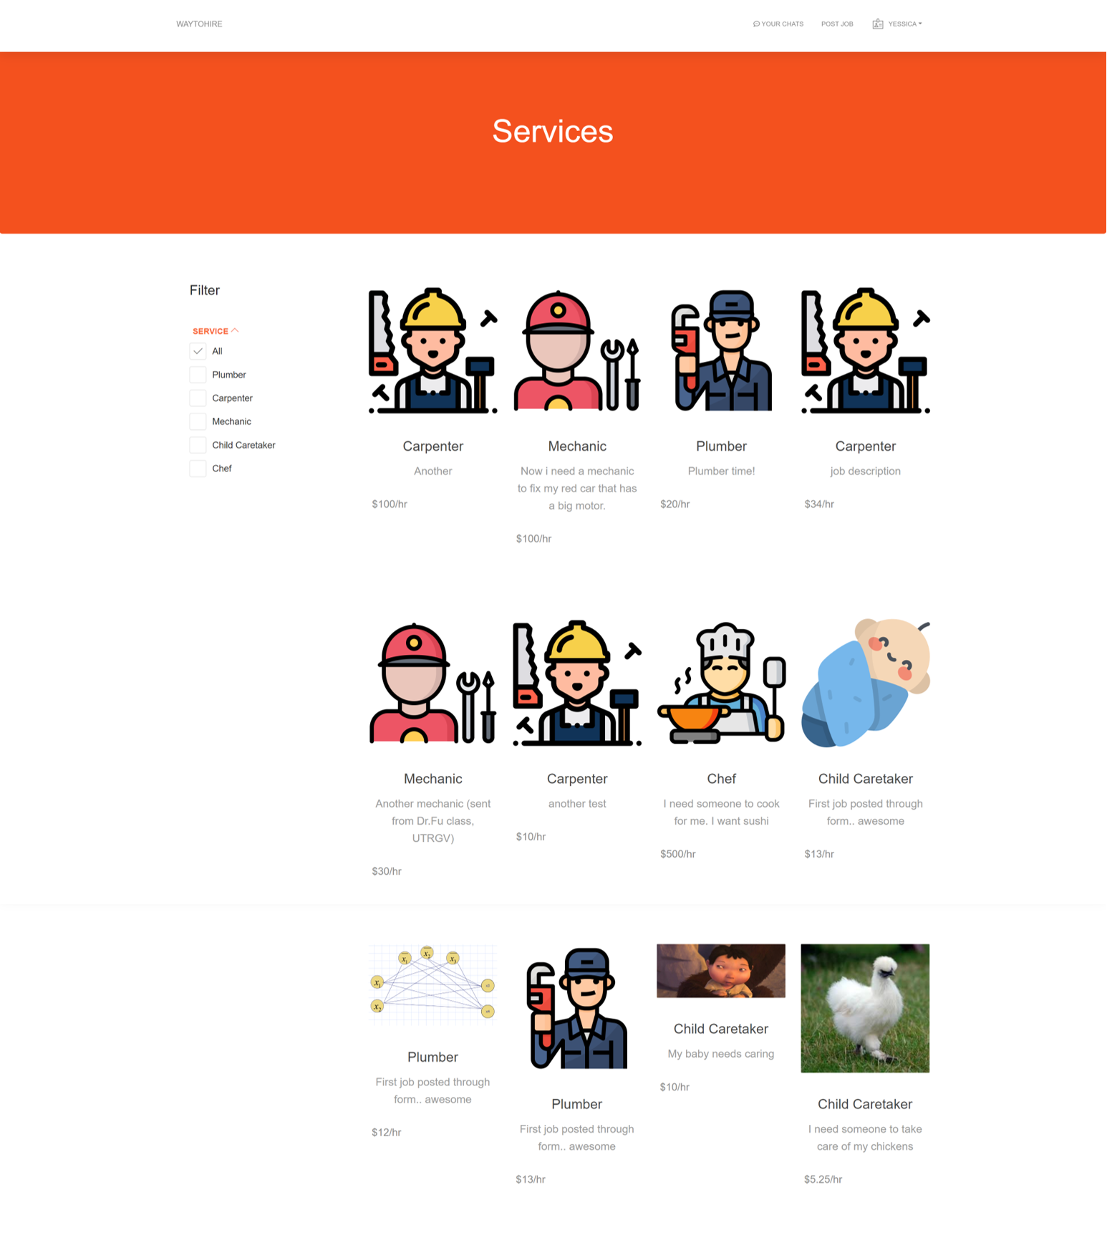

**Figure 4.1.11** The Jobs Page

The gallery contains thumbnails for each job. Each job thumbnail is composed of an image, a link, 2 labels, and button. The image is the job’s image. However, if no image was uploaded by the user when he/she created the job, it will be the job title image. Furthermore, the link returns the job page. One label, or text, is the job description. The other is the pay per hour. “Heart” button sends the job to the HNS web server. The selected job is added as one of the user’s favorite jobs in the HNS database.

### **Job Page**

The information displayed in this page is on the specific job selected by the user. The content of this page consists of job container, map container, and related container.

The job container is composed of an image gallery, header, and buttons box. The header contains the job title, amount user who posted job is willing to pay per hour worked, and the job description. The image gallery has two parts the image viewer and the image selector menu. The image viewer has two arrow buttons on the left and right to navigate through the job images. In the center, the current job image is displayed (large). The image selector menu contains each job image, which when pressed displays the selected job image in the job viewer center. The button box contains two buttons, there two options for the pair of buttons it contains.

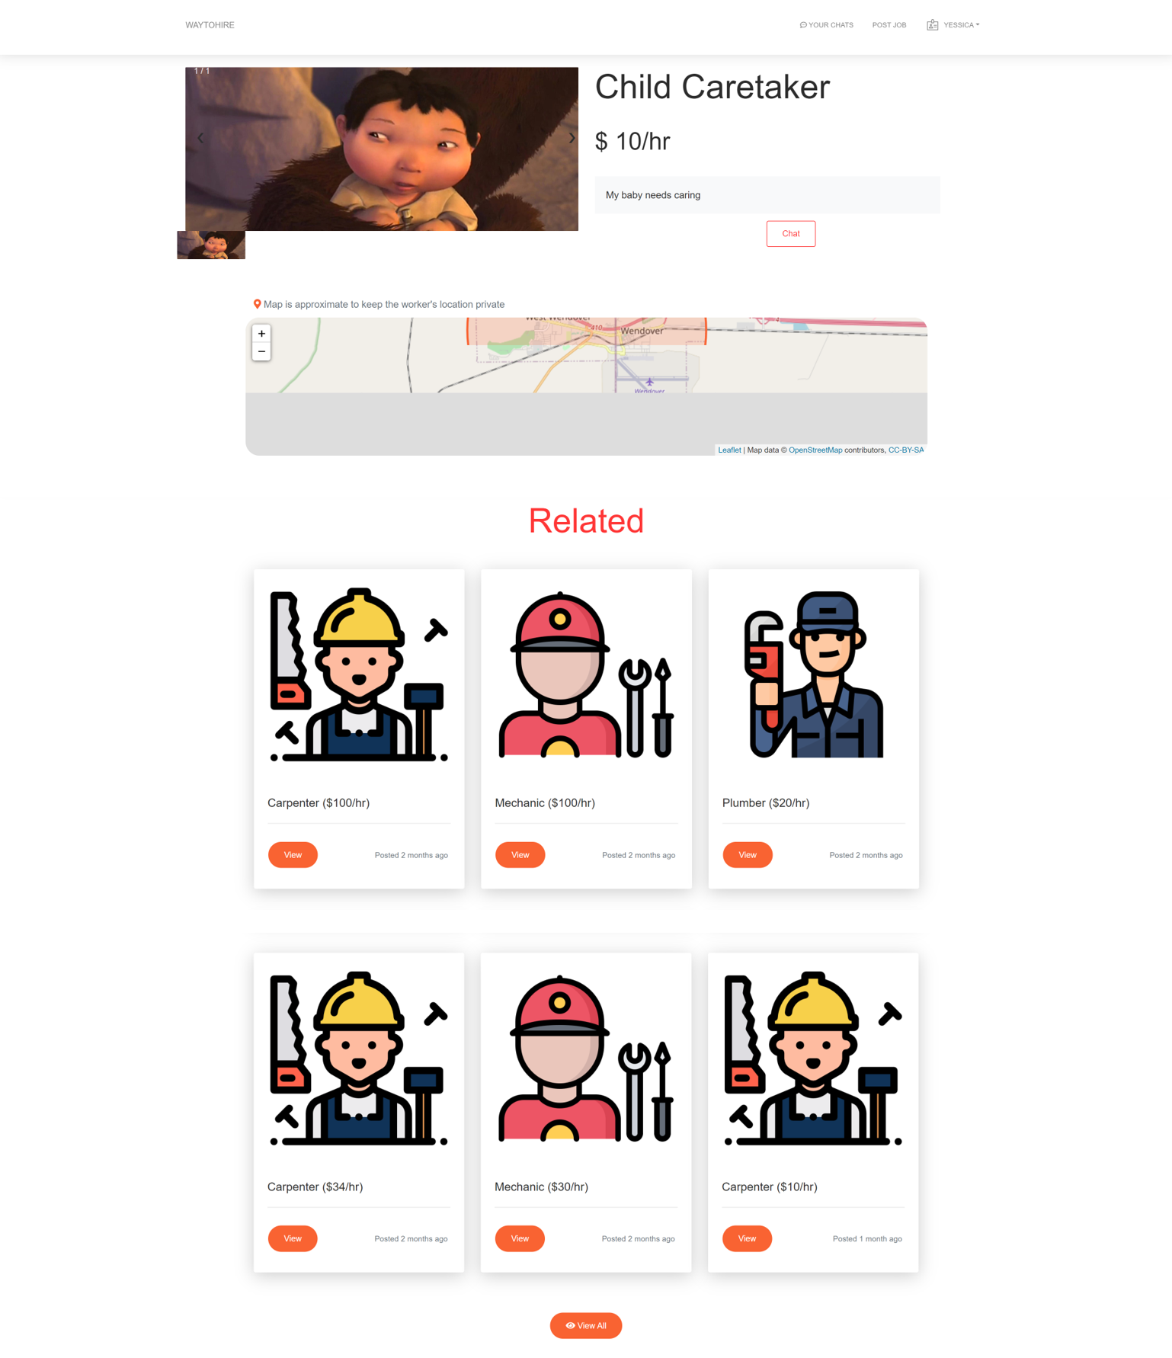

**Figure 4.1.12-1** The Job Page with Option 1 Buttons

The first option are the “View profile” and “Chat: buttons, which occurs when the currently logged in user is not the one who posted the job. “View Profile” button does not do anything. The “Chat button returns opens a pop-up that contains several buttons send a specific starter message the user can send to the user who posted the job. The “Close” and “X” buttons close the pop-up.

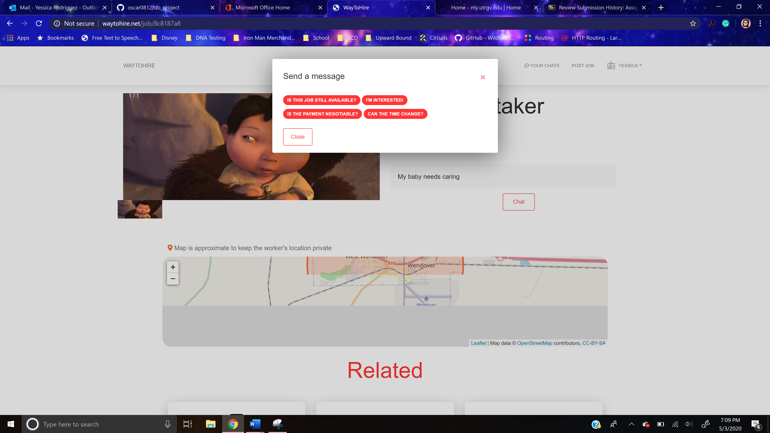

**Figure 4.1.12-2** The Job Page with Option 1 Buttons Chat Pop-up

For the second option, the button pox contains an “Edit” button and “Check Mark” button. The second option can be seen when the currently logged in user is the user who posted the job. The “Edit” button returns the create edit job page with the job’s information already entered.

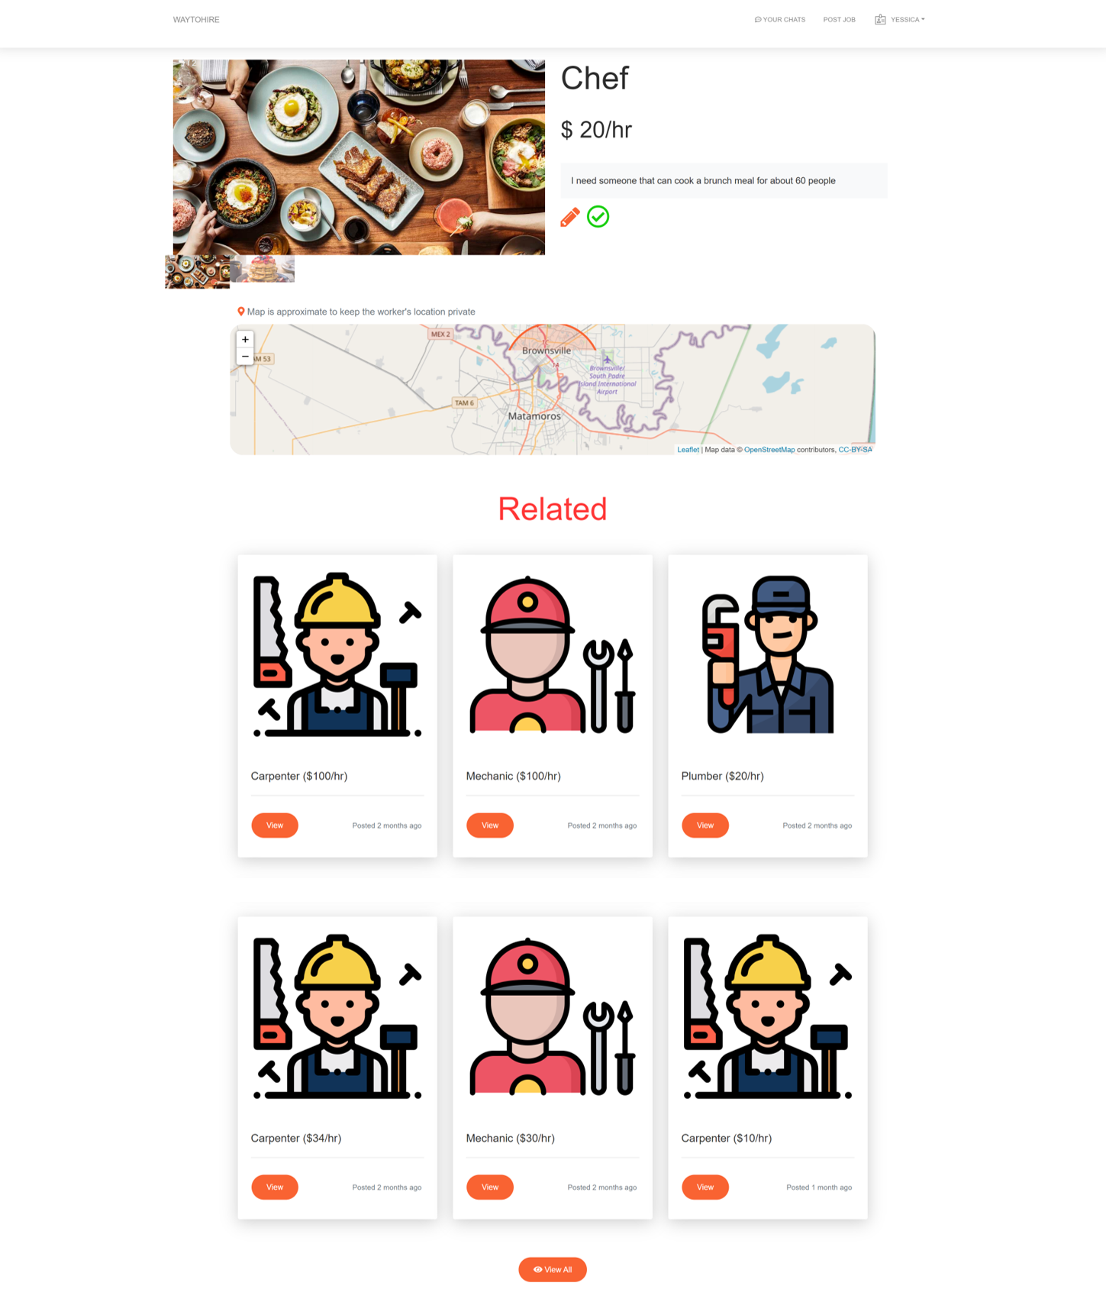

**Figure 4.1.12-3** The Job Page with Option 2 Buttons

“Check Mark” button opens a pop-up that is composed of a dropdown menu and two buttons. The user selector dropdown menu contains an option for each user other the currently logged in user. It is where the user selects the user that complete the job. The “Submit” button returns the payment page with selected user’s name. “Cancel” and “X” buttons close the pop-up.

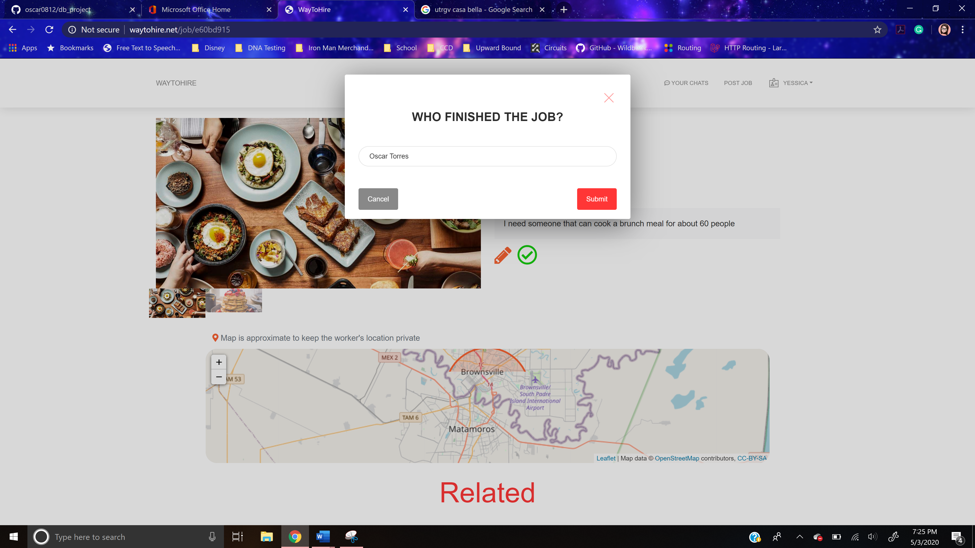

**Figure 4.1.12-4** The Job Page with Option 2 Buttons Finished Job Pop-up

Furthermore, the map container contains an interactive map that contains a pin on the job’s location. The user has the ability to zoom in and out by pressing the “+” and “-“ buttons respectively.

The related container contains a header, gallery, and footer parts. The header is composed of the title. In the gallery, the user can find other six job thumbnails for other jobs, which if pressed return the selected job’s job page. The footer part contains a “View All” button, which when pressed returns the jobs page.

### **Chats Page**

This page can be accessed from any page in the site as long as the user is logged in by the easy access menu. The content of this page consists of a sidebar and messenger container. The sidebar contains a button for each of the user’s chats with other users. The messenger container is empty.

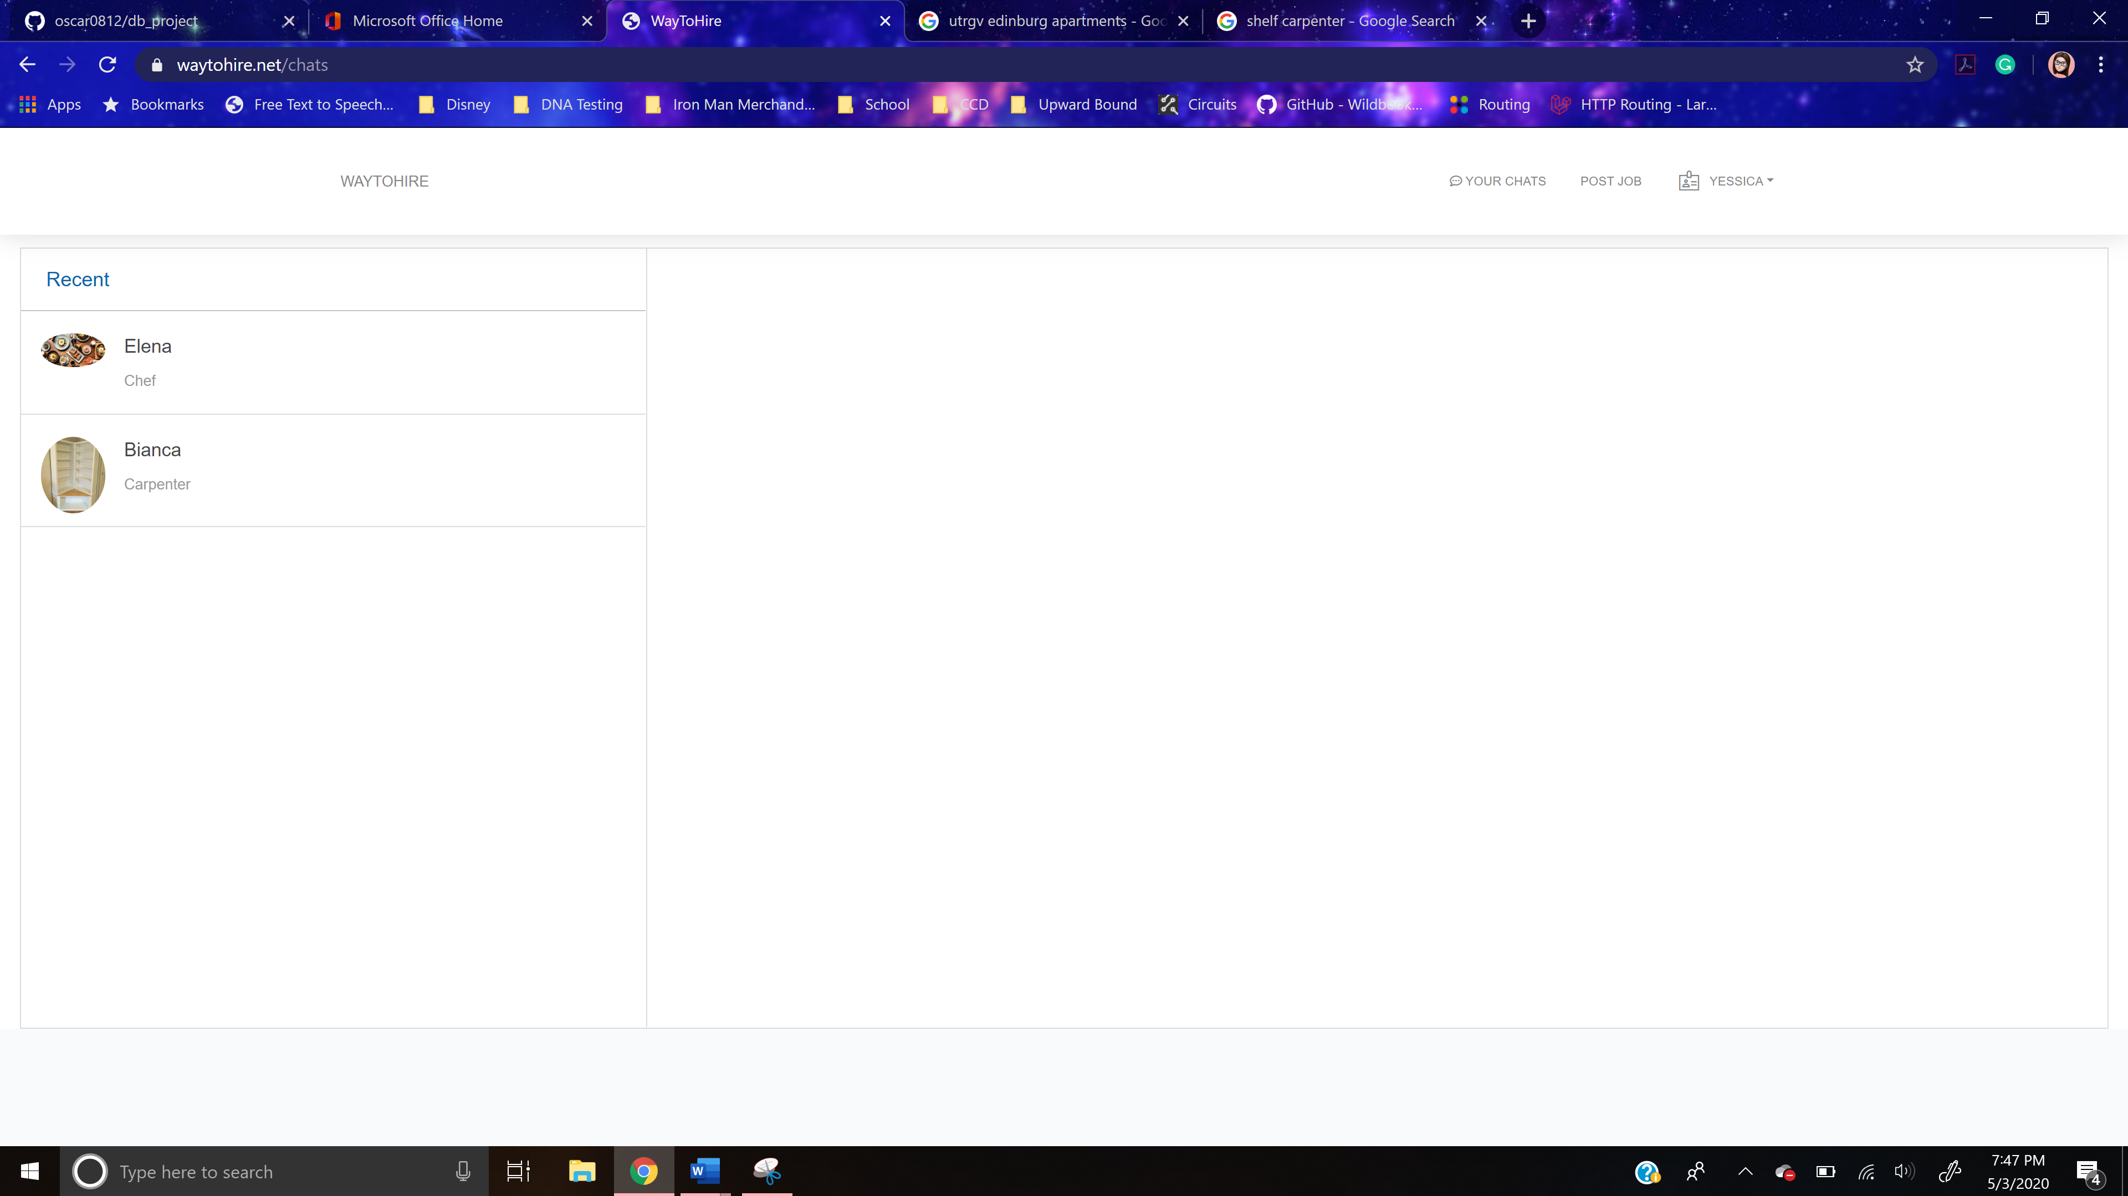

**Figure 4.1.13-1** The Chats Page

Once the user presses a chat button, the messenger container will display a header, messages container, and a text field. The header contains the profile picture and the user’s name of the user who posted the job, in the left-hand side. On the right-hand side, it has the job title, job image, and pay per hour of the job that the two users are messaging each other about. The two users messaging each other are the user interested in the job and the user who posted the job. In the messages container, all of the user’s previously sent messages with the other user are displayed. The current user’s messages are blue in color, while the other user’s messages are gray. The “Type a message” field is where the user will enter his/her message to the other user.

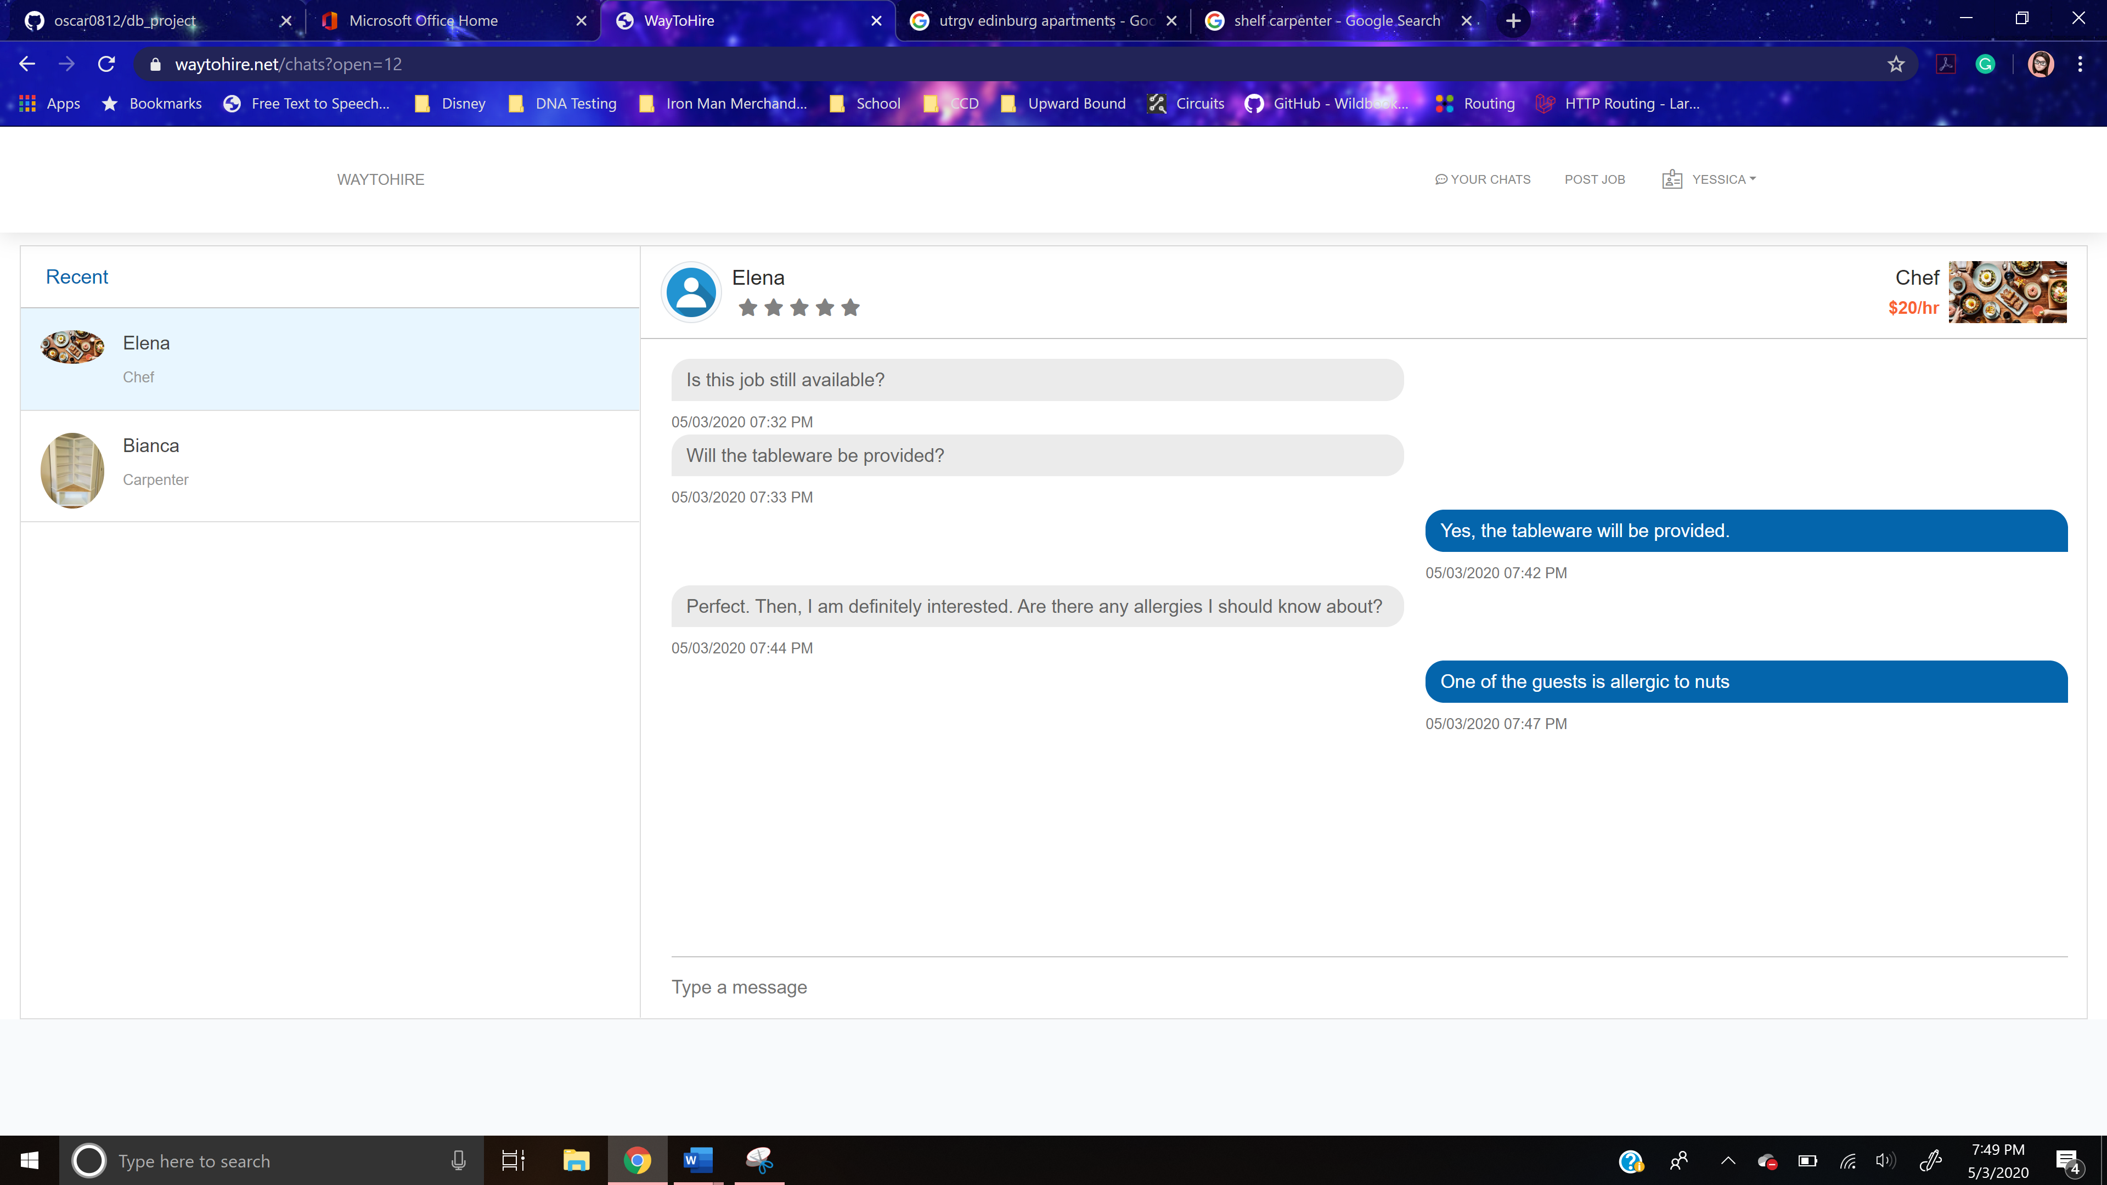

**Figure 4.1.13-2** The Chats Page Displaying Chat Messages

Once the user types something into the “Type a message” field. A button will appear next to the text field that when press will send the entered message to the other user. In addition, the user can send his/her message by just pressing ENTER.

### **Payment Page**

The content of this page consists of a header and form. The header contains the user being paid and the job title of the job he/she is being paid for.

The form consists of two main sections, which are calculate pay part and payment method part. The calculate pay part contains a text field. The “hours worked?” field is where the user enters the number of hours the user being paid worked on the job being paid. This is an integer increment-decrement input text field. It contains arrows that allow the user to increment or decrease the integer value, which starts at 1. A value located to the right of the field displays the total payment amount based on the entered hours worked. Furthermore, the payment method part contains a button to submit the form.

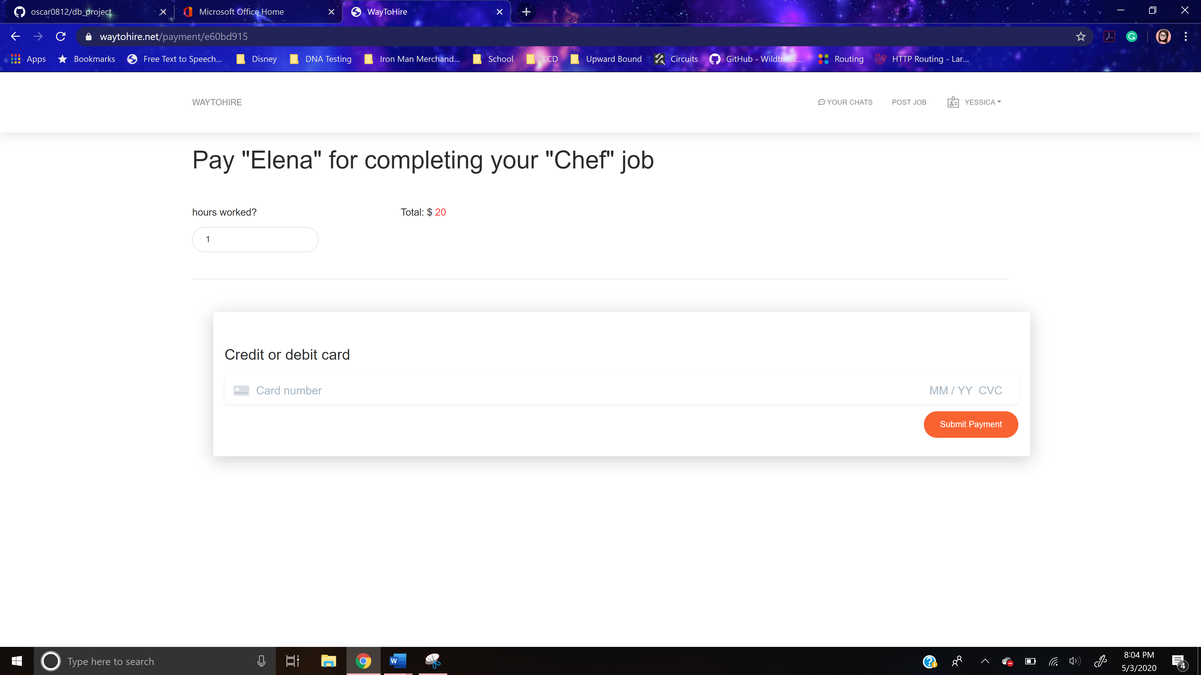

**Figure 4.1.14** The Payment Page

The only operation provided by this page is for the user to make a payment. He/she can enter the number of hours worked by the user getting paid for the job being paid. Then, the user presses the “Submit Payment” button, which sends the entered information to the HNS web server. The web server processes the payment and stores the transaction information in the HNS database.

## **Administrator User Interface**

Every administrator user interface in the system will be structured as shown in the following figure.

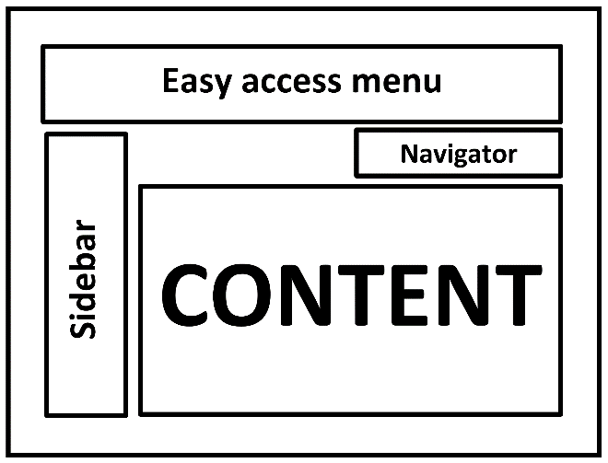

Figure 4.2 The Main Administrator User Interface Components

The top part, named “Easy access menu,” will have three part. On the left, there will be link called “WayToHire” that will lead the user back to the welcome page, which is a user interface page. In addition, there will be a button that will open and close the sidebar. On the right, there are dropdown menu with two options. The “My Account” returns the edit account info page. The next option, “Logout,” logs out the administrative user and returns the administrator login page. Below the menu, there are three sections, which are navigator, content, and sidebar. The sidebar contains series of links that are accessible to the user to conduct various operations. The navigator contains links to the dashboard page and to the current page. The content is next to the sidebar under the navigator section. If the user is not logged in, the only section visible will be the contents section. If the user is logged in, all sections will be visible.

### **Administrator Login Page**

Administrative users who play an active role in the system (in this case all users – contractors or user in need of service) should be authenticated by the system. This page provides users an interface, where they can put their authentication information and authenticate themselves to the system.

Administrative users can get to this page by adding to the original link “/admin” and no administrative user is already logged in. If there is, the already logged in administrative user must be logged out to reach this page.

The content part contains the actual form that administrative users should fill in for authentication. It consists of two fields, a button to submit the form, a link, and a checkbox. “E-Mail Address” field is for the administrative user to enter his/her email address. This is a plain text field. “Password” is for the administrative user to enter his/her password. This is a password-type input field. Login button, once clicked, submits the form with the contended filed values. “Forgot Your Password?” link that leads the authentication user to the password reset page. “Remember Me” checkbox is used to indicate to the site to remember the authenticated administrative user.

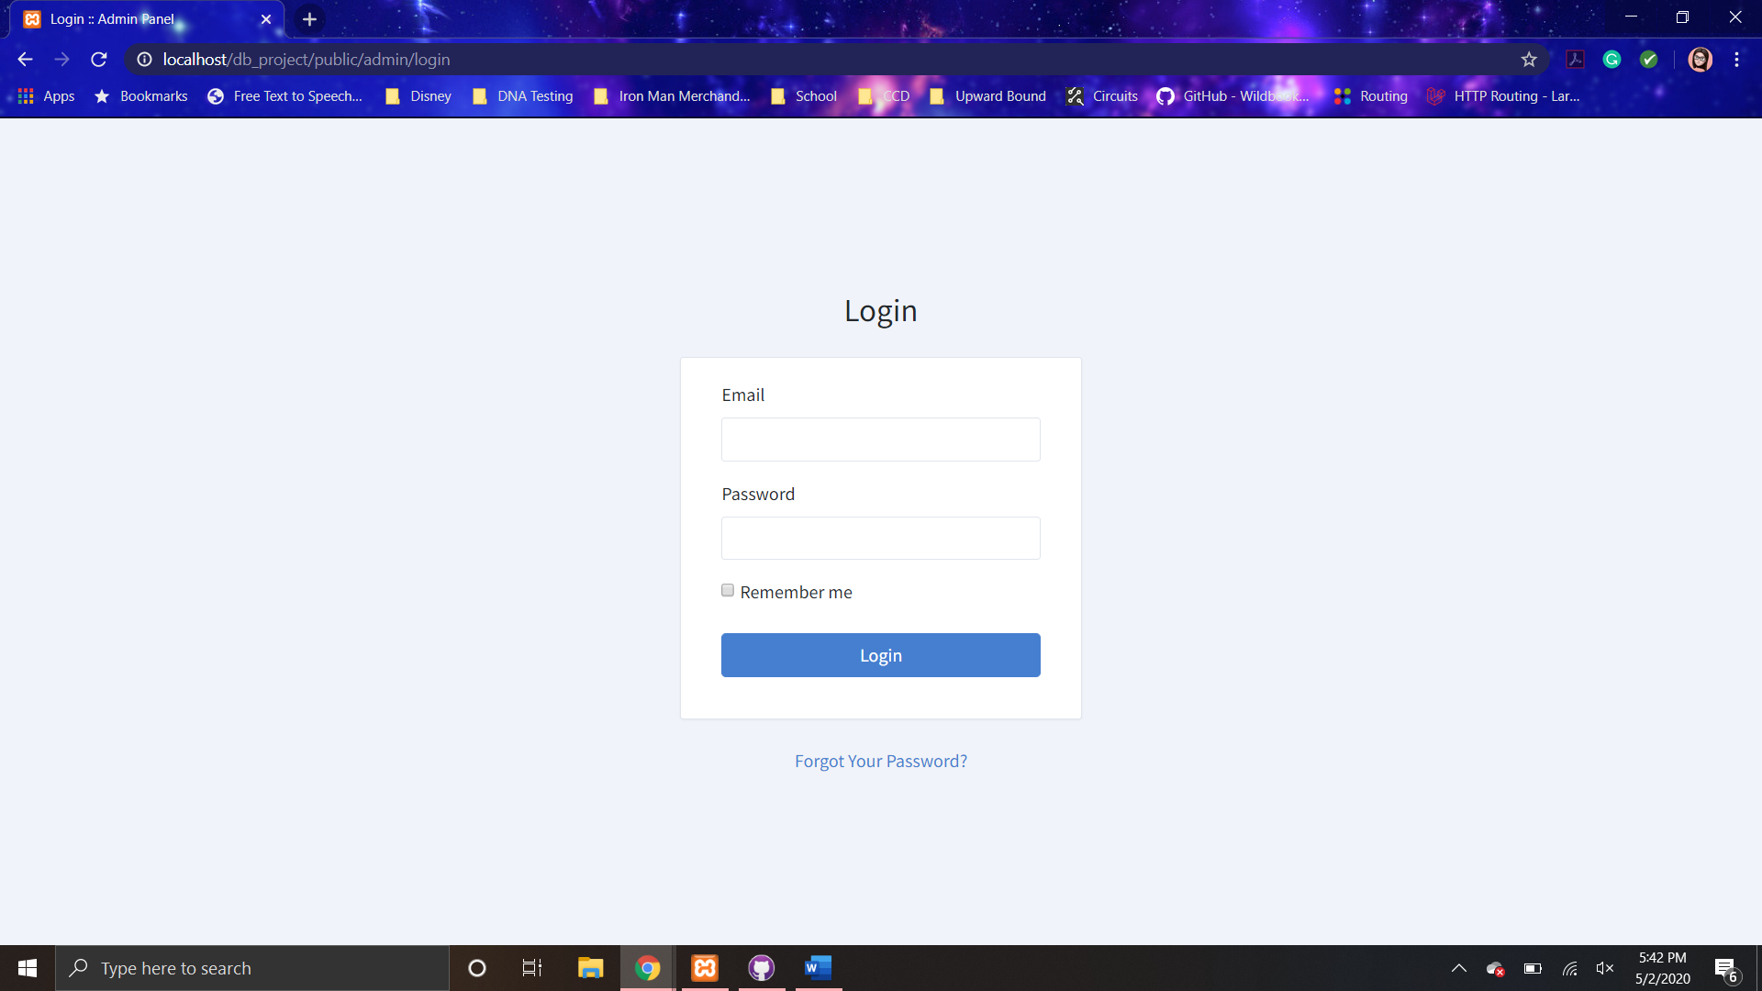

Figure 4.2.1 The Administrator Login Page

The only operation provided by this page is to authenticate an administrative user. He/she enters his/her email address into “E-mail Address” filed and his/her password into “Password” filed. Then he/she clicks on the “Login” button, which sends these data to the HNS web server. The web server will authenticate the user and return the profile page for him/her. If the web server cannot authenticate the user (password or email address is wrong), it responds with an error page.

### **Administrator Password Reset Page**

This page is provided as a method to obtain permission to change their account password for those administrative users who forget their passwords.

Administrative users can get to this page only from the administrative login page. However, an administrative user can change their password in the edit account info page but one needs to be already logged in to access it. In addition, another administrative user could change another’s administrative user’s password in the edit page.

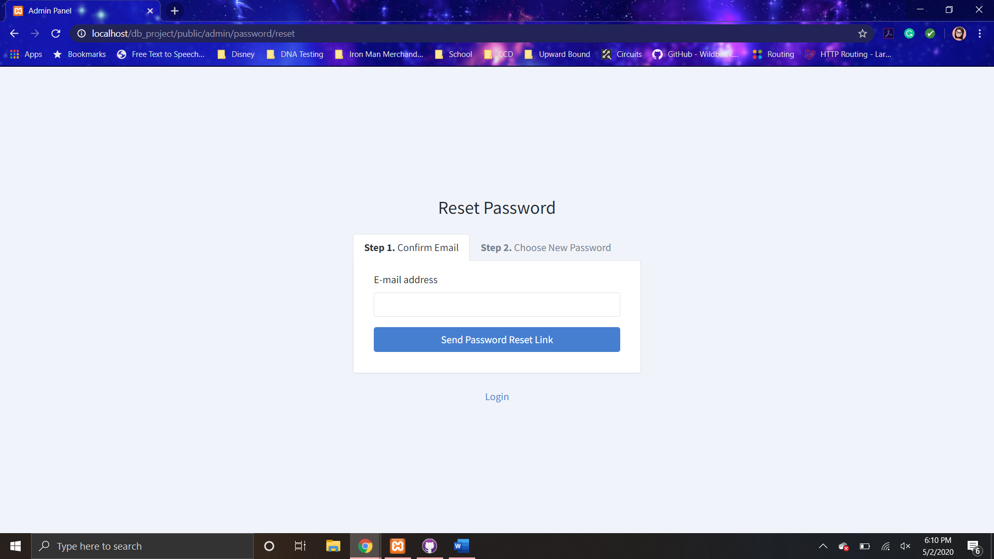

**Figure 4.2.2-1** The Administrator Password Reset Page

Figure 4.2.2 above shows the appearance of this page. This page asks for the user’s email address only. After user enters user email address, he/she shall click on the “Send Password Reset Link” button, which sends the entered email address to the HNS web server. If the email address does not match the email address of an administrative user in the HNS database, an error message is shown to the administrative user. However, if the email address does match, the change password link is sent to that email address. In addition, a message appears informing the administrative user that the link has been sent.

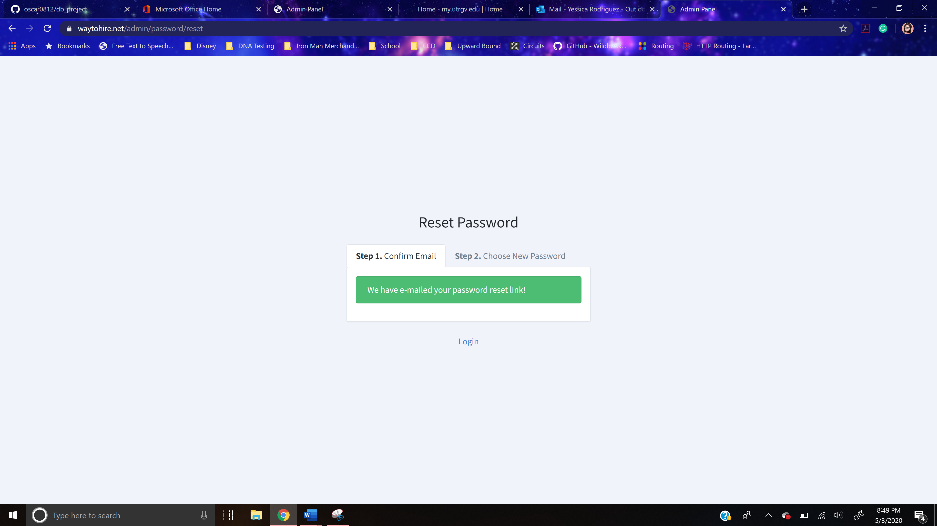

**Figure 4.2.2-2** The Administrator Password Reset Page Success Message

In the email entered, the administrative user will find in their inbox an email with the appearance as shown below.

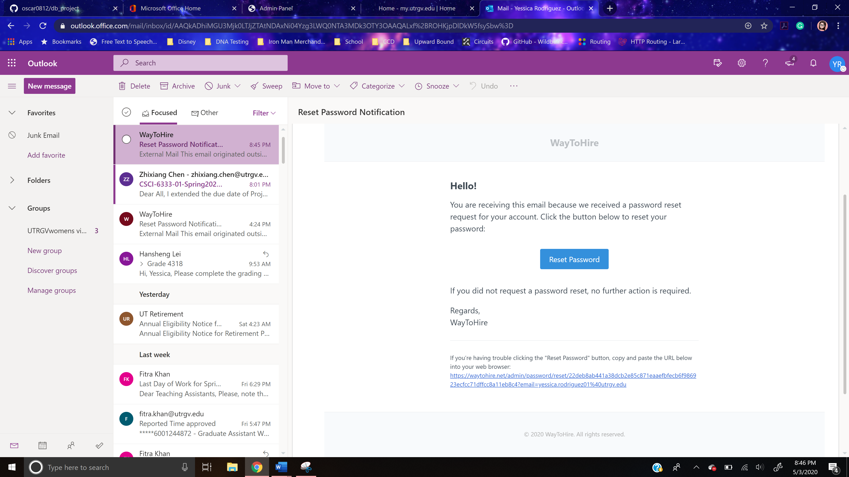

**Figure 4.2.2-3** The Administrator Password Reset Page Sent Email

The “Reset Password” button returns the administrative change password page.

### **Administrator Change Password Page**

The content part of this page contains a form that administrative users should fill in to change their password and authenticate themselves with the new password. It consists of three fields. “E-Mail Address” field is for the administrative user to enter his/her email address. This is a plain text field. “Password” and “Confirm Password” is for the administrative user to enter his/her new password. They are both password-type input fields. “Change Password” button, once clicked, submits the form with the contended filed values.

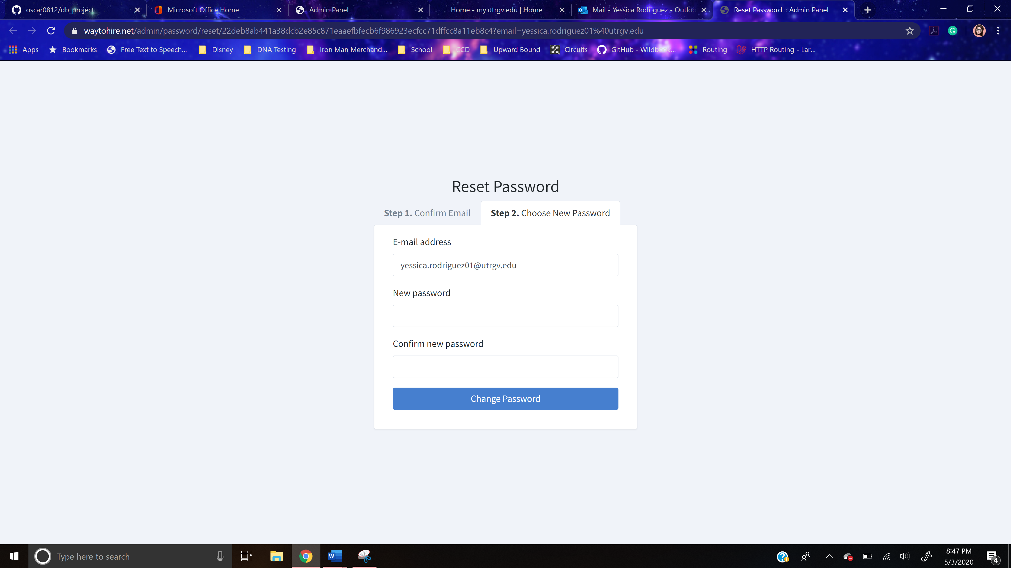

**Figure 4.2.3** The Administrator Change Password Page

The operations provided by this page is to change the administrative user’s password and to authenticate the administrative user. He/she enters his/her email address into “E-mail Address” filed and his/her new password into “Password” and “Confirm Password” fields. Then he/she clicks on the “Change Password” button, which sends these data to the HNS web server. The web server checks if the entered passwords in “Password” and “Confirm Password” match. If it does, it will authenticate the administrative user and return the dashboard page with the administrative user logged in. In addition, it changes the password stored for the administrative user in the HNS database. On the other hand, if the passwords do not match, an error message appears.

### **Dashboard Page**

This page will be the main entrance to the administrator part of the site. Users will small description of the functions an administrator can perform and a button. The “Logout” button logs out the administrative user and returns the administrator login page. Figure 4.1.1 shows the appearance of the page.

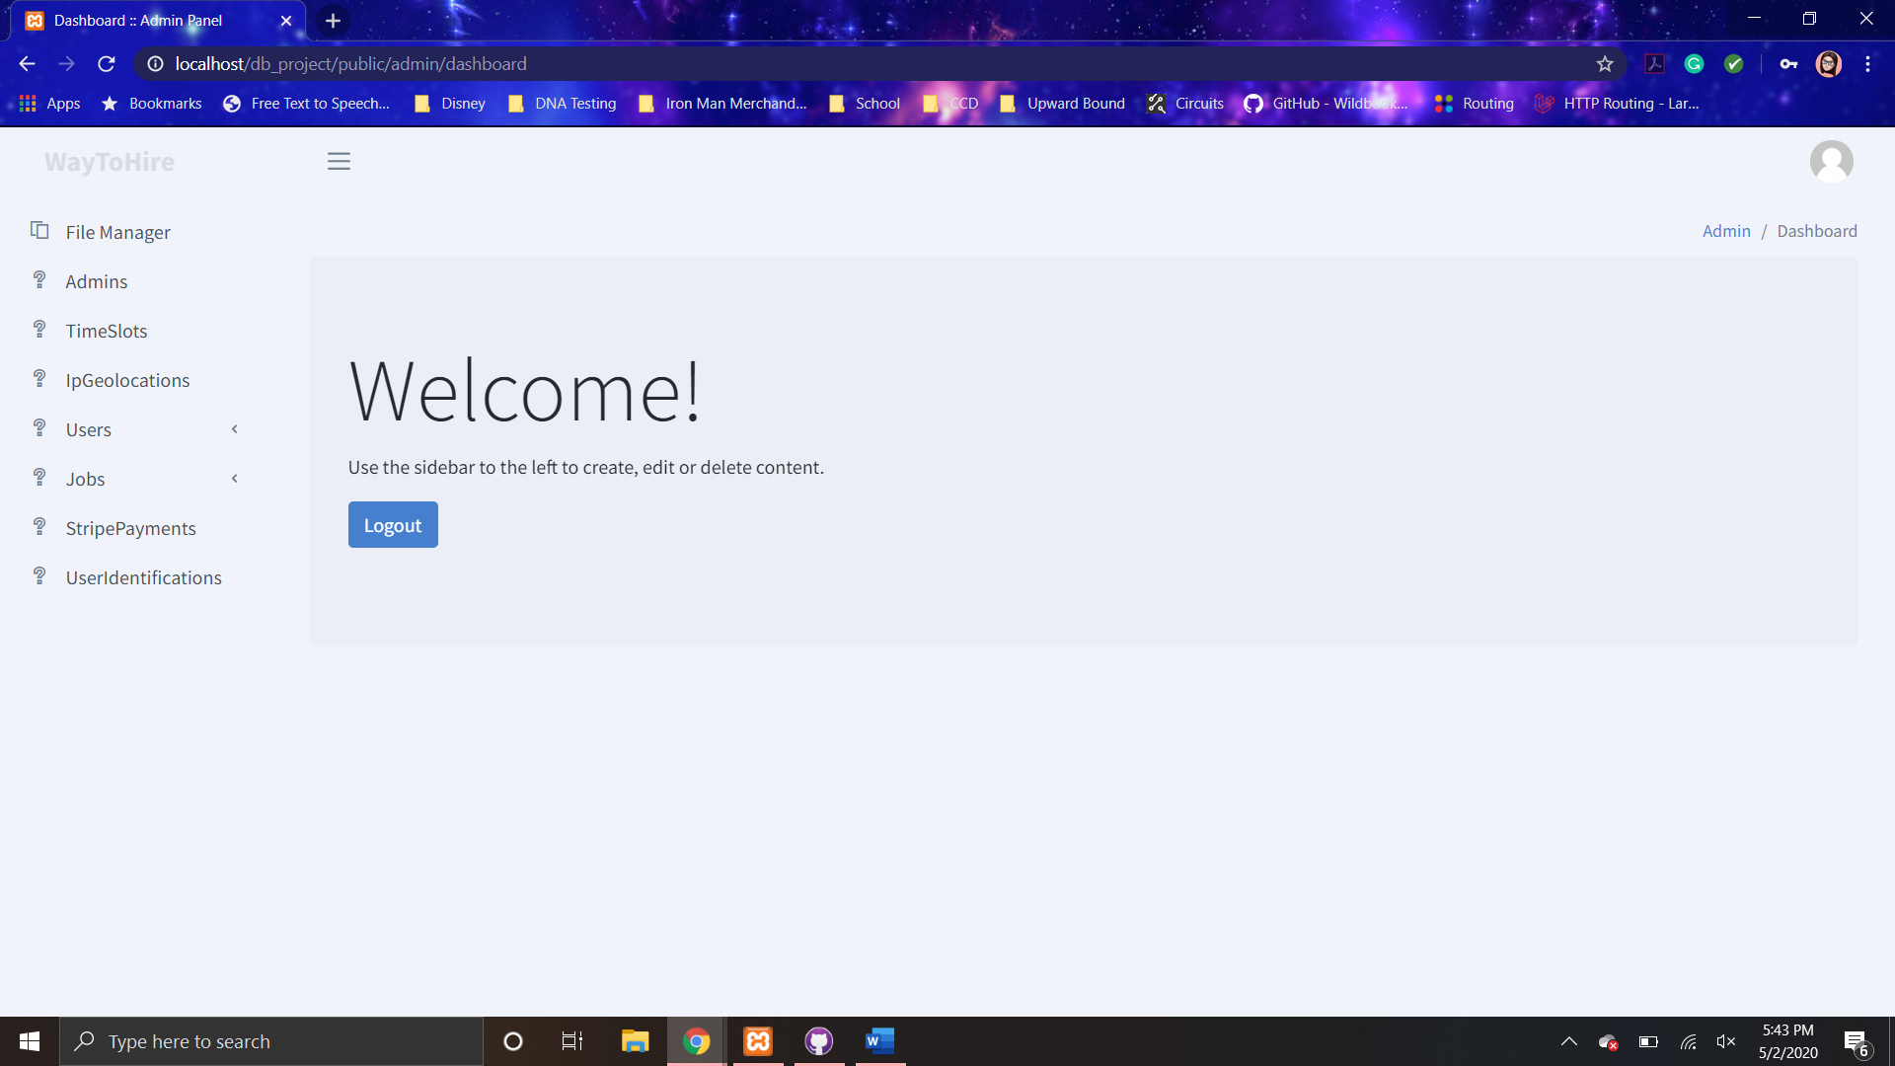

**Figure 4.2.4** The Administrator Dashboard Page of the HNS program

For any page in the system, user can return back to the dashboard page by just clicking on the “Admin” link in the navigator.

### **File Manager Page**

The content section in this page consists of two parts a header and sub-content container. The header contains a label with the title of the page. The administrative user can access this page by clicking on the corresponding button on the sidebar.

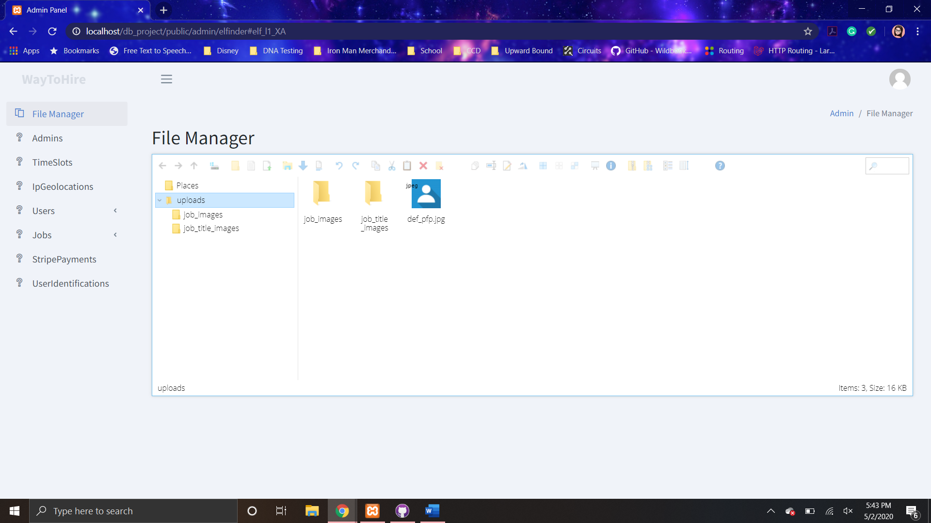

**Figure 4.2.5** The File Manager Page

The sub-content container contains an interactive reflection of computers file explorer that allows the administrative user to add, delete, and modify the images and other files stored in the HNS web server.

### **Database Record Pages**

The database record pages are the available pages to the administrative user to allow him/her to view, modify, add, and delete the information stored in the HNS database. These pages can be accessed by clicking in the corresponding button in the sidebar. The database record pages include:

* Admins Page
* Time Slot Page
* IP Geolocations Page
* Users Page
* Addresses Page
* Phone Numbers Page
* Ratings Page
* Jobs Page
* Job Title Page
* Finished Jobs Page
* Job Images Page
* Stripe Payments Page
* User Identifications Page

The content section in these pages is divided into four parts, which include the header, sub-navigator, and table display container, and footer. The header contains two labels. The first label is of the page’s title. The second label contains the current table page the administrative user is viewing and the total number of records per page compared to the total number.

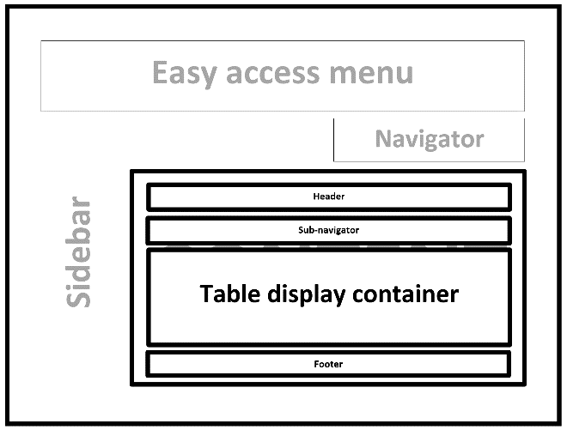

**Figure 4.2.6-1** The Record Pages Basic Setup

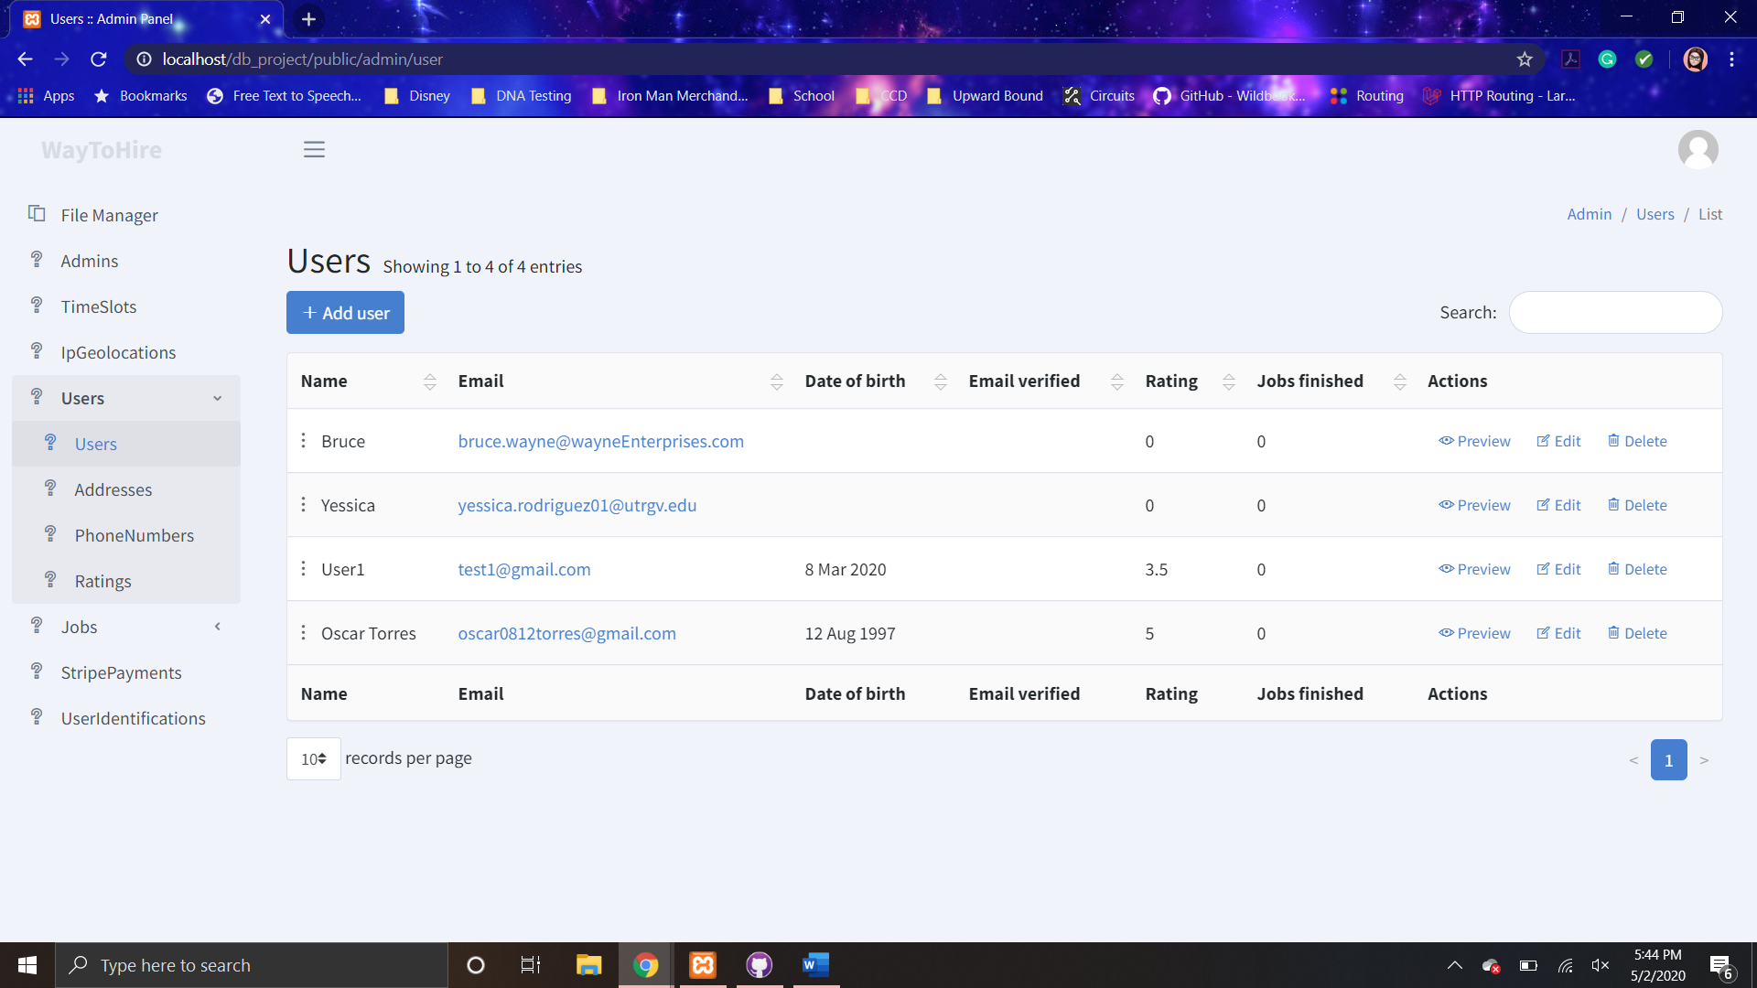

**Figure 4.2.6-2** The Record Pages Example Users Page

The sub-navigator contains two objects on the left and right. On the left, there is a “+ Add <*database entity*>,” which returns the create page. On the other hand, a “Search” text field is located on the right that filters the displayed records based on the entered text.

The table display container contains a row for each record in the database entity being viewed by the user. Each row displays the records stored values for each attribute along with three buttons. “Preview” button returns the show page. The “Edit” button returns the edit page. Finally, the “delete” button results in a pop-up that verifies that the administrative user wishes to delete the record.

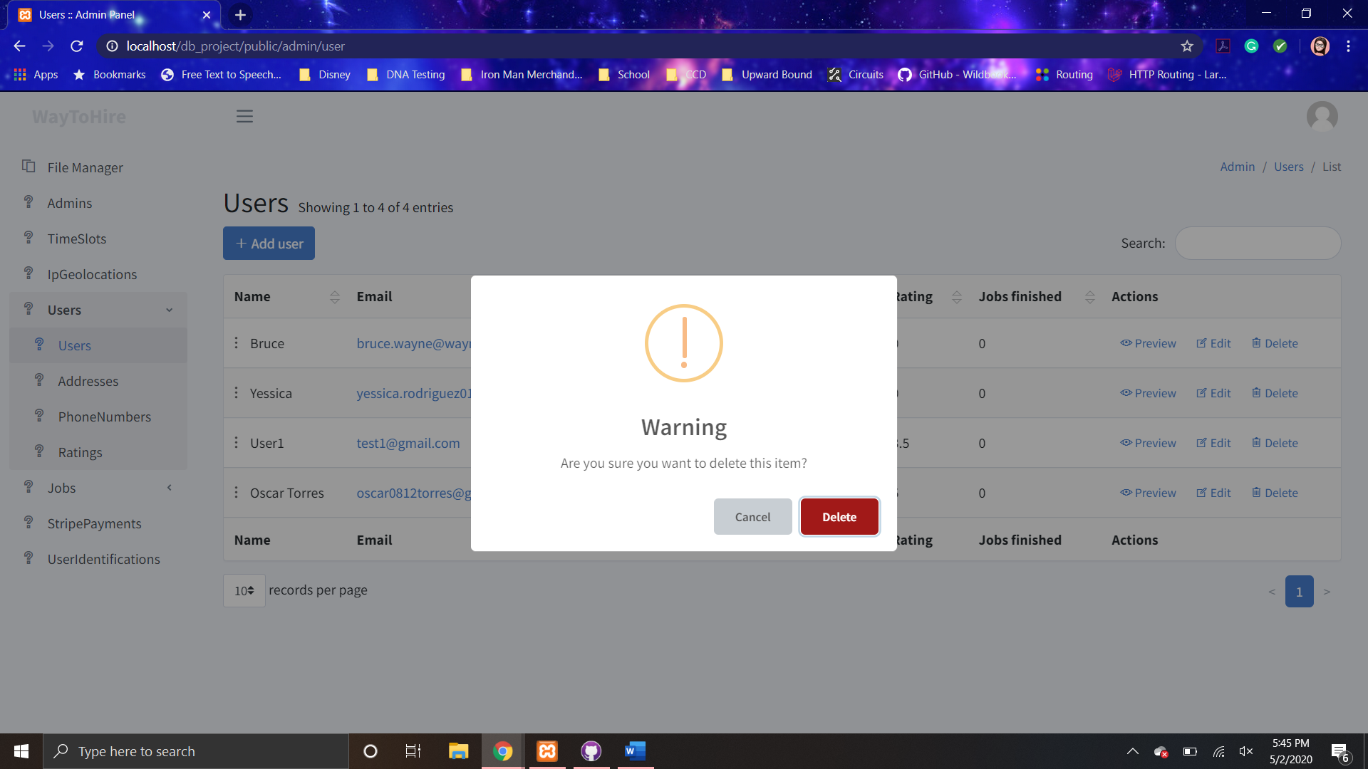

**Figure 4.2.6-3** The Record Pages Delete Pop-up Verification

If the administrative user clicks the “Cancel” button, the pop-up disappears without any record being deleted. However, if “Delete” button is pressed, the HNS system attempt to delete the record. If the record is successfully deleted, a pop-up appears informing the user and the row for that record is removed from the table display container.

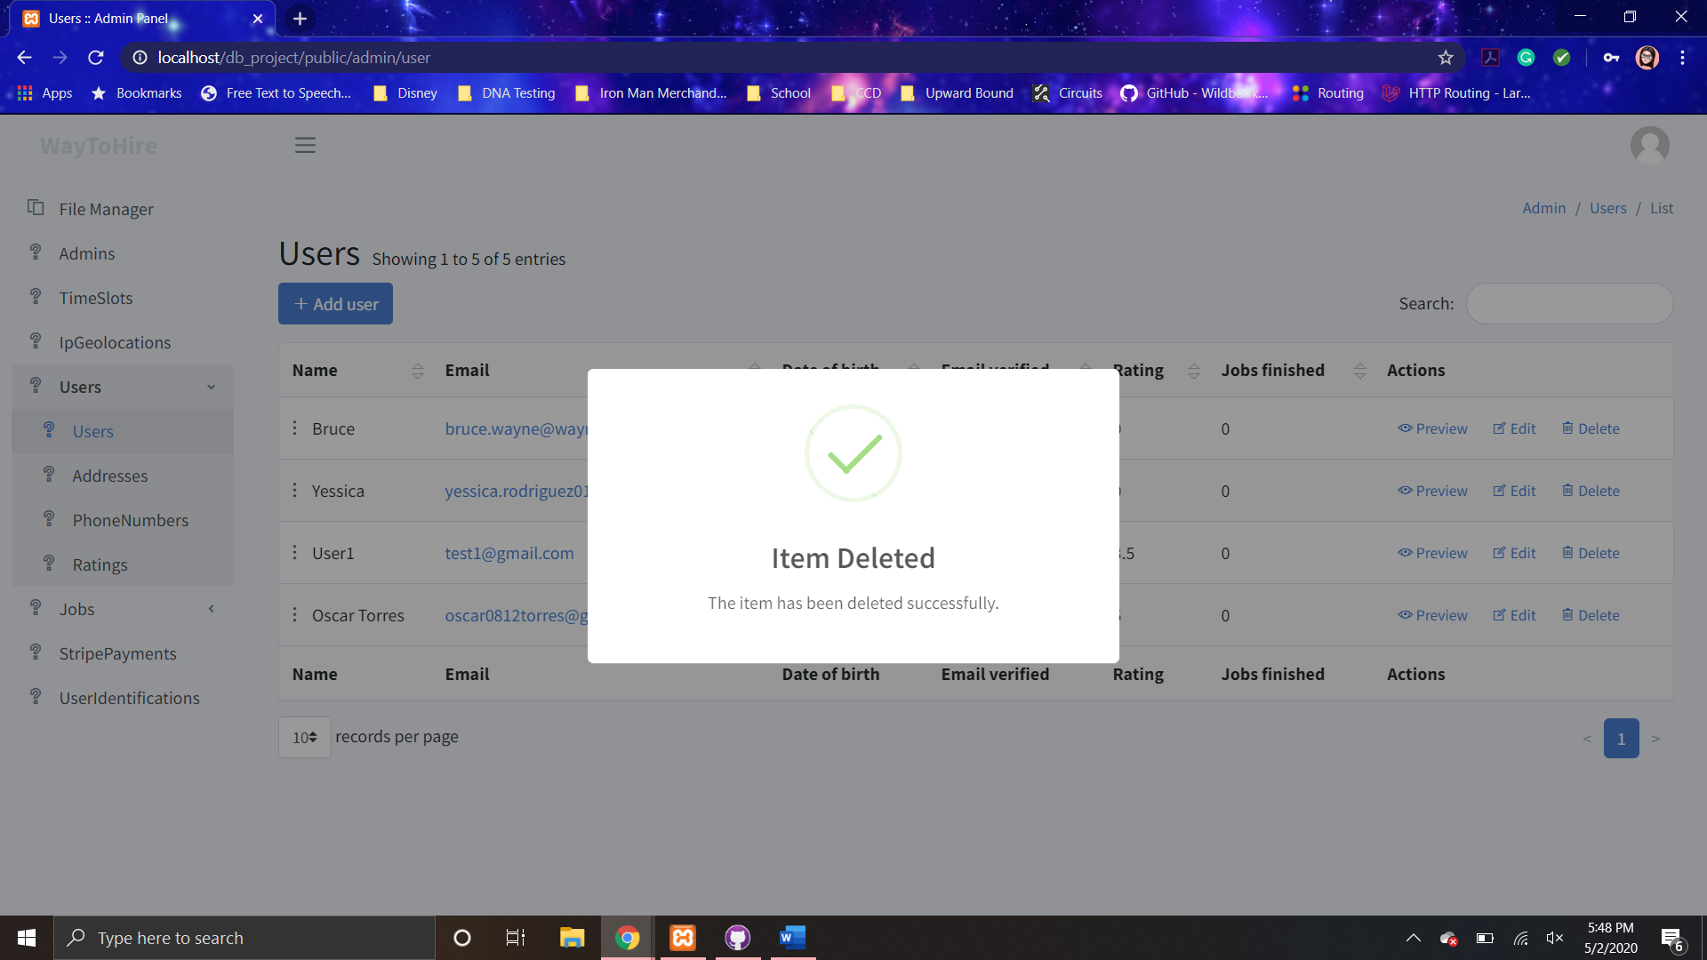

**Figure 4.2.6-4** The Record Pages Delete Pop-up Success

If any conflict or error occurs in the attempt to delete the record, the record is not deleted and a pop-up appears notifying the administrative user, which disappears after anything else on the screen is pressed.

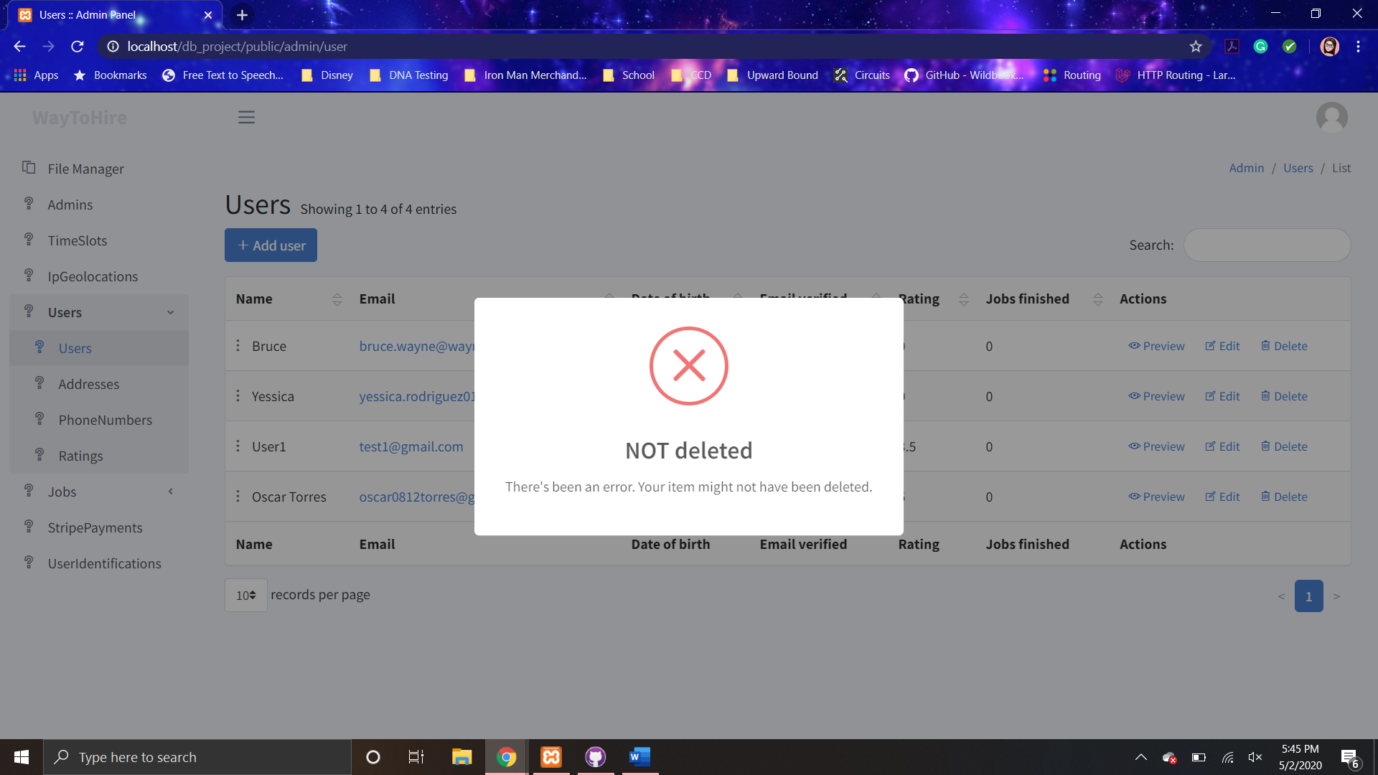

**Figure 4.2.6-5** The Record Pages Delete Pop-up Error

The footer contains two main aspects on the left and right. There is a “records per page” dropdown menu that allows the user to choose an option that will adjust the number of records available to be viewed per page (table page). Then there is a carousel menu that contains that contains all of the available table page numbers for the administrative user to select the table page he/she wishes to view. The stripe payments, addresses, and ip geolocations pages contain an addition two dropdown menu in the center of the footer. “Export” dropdown menu contains a list of data type options that the data can be obtained to use elsewhere. These options include Excel, PDF, print, and more. “Column visibility” dropdown menu allows the user to select specific attribute(s) to not be visible in the rows in the table display container.

### **Create Page**

The contents of this page consist of a header, and form. The header consists of a label of the title of the HNS database entity, in which a new record will be added, along with a link back to the corresponding database record page.

The form consists of the all the relevant text fields that are necessary in a record in the entity and two buttons. These text fields might be plain text fields, password-input field, or a date selector. It will mostly vary basing on the necessary information. The “Save and back” button submits the form once all the information is entered. The button “Cancel” returns the user to the corresponding database record page.

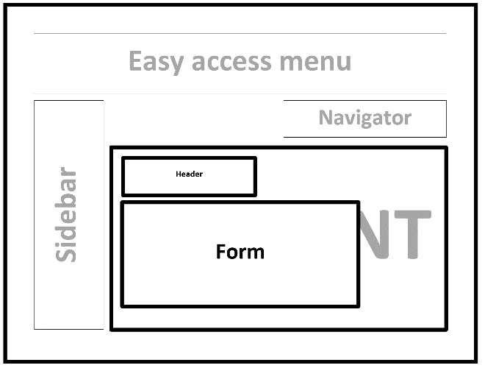

**Figure 4.2.7-1** The Create Page Basic Set Up

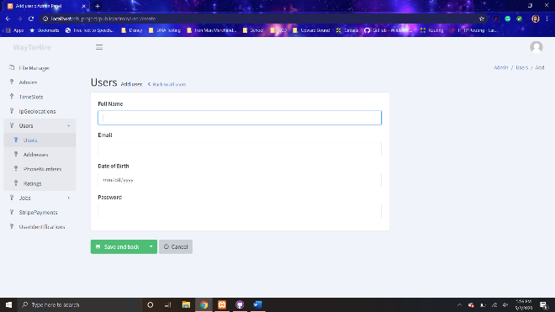

**Figure 4.2.7-2** The Create Page Example Users Entity

The only operation provided by this page is to create a new record in the chosen entity. He/she enters the necessary information. Then, he/she clicks the “Save and back” button, which sends the entered information to the HNS web server. The record is inserted to the HNS database with the entered information. Once the record is created, the administrative user is returned to the corresponding database record page with the additional row for the new record in the table display container and a pop-up that notifies the user of the successful addition of the record, which disappears after a couple of seconds.

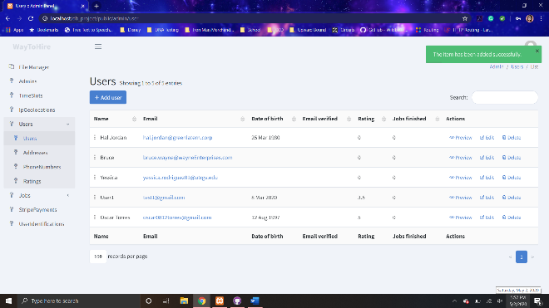

**Figure 4.2.7-3** The Creation Successful Pop-up Create Page

### **Show Page**

The contents of the page consist of a header and table. The header consists of a label o label of the title of the HNS database entity, in which the viewing records belongs to, along with a link back to the corresponding database record page. The table will contain a row for each entity and two columns. The first column contains the attribute names, while the second have the stored value for that attribute.

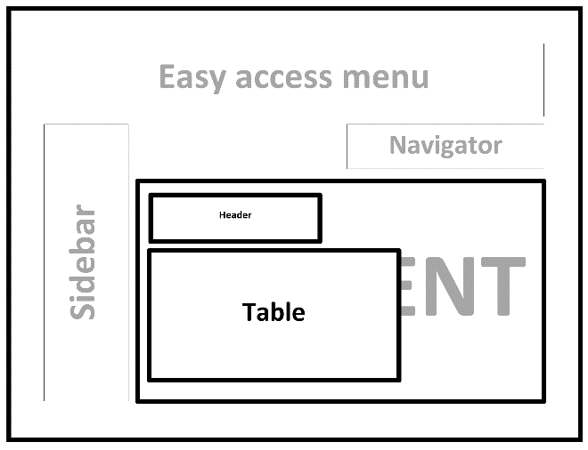

**Figure 4.2.8-1** The Show Page Basic Set Up

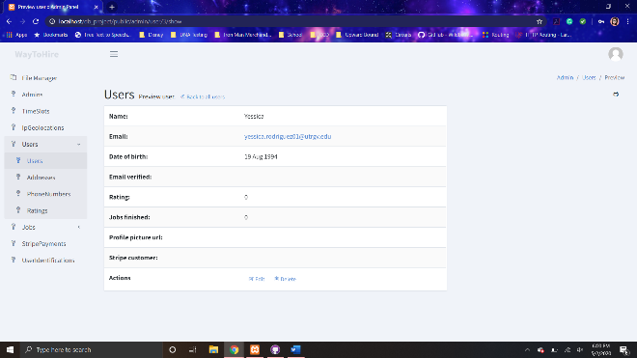

**Figure 4.2.8-2** The Show Page Example Users Entity Record

### **Edit Page**

The contents of this page consist of a header, and form. The header consists of a label of the title of the HNS database entity, in which the selected record to be edited belongs to, along with a link back to the corresponding database record page.

The form consists of the all the relevant text fields that are necessary in a record in the entity and two buttons. These text fields might be plain text fields, password-input field, or a date selector. It will mostly vary basing on the necessary information. The fields are automatically filled with the current information stored in the selected record. The “Save and back” button submits the form once all the information is entered. The button “Cancel” returns the user to the corresponding database record page.



**Figure 4.2.9-1** The Edit Page Basic Set Up

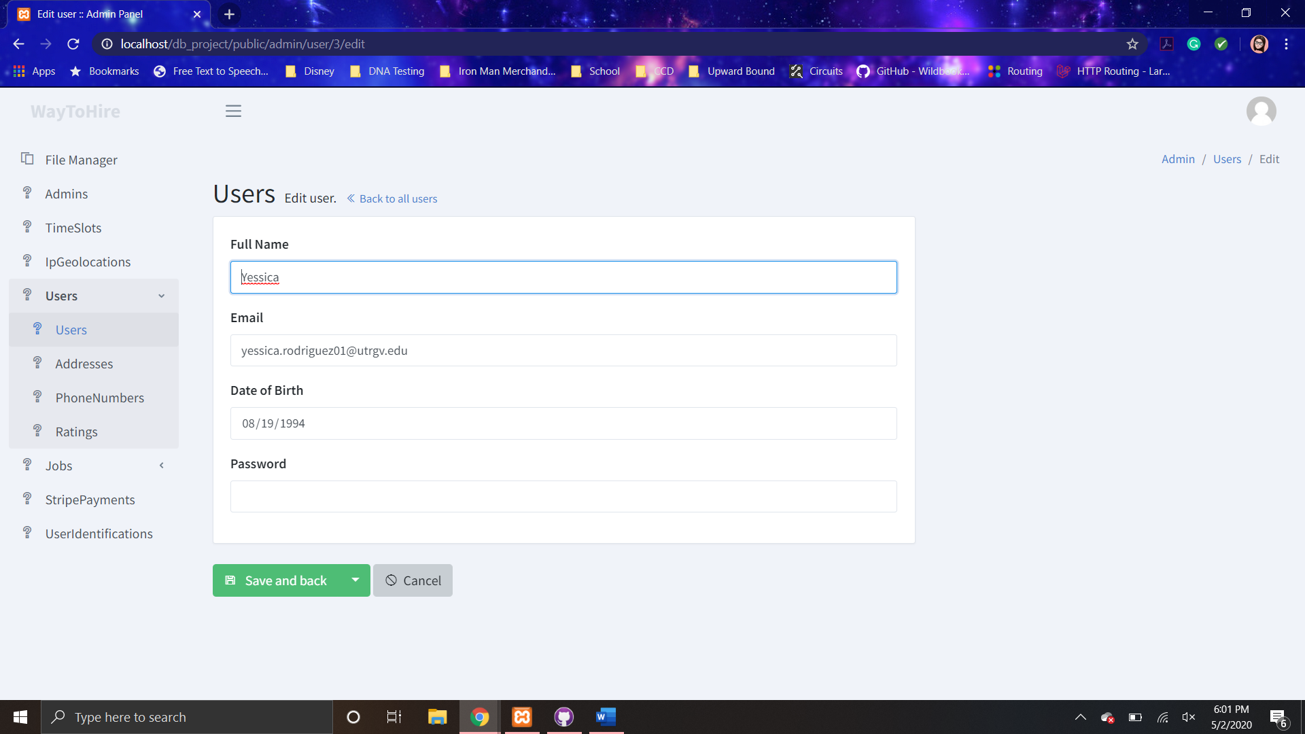

**Figure 4.2.9-2** The Edit Page Example Users Entity

The only operation provided by this page is to edit or modify a selected record in specific entity. He/she enters the modifies the already automatically entered information that he/she wishes to. Then, he/she clicks the “Save and back” button, which sends the information to the HNS web server. The selected record in the HNS database is modified based on the entered information. Once the record is modified, the administrative user is returned to the corresponding database record page with the row in the table display container for the selected record reflecting the modified information and a pop-up that notifies the user of the successful modification of the record, which disappears after a couple of seconds.

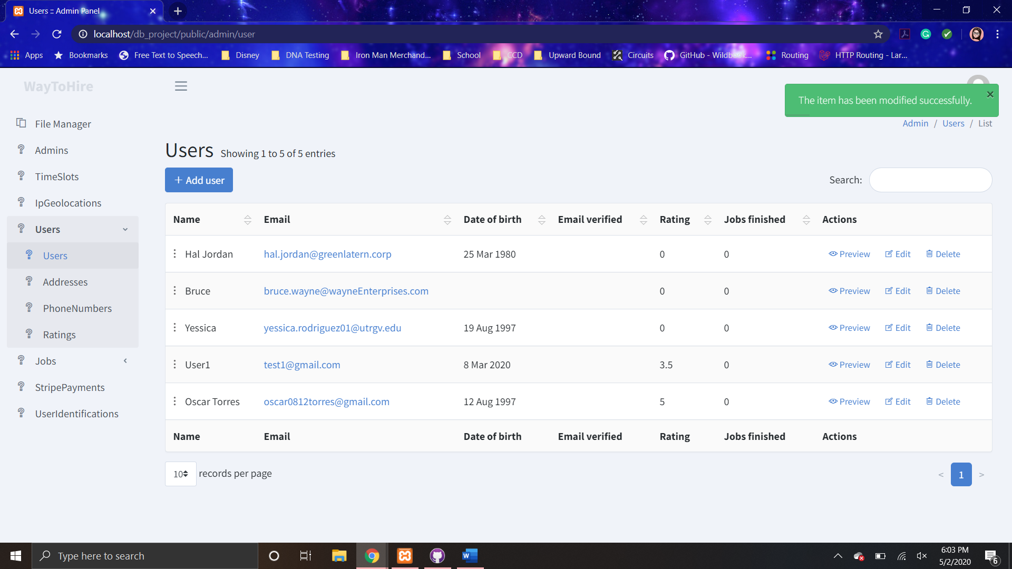

**Figure 4.2.9-3** The Edit Successful Pop-up Edit Page

### **Edit Account Info Page**

The contents information in this page consists of a header and two forms. The header consists of the title “My Account.”

The update account information form consists of two text fields and two buttons. “Name” field is where the administrative user enters his/her name or username. The “Email” field is where the administrative user enters his/her email address. Both of these are plain text fields. The “Save” button submits the form when pressed. On the other hand, the “Cancel” button cancels the submission of the form.

The change password form consists of three text fields. “Old password” field is where the user enters his/her old password. In the fields “New password” and “Confirm password,” the user should enter his/her new password. The password entered in both of these fields should match. All three fields are a password-type input field. The “Change Password” button submits the form when pressed. On the other hand, the “Cancel” button cancels the submission of the form.

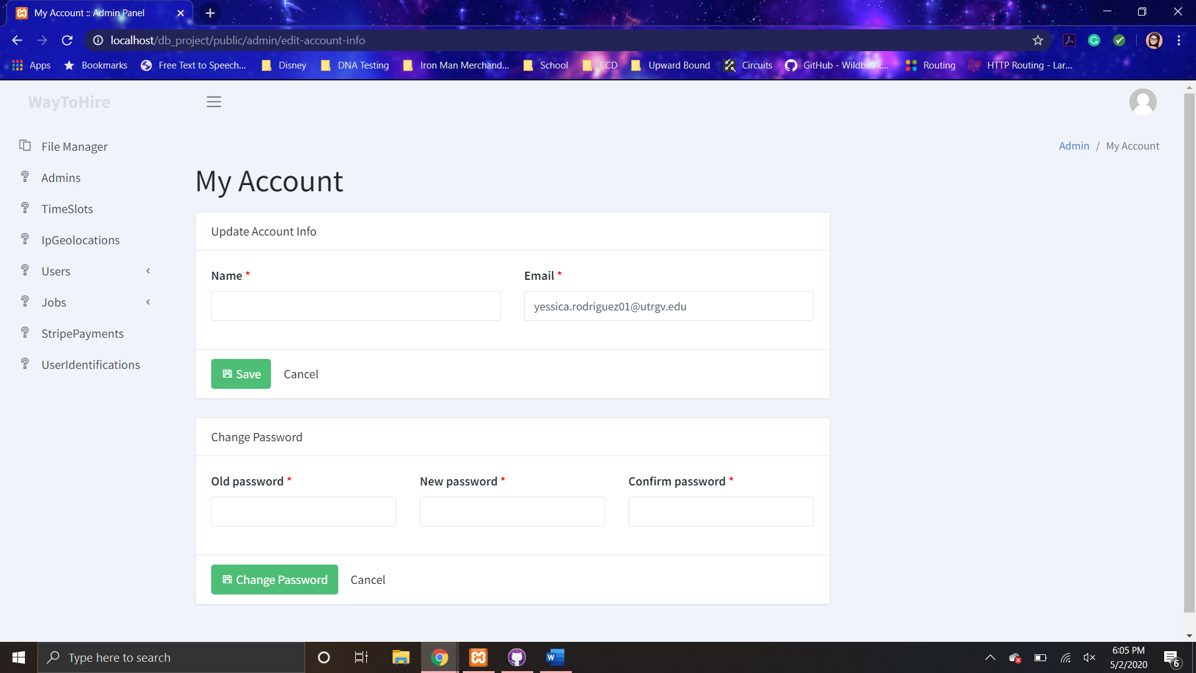

**Figure 4.2.10-1** The Edit Account Info Page

The only operation provided by this page is to edit or modify an administrative user’s own administrative account. Both forms work exactly the same. He/she enters the modifies the already automatically entered information that he/she wishes to. Then, he/she clicks the “Save” or “Change Password” button, which sends the information to the HNS web server. The administrative user’s information in the HNS database is modified based on the entered information. Once the record is modified, a pop-up is displayed that notifies the user of the successful modification of the administrative user’s account, which disappears after a couple of seconds.

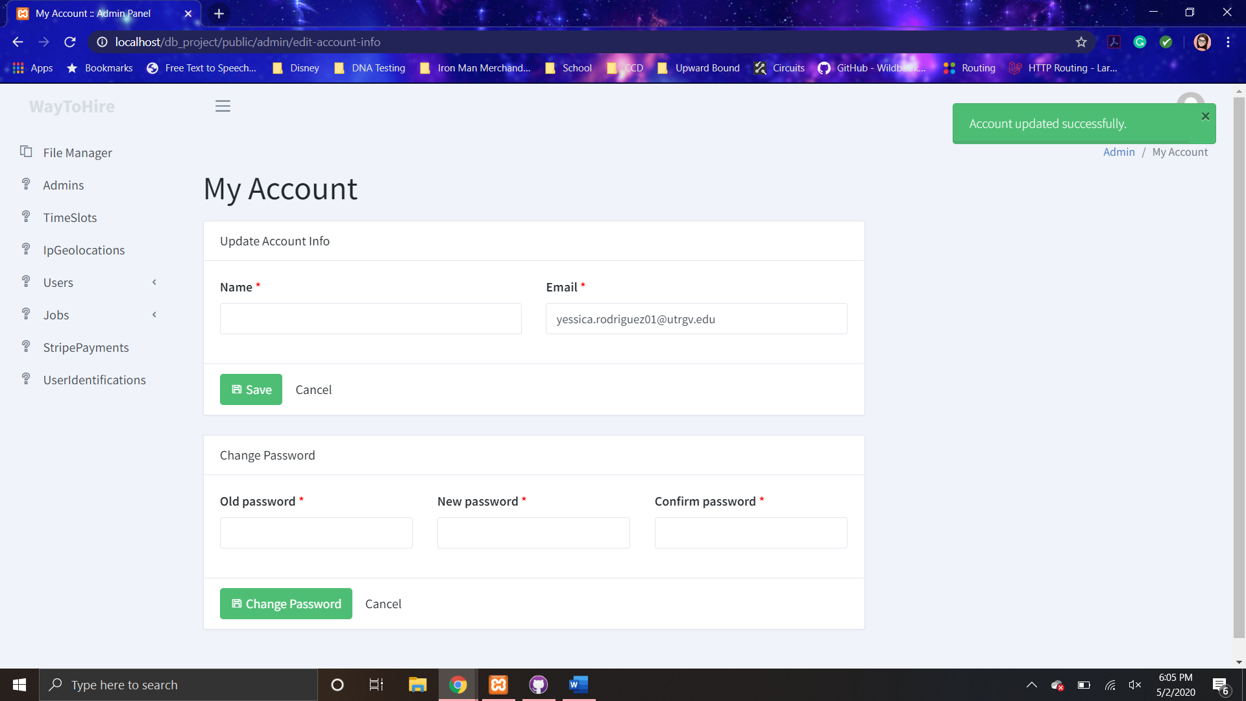

**Figure 4.2.10-2** The Edit Successful Pop-up Edit Account Infor Page

# **TESTING**

A system test was conducted on the site to evaluate the overall performance and functionality of the site. The test was conducted with a regular user account and an administrative user account by several group members, which are identified in section 6. The site was tested in various browsers including Google Chrome, Mozilla Firefox, Safari. The procedure, method of evaluation and the results of the test are described below.

Each test participant, individual conducting test, accessed the site and went through the site and attempted each process available to them. Thus, for the regular user evaluations, the following procedures were tested:

* Functionality of links
  + Access to each page (navigation)
  + Modification and submission of forms
* Interaction with data (database)
* Ease of Use
* General Appearance
* Content (necessity and quality)
* Mobile Browsing

The performance of the site will be evaluated based on participants own observations and feelings while running the test. The concluding results obtained from the reports of each participant are described below.

The site has overall functional links. One can access each of the pages available. However, the administrator pages are accessed only by adding “/admin” to the original URL of the site. There is no button to access it. In addition, one cannot register for a administrator account another administrator must create one for another person. In addition, the welcome page contains several links that do not lead anywhere or have any use. The user can fill out the available forms and submit it. The processed information would modify the database and the information displayed on the site. The only issue found in this area was when posting a job. The job images uploaded are not displayed into the job page returned is reloaded.

Furthermore, the website is overall easy to use. There might be a few links that are not obvious to the user such as the “Services” link to the jobs page in the welcome page and the “job title” link to the job page in the jobs page. The method of starting a chat is a little complicated. The only method is for a user from the job page to press the chat button. A pop-up opens with several starter chat message buttons for the user to select from. The chat starts when the user presses one of them. Afterwards, the user can send any message they want at any given time in the chats page within the chosen chat. Moreover, the website looks overall pleasing with repeating color scheme in each page. There are only a few issues with the content of the page. In the welcome page, several information is repeated. While in the job page, the job page the date and time for the posted job is not provided anywhere. Finally, when it comes to using the site in a mobile device the only page that suffers in appearance is the chats page. However, the entire site has the same functions and uses as it does when access in a desktop device.

The overall results were favorable. The site is overall function and performs admirable. There does not appear to be any issues with the execution time of any functions. However, several improvements could be conducted. In addition, there results might be biased due to the participants being group members that contributed to the creation of the site. Furthermore, more tests and user feedback obtain in future tests might reveal further issues. Future test to be conducted would be on security, web load testing (number of users accessing site affect on performance), and more.

# **GROUP MEMBER CONTRIBUTIONS**

## **Yessica Rodriguez -**

Yessica Rodriguez meet with and discussed with her group the overall design of the system. She contributed to the writing of the HNS System Database Design (Part B). Yessica wrote the problem description. The table detailed descriptions were written by her and several of her other group members. In addition, Yessica contributed to the writing of the HNS System Architecture Design (Part C). She wrote sections 1-5 entirely. Furthermore, she worked on the jobs page to allow the user to filter the jobs available by the job title (in other word profession). She helped with the modifying several views and linking pages together so they can be accessible to the user. She worked in testing of the site notifying other group members of errors and other functions that still needed to be done. Finally, Yessica contributed to the writing of this report. Yessica wrote sections 1,2, and 4.

## **Oscar Torres -**

Oscar Torres meet with and discussed with his group the overall design of the system. He contributed to HNS System Database Design (Part B) with the creation of the E-R Diagram and Relational Diagram. In addition, Oscar created the database and shared it with the rest of the group members through GitHub. Oscar contributed to HNS System Architecture Design (Part C) with the creation of the State Diagram. Furthermore, in both system design reports (Part B, C, D), he guided members in the brainstorming of the content of what should be written. In addition, Oscar created the general framework of the site. He mostly contributed the administration user interface and backend of the site. However, he did help in the making or modifications of several views.

## **Daniela Tamayo -**

Daniela Tamayo meet with and discussed with her group the overall design of the system. She contributed to the writing of the HNS System Database Design (Part B). Daniela helped write the table detailed descriptions along with several of her group members. In addition, Daniela helped guide members in the brainstorming of the content of what should be written in the system design reports (Part B, C, and D). Furthermore, Daniela worked on creating and modifying the views of the site. She created and designed the welcome page. Worked on the job view to display each one of them and added a credit card form to give user directly the option to pay. Implemented details to the welcome page in order to make it look more professional and realistic.

## **Ulvi Bajarani -**

Ulvi Bajarani meet with and discussed with his group the overall design of the system. He contributed to the HNS System Database Design (Part B) with the creation of a Table Diagram for each table in the database. In addition, Ulvi provided the route and controller information for section 6 of the HNS System Architecture Design (Part C). Furthermore, Ulvi contributed to the site by working on some of the views and testing the site for any errors. In addition, Ulvi helped with the writing of this paper. He wrote section 3.

# **CONCLUSION**

The HNS system involves the flow of data between a web server and database. It provides a user interface that enables the user to view, store, and modify information from the HNS database. The user is able to create an account, login, view posted jobs, create a job post, and upload personal information. They can chat with other users about posted jobs and make payments for their posted jobs that have been completed. Along with the user interface, the system provides an administrator user interface that allows administrators to control the content of the site and users’ information and access (delete or create user account).

Although there could be improvements to be made, the HNS system presented in this paper meets the overall basic requirements. The user is able to find jobs for his/her profession that otherwise they might not have been able to. In addition, users can connect to professionals for needed services that are not easy to get in contact with.

# **REFERENCES**

Rodriguez, Y., Torres, O., Tamayo, D., Bajarani, U. (2020). Group 6: PROgrammers – HomeNeedsService.com System Database Design (Part B). 1 – 19.

Rodriguez, Y., Torres, O., Tamayo, D., Bajarani, U. (2020). Group 6: PROgrammers – HomeNeedsService.com System Architecture Design (Part C). 1 – 22.